4th class work (Plan 4)
Ms. J. Manley
Hello all. Hope you are all keeping well. Again if you have any questions at all about the work or anything else, please don’t hesitate to contact me via my email address: jennifer.manley@northpresprimary.ie or I can ring you if you wish.
The plan below is for the week. Everyday there is Maths, English and homework. I will put in one additional subject then each day. Again there is absolutely no pressure to get this work completed. The work below is mostly what we would have been covering in school this week.
There is no need to print off the pages unless you really want to. The girls are well able to read the pages and complete written activities in their copies or on any pages that you may have at home. It might be handy to use the zoom tool on the bottom right of the screen so you can see the images more clearly.

Monday 27th April
Maths:
This week we will be studying capacity in maths.
- Capacity: is the total amount of fluid that can be contained in a container. It is the word we use when measuring liquids. There are 1000ml in one litre. Have a look at home at various containers holding liquids and read the amount in ml or litres. Examples you might want to have a look at are: cartons of milk/juice, minerals, bottles of water, deodorant, make up, toothpaste, moisturiser, cleaning products.....
- For today’s Maths lesson I want you to simply look around your house for various containers that hold different liquids. I have given you some ideas above. Draw them into your copy and write down next to the it what amount each container holds.

English:
Read the text and answer the quick questions in your copy.
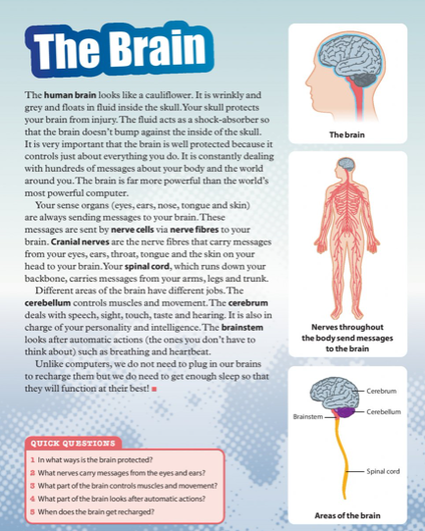

PE:
Athletics with Clare. You worked with Clare last year in 3rd class. She was delivering an Athletics course. She now has weekly videos up on you tube that you can do in your home. The first lesson is focusing on the skill of hopping. Enjoy!
Go to YouTube and type in PE @ Home with Coach Clare Week 1.

Homework:
Spellings from Spellbound – Unit 22 – The Farm: Box 1 (A and B).
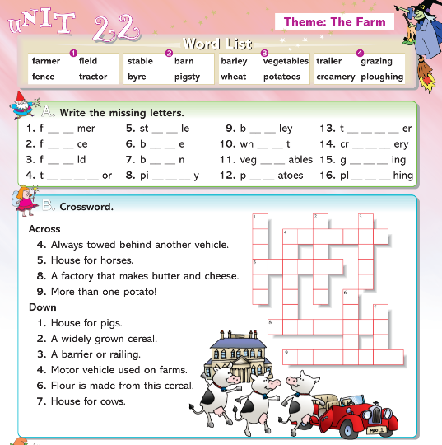

Mental Maths 4: (Week 30 – Monday and Problem Solving). The girls will have these books at home so write away into them as we usually do.

Tables: revise 5 multiplication tables.

Tuesday 28th April
Maths: Capacity: Below colour the containers to show the correct amount of liquids. (If you can’t print it out just point to the correct level in each container).
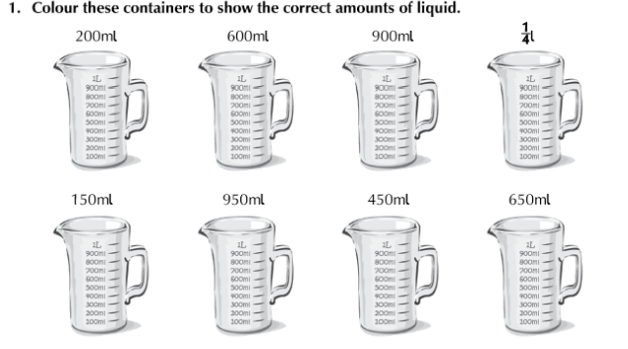
English: Read the text and answer the questions in your copy.
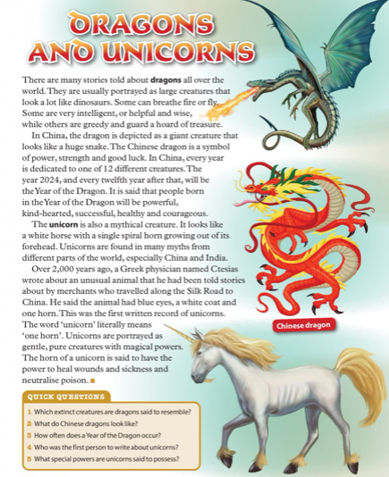
History:
The Celts. Read the following piece and answer the questions into your copies.
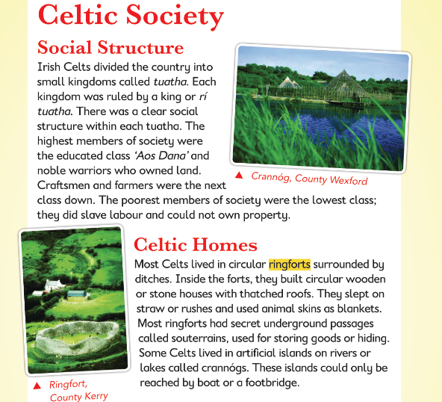

- Who were the ‘Aos Dana’ in Celtic society?
- What type of homes did the Celts live in?
- Describe a crannóg.
- What did the lowest class do in Celtic times?

Homework:
Spellings from Spellbound – Unit 22 – The Farm: Box 2 (C and D).
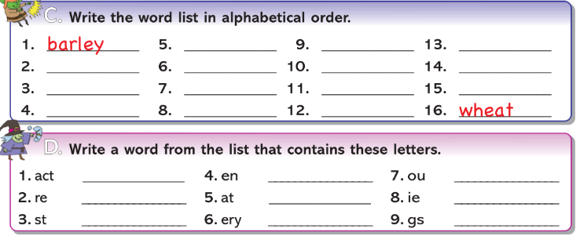

Mental Maths 4: (Week 30 – Tuesday and Problem Solving). The girls will have these books at home so write away into them as we usually do.

Tables: revise 5 multiplication tables.

Wednesday 29th April
Maths: Capacity:
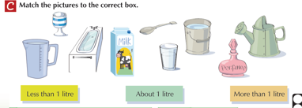

English: Read the text and answer the questions in your copy.
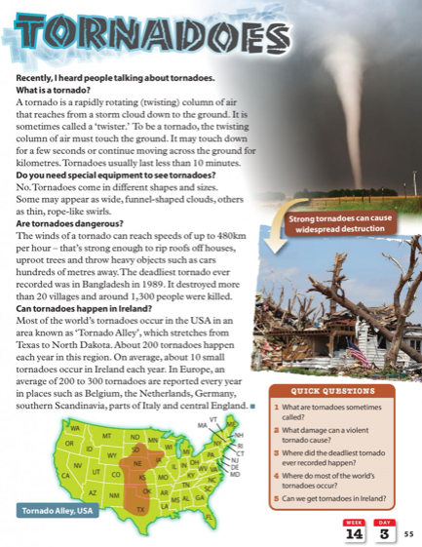

Irish: Revise counting people this week. Write each number out into your copy or on a page and put the corresponding amount of people next to the number.
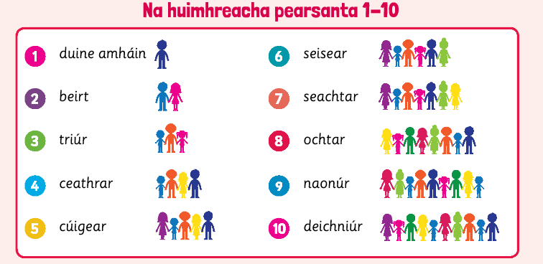
Homework:
Spellings from Spellbound – Unit 22 – The Farm: Box 3 (E and F).
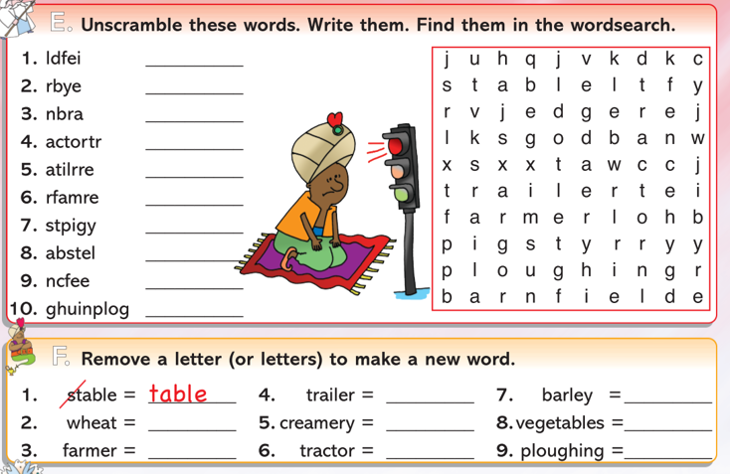
Mental Maths 4: (Week 30 – Wednesday and Problem Solving). The girls will have these books at home so write away into them as we usually do.

Tables: revise 5 multiplication tables.
Thursday 30th April
Maths: Capacity: Write the following as milliltres.
- (a) 1l 300ml = 1300ml (b) 1l 700ml = 1700ml. Keep going like this.
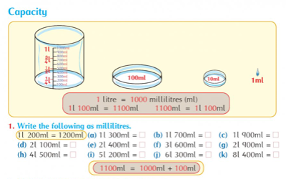
English: Read the text and write the answers in your copy.
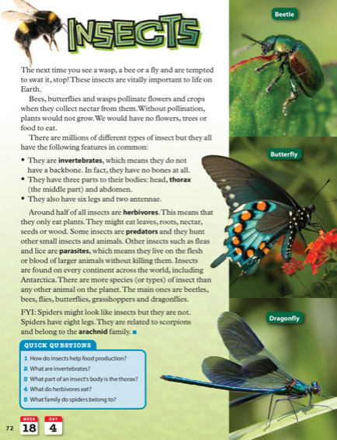
Art: One point perspective drawing lesson. We did something similar to this when we drew the street and the buildings. Remember the nearer the object is to you, the bigger it is and the further away it is, the smaller it is. Have a go and see how you get on!!
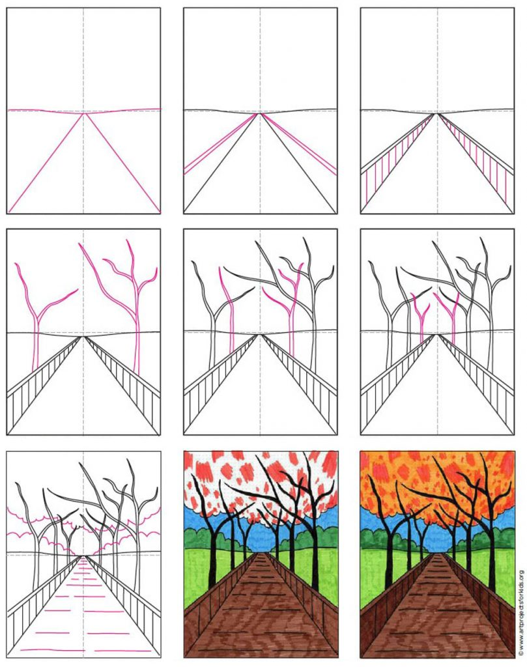
Homework: Spellings from Spellbound – Unit 22 – The Farm: Go back over Boxes 1 – 4 (G and H).
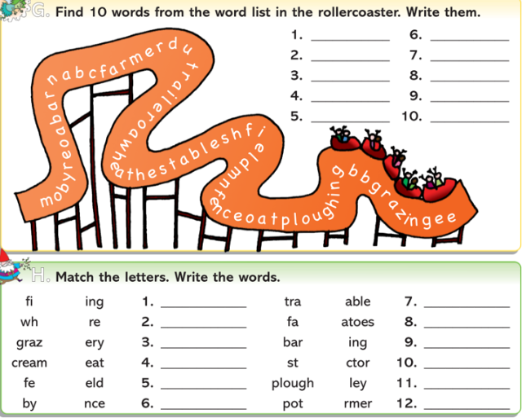
Mental Maths 4: (Week 30 – Thursday and Problem Solving). The girls will have these books at home so write away into them as we usually do.
Tables: revise 5 multiplication tables.
Friday 1st May
Maths: Capacity: Write the following as litres and milliltres.
- (a) 1400ml = 1l 400ml (b) 1800ml = 1l 800ml. Keep going like this.

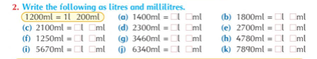
English:
Read the text and write the answers in your copy.
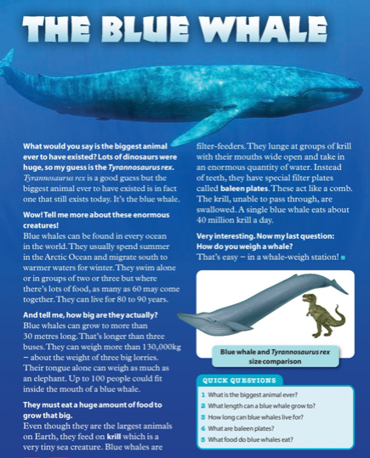

DEAR Time: Drop everything and just simply read some pages from your favourite book or a library book for 20 minutes or more. Enjoy!!!
Weekly Friday Test:
If you would like to give your daughter a test today, here is the list of words:
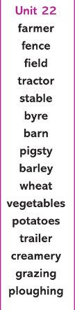

They could also do the Friday review in their Mental Maths 4 books.
Write out the 5 multiplication tables.

-

