4th class work (Plan 5)
Ms. J. Manley
Hello all. Hope you are all keeping well. Again if you have any questions at all about the work or anything else, please don’t hesitate to contact me via my email address: jennifer.manley@northpresprimary.ie or I can ring you if you wish.
The plan below is for the week ahead. As Monday is a bank holiday there won’t be any work assigned for that day. Again this week there is English, Maths and homework each day Tuesday – Friday and one additional subject then each day. Again there is absolutely no pressure to get this work completed. The work below is mostly what we would have been covering in school this week.
There is no need to print off the pages unless you really want to. The girls are well able to read the pages and complete written activities in their copies or on any pages that you may have at home. It might be handy to use the zoom tool on the bottom right of the screen so you can see the images more clearly.

Tuesday 5th May

Maths:
We will continue to study capacity in maths this week. I have put in some number work too if you want to revise it.
Capacity:
- Adding litres and millilitres.
- Add the millilitre side first. Then add the litres.

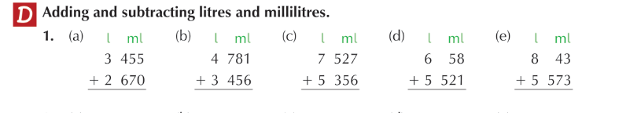
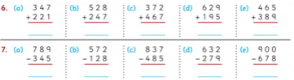

English:

Handwriting: Copy this piece of text below into your copies in joined writing.
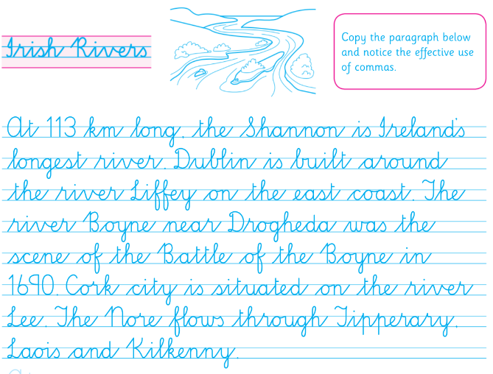

Comprehension: Read the text below and answer the questions in your copy.

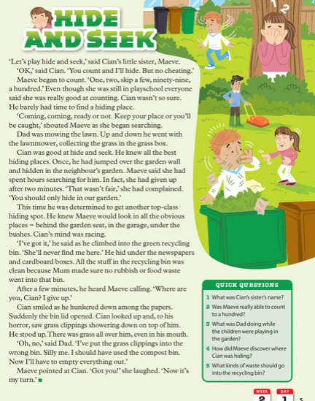

Geography:
Look at the 2 pictures below. One is of Oak Village 100 years ago. The other is Oak Village today. Study both pictures and answer the questions below into your copies.
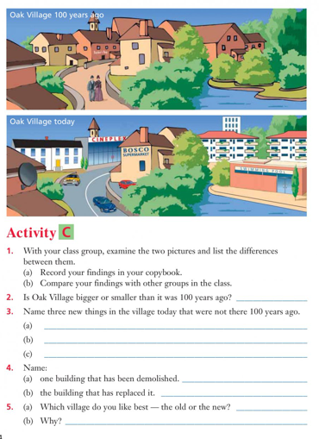

Homework:
Spellings from Spellbound – Unit 25 – Buildings: Box 1 (A and B).
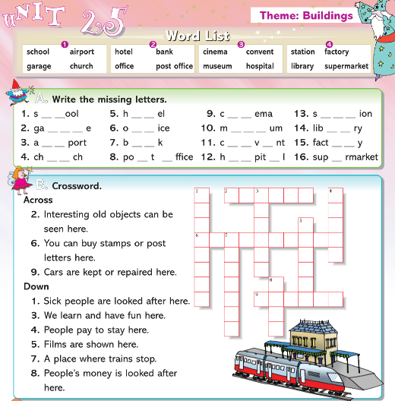

Mental Maths 4: (Week 31 – Monday and Problem Solving). The girls will have these books at home so write away into them as we usually do.

Tables: revise 10 multiplication tables.

Wednesday 6th May

Maths: Capacity:
- Adding litres and millilitres.
- Add the millilitre side first. Then add the litres.
- Put your answer in ml first and then in litres. eg. 1340ml / 1.34l

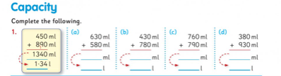

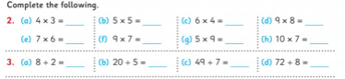

English:
Cloze procedure: write this passage into your copies and fill in the missing words.
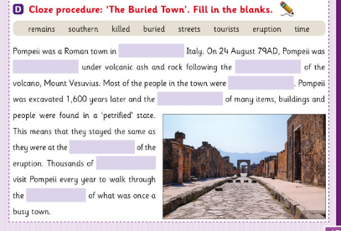
Comprehension:
Read the text below and answer the questions in your copy.

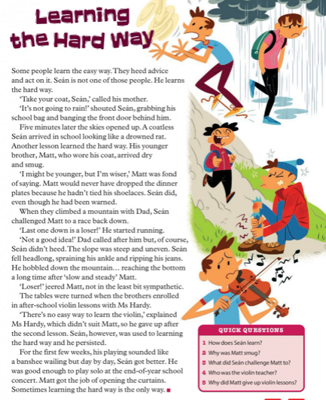

PE:
Athletics with Clare. You worked with Clare last year in 3rd class. She was delivering an Athletics course. She now has weekly videos up on you tube that you can do in your home. The next lesson is focusing on the skill of jumping for distance and landing safely. Enjoy!
Go to the following website and Week 2 is up: http://weplay.ie/peathome/

Homework:
Spellings from Spellbound – Unit 25 – Buildings: Box 2 (C and D).
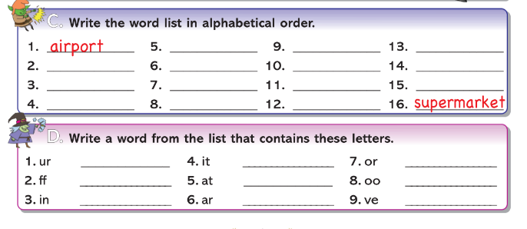

Mental Maths 4: (Week 31 – Tuesday and Problem Solving). The girls will have these books at home so write away into them as we usually do.

Tables: revise 10 multiplication tables.

Thursday 7th May
Maths: Capacity:
- Adding litres and millilitres.
- Add the millilitre side first. Then add the litres.

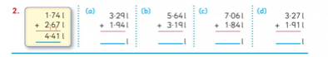

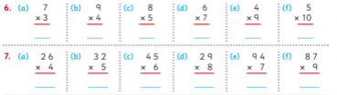
English: Phonics: ‘qu’ – study the ‘qu’ words below. Complete parts A and B into your copies using the words provided.
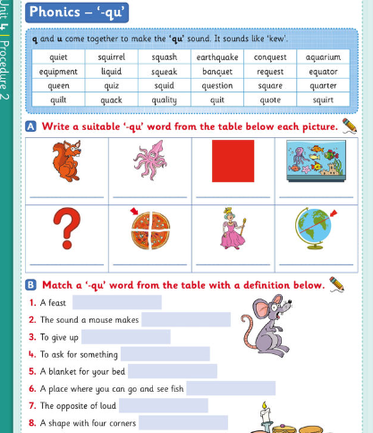
Comprehension:
Read the text below and write the answers in your copy.

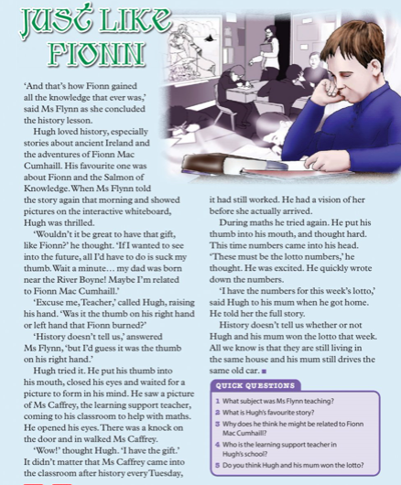
Irish: Write this table out into your copies and maybe get someone to test you.
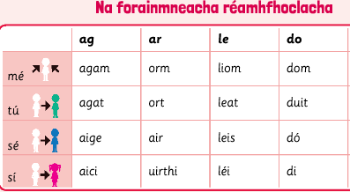
Homework:
Spellings from Spellbound – Unit 25 – Buildings: Box 3 (E and F).
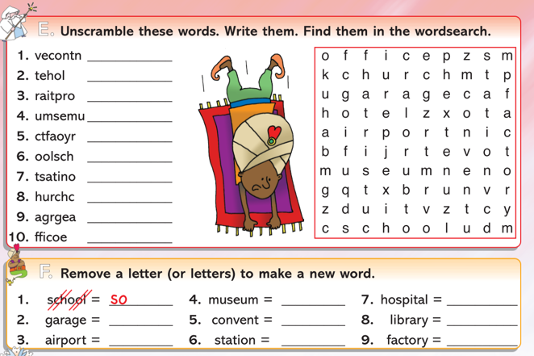

Mental Maths 4: (Week 31 – Wednesday and Problem Solving). The girls will have these books at home so write away into them as we usually do.

Tables: revise 10 multiplication tables.

Friday 8th May
Maths: Capacity:
- Subtracting litres and millilitres.
- Remember when subtracting if the number is bigger on the bottom row go next door and borrow.
- Put your answer in litres. eg. 5.79l.
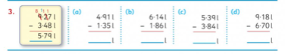
English:
Grammar: plurals activity – complete Part A below into your copies. Remember all the rules when changing a word from singular to plural (more than one).

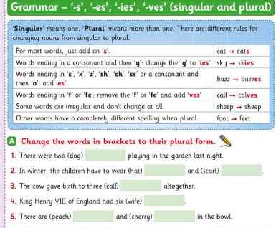

Comprehension:
Read the text and write the answers in your copy.
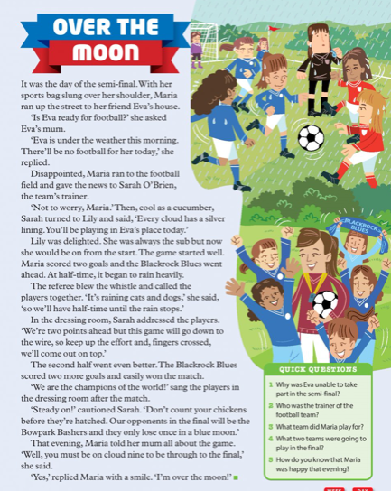

Homework: Spellings from Spellbound – Unit 25 – Buildings: Go back over Boxes 1 – 4 (G and H).
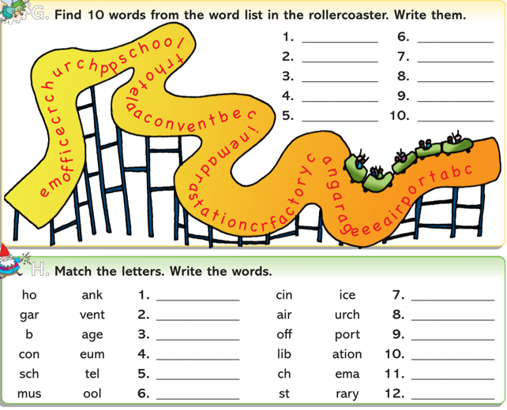
Mental Maths 4: (Week 31 – Thursday and Problem Solving). The girls will have these books at home so write away into them as we usually do.

Tables: revise 10 multiplication tables.

DEAR Time: Drop everything and just simply read some pages from your favourite book or a library book for 20 minutes or more. Enjoy!!!

Weekly Friday Test:
If you would like to give your daughter a test today, here is the list of words:

They could also do the Friday review in their Mental Maths 4 books.

Write out the 10 multiplication tables.

