4th class work (Plan 6)
Ms. J. Manley
Hello all. Hope you are all keeping well. Again if you have any questions at all about the work or anything else, please don’t hesitate to contact me via my email address: jennifer.manley@northpresprimary.ie or I can ring you if you wish. The plan below is for the week ahead. Again this week there is English, Maths and homework each day and one additional subject then each day. Again there is absolutely no pressure to get this work completed. The work below is mostly what we would have been covering in school this week.
I have also created a padlet, which is an online noticeboard. Here is the link:
https://padlet.com/jennifermanley/t1pqxej4f3xt1py6

On this padlet, you will find everything you need in one place. It is divided into columns for each day Monday to Friday. The activities are displayed there with accompanying worksheets, videos and links to other websites.

Monday 11th May
Maths:
We will study weight in maths this week. I have put in some number work too if you want to revise it. Weight: Remember 1kg = 1000g. We use kilogrammes (kg) to weigh heavy objects. We use grammes (g) to weigh lighter objects.
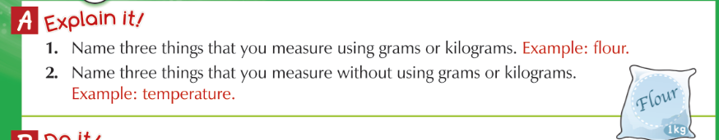

Number: Adding with no regrouping.

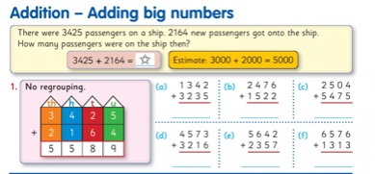

English: Handwriting: Copy this piece of text below into your copies in joined writing.
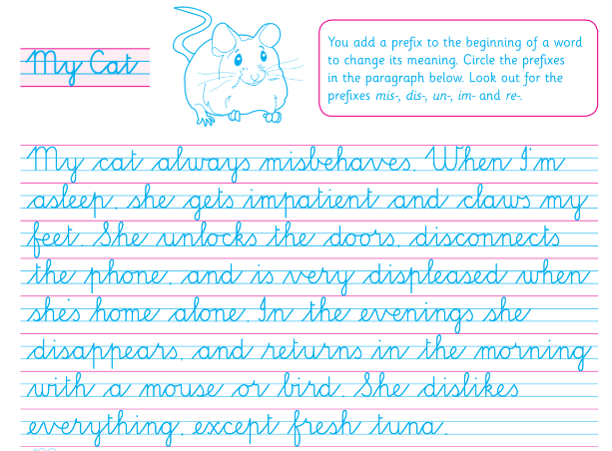
Comprehension: Read the text below and answer the questions in your copy.
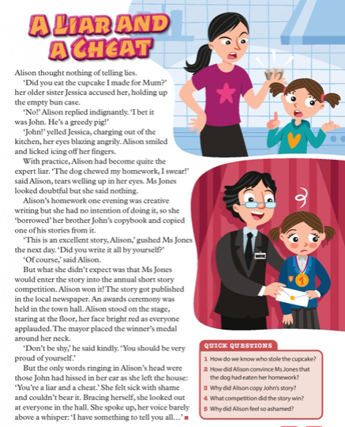
Science:
Habitats: Think of 4 habitats in your local area. Draw and label the plant and animal life that you would expect to find in each of these habitats.
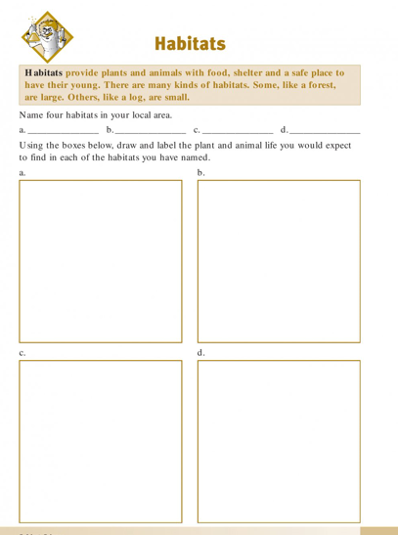

Homework:
Spellings from Spellbound – Unit 28 – Games: Box 1 (A and B).
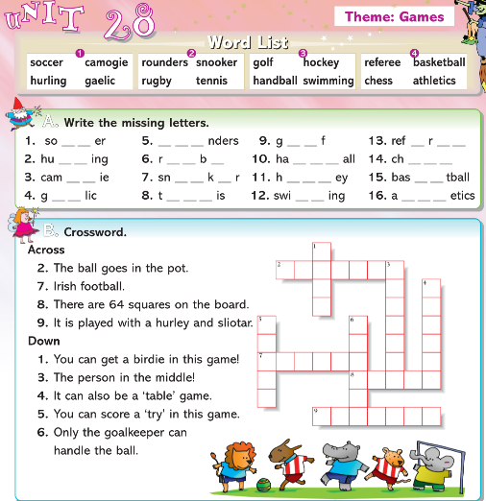

Mental Maths 4: (Week 32 – Monday and Problem Solving). The girls will have these books at home so write away into them as we usually do.

Tables: revise 7 multiplication tables.

Tuesday 12th May

Maths:
Weight: Remember 1kg = 1000g. We use kilogrammes (kg) to weigh heavy objects. We use grammes (g) to weigh lighter objects.
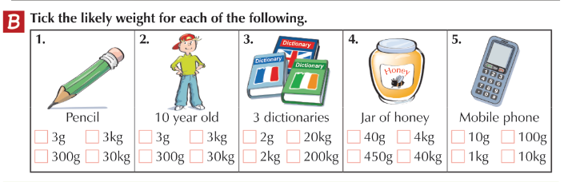

Number: Adding with regrouping.
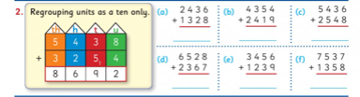
English:
Cloze procedure: write this passage into your copies and fill in the missing words.
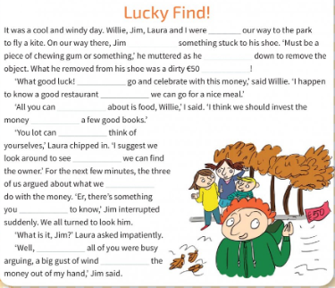
Comprehension:
Read the text below and answer the questions in your copy.
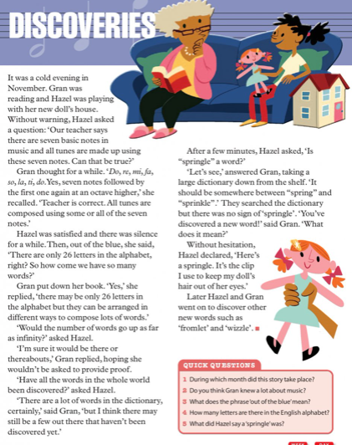

PE:
Athletics with Clare. You worked with Clare last year in 3rd class. She was delivering an Athletics course. She now has weekly videos up on you tube that you can do in your home. The next lesson is focusing on the skill of hand – eye coordination & striking and mindfulness. Enjoy!
Go to the following website and Week 3 is up: http://weplay.ie/peathome/

Homework:
Spellings from Spellbound – Unit 28 – Games: Box 2 (C and D).
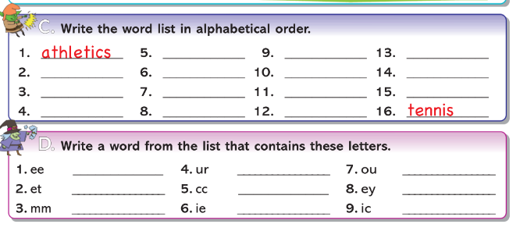

Mental Maths 4: (Week 32 – Tuesday and Problem Solving). The girls will have these books at home so write away into them as we usually do.

Tables: revise 7 multiplication tables.

Wednesday 13th May
Maths:
Weight: There are lots of different types of weighing scales: a spring scales (fruit / vegetables), a kitchen scales (flour), livestock scales (animals).
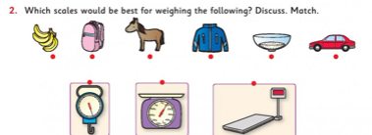

Number work: Adding with regrouping.
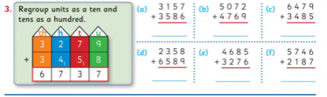

English: Phonics: ‘-ough’ – study the ‘-ough’ words below. Complete the grid into your copies.
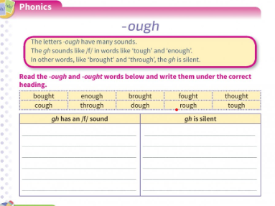

Comprehension: Read the text below and write the answers in your copy.
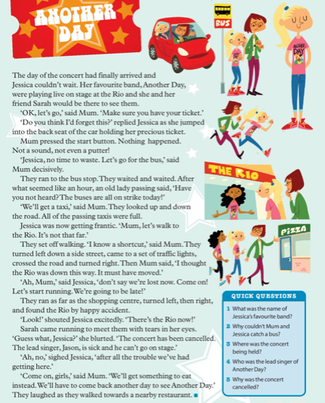

Irish: Write this table out into your copies and maybe get someone to test you on the colours in Irish.
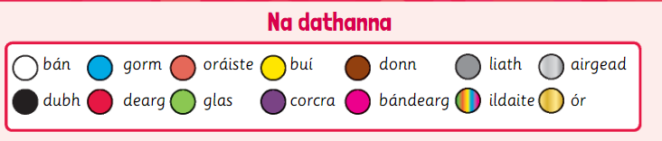

Homework:
Spellings from Spellbound – Unit 28 – Games: Box 3 (E and F).
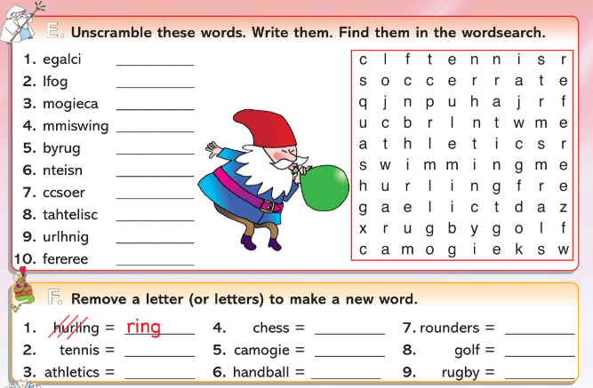

Mental Maths 4: (Week 32 – Wednesday and Problem Solving). The girls will have these books at home so write away into them as we usually do.

Tables: revise 7 multiplication tables.

Thursday 14th May

Maths: Weight: Change the following into grammes. 4kg 300g = 4,300g.
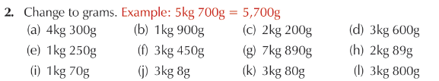
Number work: Adding more bigger numbers.
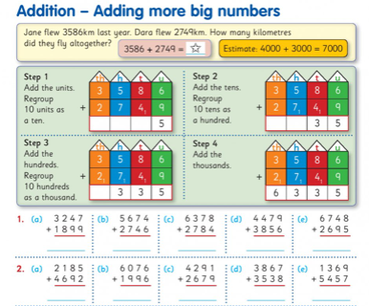
English: Grammar: plurals activity – complete Parts A and B below into your copies. Remember all the rules when changing a word from singular to plural (more than one).

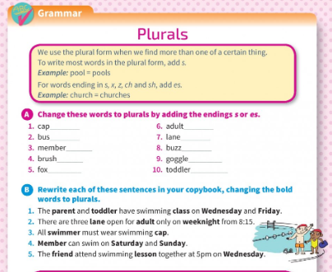
Comprehension:
Read the text and write the answers in your copy.
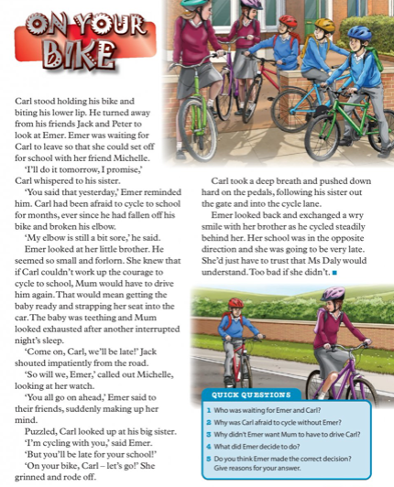

Art:
Exploring nature: Sit outside or look out your window and sketch plants, trees, birds or scenes you find interesting. Use lots of colours to make your sketch come to life.

Homework: Spellings from Spellbound – Unit 28 – Games: Go back over Boxes 1 – 4 (G and H).
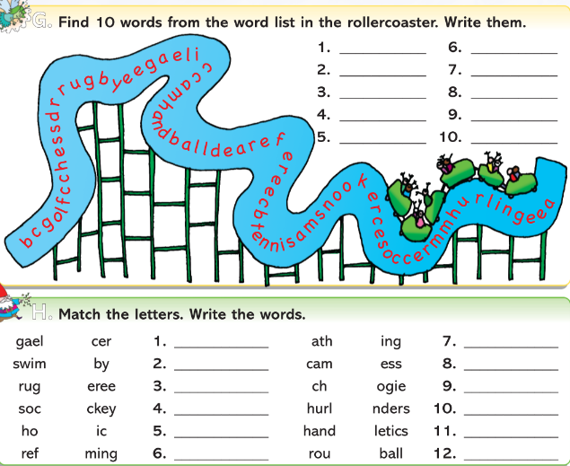

Mental Maths 4: (Week 32 – Thursday and Problem Solving). The girls will have these books at home so write away into them as we usually do.

Tables: revise 7 multiplication tables.

Friday 15th May
Maths:
Weight: Change the following to kilogrammes and grammes. 1,300g = 1kg 300g.
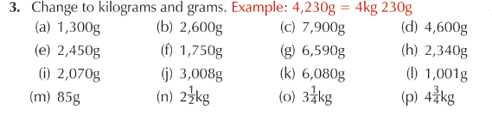

Number work: Adding more bigger numbers.
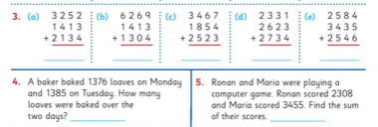

English:
Free writing:
Girls you can write on any topic of your choice. Write a story, a news report, a diary entry…whatever style of writing you like. Be as imaginative as you can!!!

Comprehension:
Read the text and write the answers in your copy.

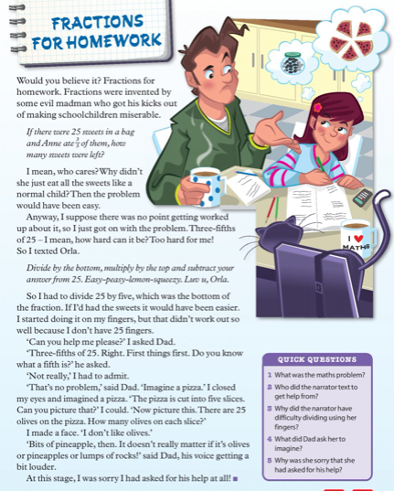
DEAR Time: Drop everything and just simply read some pages from your favourite book or a library book for 20 minutes or more. Enjoy!!!

Weekly Friday Test:
If you would like to give your daughter a test today, here is the list of words:
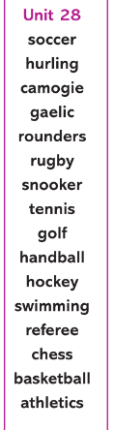

They could also do the Friday review in their Mental Maths 4 books.

Write out the 7 multiplication tables.

