4th class work (Plan 7)
Ms. J. Manley
Hello all. Hope you are all keeping well. Again if you have any questions at all about the work or anything else, please don’t hesitate to contact me via my email address: jennifer.manley@northpresprimary.ie or I can ring you if you wish. The plan below is for the week ahead. Again this week there is English, Maths and homework each day and one additional subject then each day. Again there is absolutely no pressure to get this work completed. The work below is mostly what we would have been covering in school this week.
I have also created a padlet, which is an online noticeboard. Here is the link:
https://padlet.com/jennifermanley/t1pqxej4f3xt1py6

On this padlet, you will find everything you need in one place. It is divided into columns for each day Monday to Friday. The activities are displayed there with accompanying worksheets, videos and links to other websites.

Monday 18th May
Maths:
We will study weight in maths this week. I have put in some number work too if you want to revise it. Weight: Addition: Add the following sums. Don’t forget to use g for grammes and kg for kilogrammes. The first one is done for you. The answer is 1350g = 1.35kg.
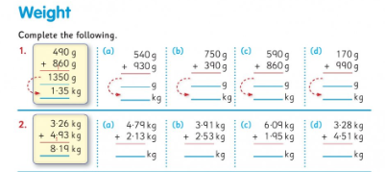

Number: Multiplication.
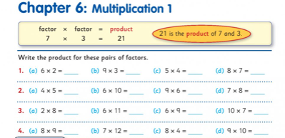
English:
Handwriting: Copy this piece of text below into your copies in joined writing.
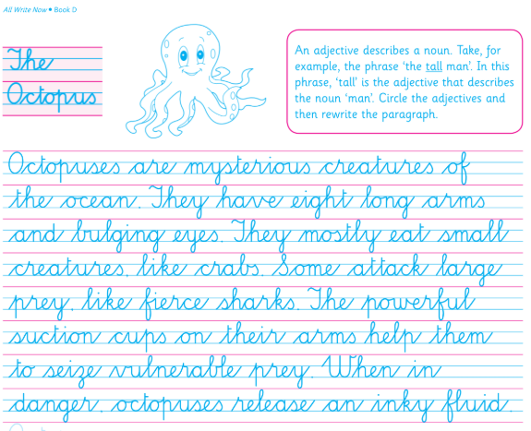

Comprehension: Read the text below and answer the questions in your copy.

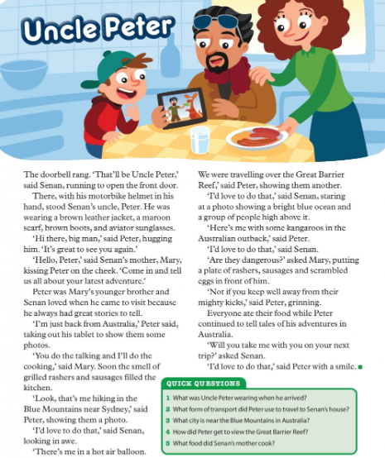

History:
The Greeks: Read the 2 pieces of text below and answer the questions in your copies.
What was the name of the group of people who lived on the island of Crete?
2. How long did Greek civilisation last for?
3. Name 2 city-states in Greece.
4. Where does the city of Athens get its' name from?
5. Describe the houses the normal Athenians lived in.
6. Name 2 great thinkers in Athenian times.
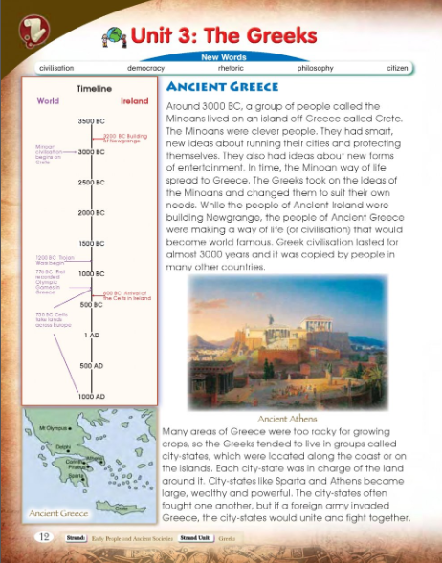
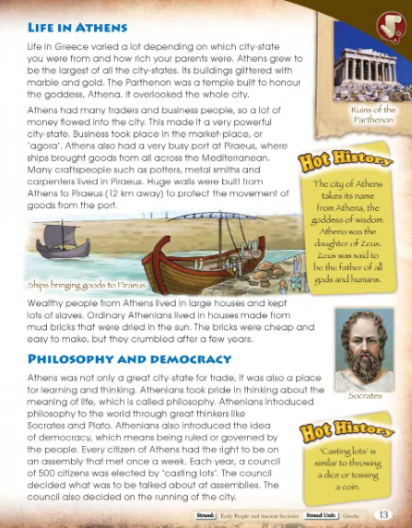

Homework:
Spellings from Spellbound – Unit 30 – Commonly Misspelled Words: Box 1 (A and B).
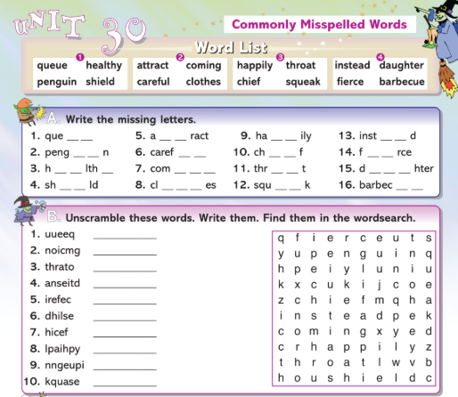

Mental Maths 4: (Week 33 – Monday and Problem Solving). The girls will have these books at home so write away into them as we usually do.

Tables: revise 9 multiplication tables.

Tuesday 19th May

Maths:
Weight: Addition.
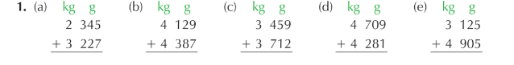

Number: Multiplication.
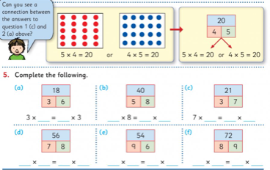

English:
Cloze procedure: write this passage into your copies and fill in the missing words.
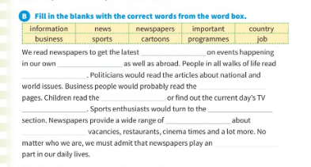

Comprehension:
Read the text below and answer the questions in your copy.
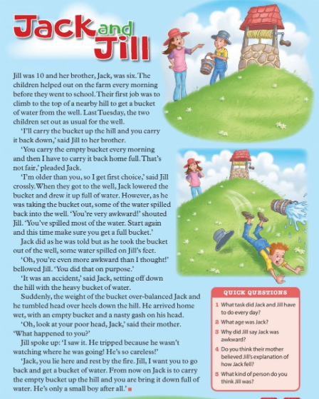

PE:
Athletics with Clare. You worked with Clare last year in 3rd class. She was delivering an Athletics course. She now has weekly videos up on you tube that you can do in your home. The next lesson is focusing on the skill of underarm throwing and kindness. Enjoy!
Go to the following website and Week 4 is up: http://weplay.ie/peathome/

Homework:
Spellings from Spellbound – Unit 30 – Commonly Misspelled Words: Box 2 (C and D).

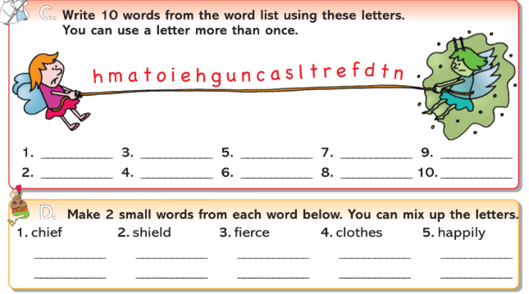

Mental Maths 4: (Week 33 – Tuesday and Problem Solving). The girls will have these books at home so write away into them as we usually do.

Tables: revise 9 multiplication tables.

Wednesday 20th May
Maths:
Weight: Addition.
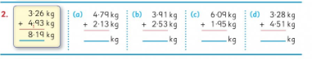

Number: Multiplication.
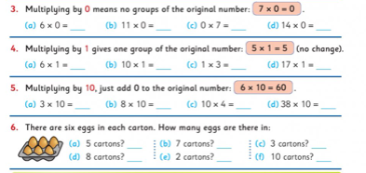

English:
Phonics: double consonants. Complete Part A into your copies.
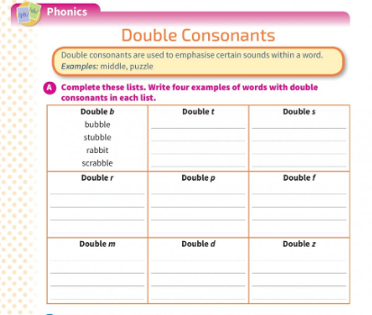
Comprehension: Read the text below and write the answers in your copy.

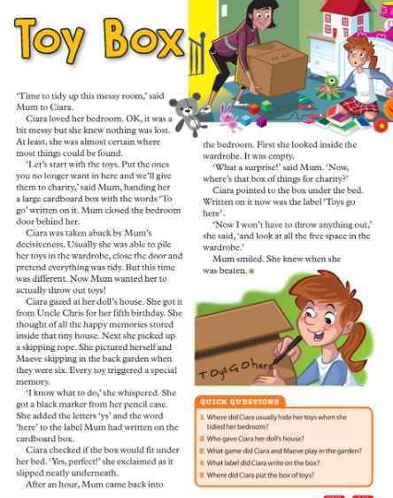

Irish: Write this table out into your copies and maybe get someone to test you on the feelings in Irish.
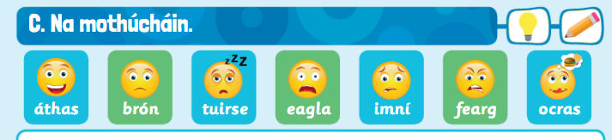

Homework:
Spellings from Spellbound – Unit 30 – Commonly Misspelled Words: Box 3 (E and F).

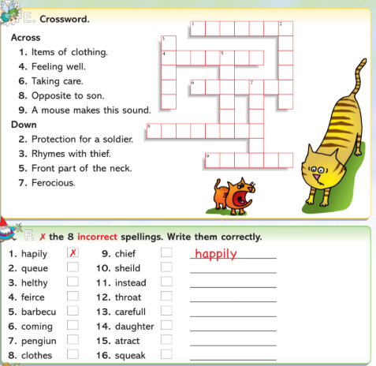

Mental Maths 4: (Week 33 – Wednesday and Problem Solving). The girls will have these books at home so write away into them as we usually do.

Tables: revise 9 multiplication tables.

Thursday 21st May

Maths: Weight: subtraction.

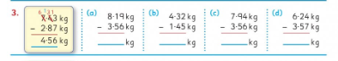

Number: multiplication.
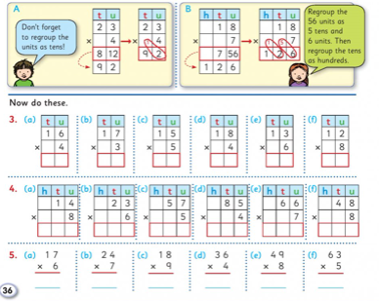

English: Grammar: pronouns – complete Part A below into your copies.
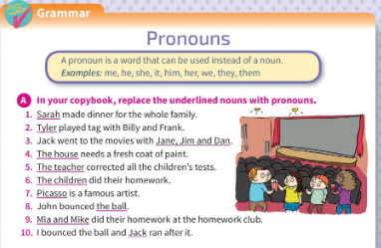

Comprehension:
Read the text and write the answers in your copy.
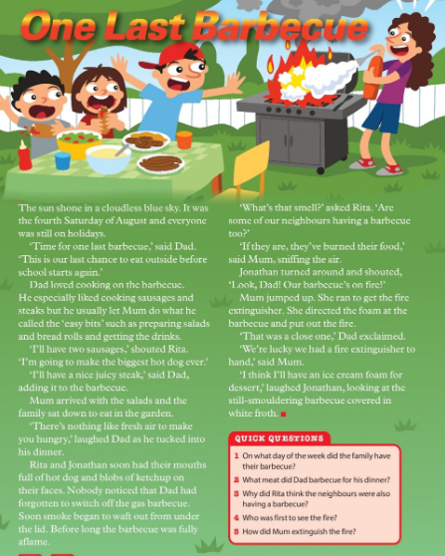

Art:
Creative Call: The Lord Mayor of Cork is looking for you to send him your creative work. The competition runs until the 29th May. Get your thinking hats on. You can send your entries to the following email address: creativecall@corkcity.ie

Homework: Spellings from Spellbound – Unit 30 – Commonly Misspelled Words: Go back over Boxes 1 – 4 (G).
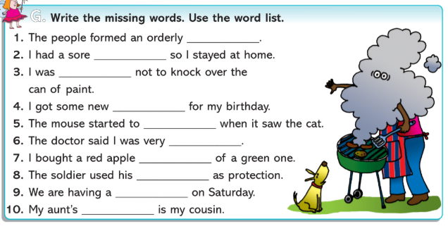

Mental Maths 4: (Week 33 – Thursday and Problem Solving). The girls will have these books at home so write away into them as we usually do.

Tables: revise 9 multiplication tables.

Friday 22nd May
Maths:
Weight: subtraction.
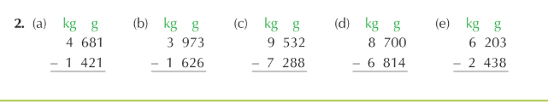

Number: multiplication.
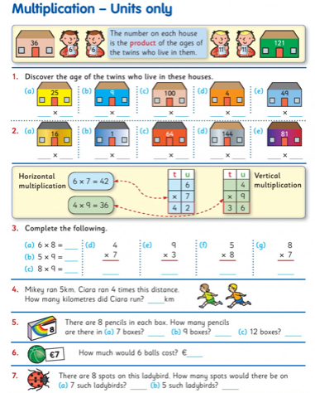

English:
Oral language:
Girls can you chat to an adult in your house about something you enjoyed doing this week. It doesn’t have to be about school work, it can be about anything. Talking and sharing your experiences is so important.
Comprehension:
Read the text and write the answers in your copy.
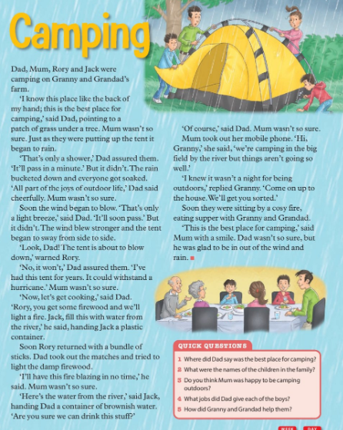

DEAR Time: Drop everything and just simply read some pages from your favourite book or a library book for 20 minutes or more. Enjoy!!!

Music: I have included a song from Moana on the padlet this week. Its called How Far I’ll Go. It would be nice to listen and sing along to it.

Weekly Friday Test:

If you would like to give your daughter a test today, here is the list of words:
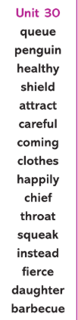

They could also do the Friday review in their Mental Maths 4 books.

Write out the 9 multiplication tables.

