4th class work (Plan 8)
Ms. J. Manley
Hello all. Hope you are all keeping well. Again if you have any questions at all about the work or anything else, please don’t hesitate to contact me via my email address: jennifer.manley@northpresprimary.ie or I can ring you if you wish. The plan below is for the week ahead. Again this week there is English, Maths and homework each day and one additional subject then each day. Again there is absolutely no pressure to get this work completed. The work below is mostly what we would have been covering in school this week.
I have also created a padlet, which is an online noticeboard. Here is the link:
https://padlet.com/jennifermanley/t1pqxej4f3xt1py6

On this padlet, you will find everything you need in one place. It is divided into columns for each day Monday to Friday. The activities are displayed there with accompanying worksheets, videos and links to other websites.

Monday 25^{h} May
Maths:
Length: (We have done some length already in school so you should hopefully remember it). Remember 1 metre = 100 centimetres.
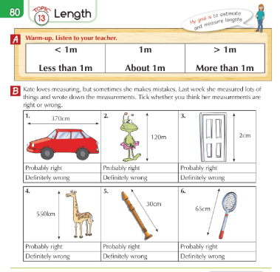

Algebra: Pattern work – complete the patterns below.

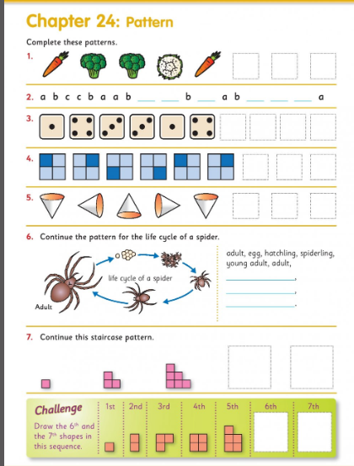

English:
Cloze procedure: write this passage into your copies and fill in the missing words.
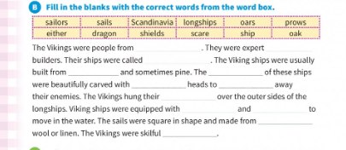

Comprehension: Read the text below and answer the questions in your copy.

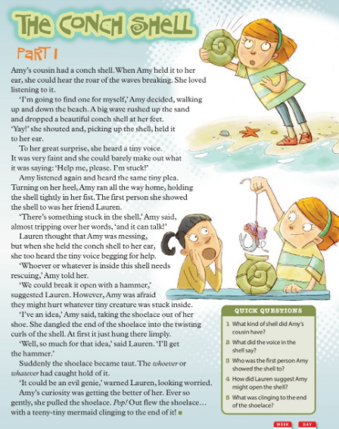

Geography:
Communications.
1. What is the name of the company that collects and delivers mail in Ireland?
2. What type of transport is now used to deliver letters?
3. How do deaf people communicate?
4. How do blind people communicate?
5. Name 3 ways you communicate in school.
6. Name your favourite way to communicate with your friends.

Homework:
Spellings from Spellbound – Unit 32 – Commonly Misspelled Words: Box 1 (A and B).
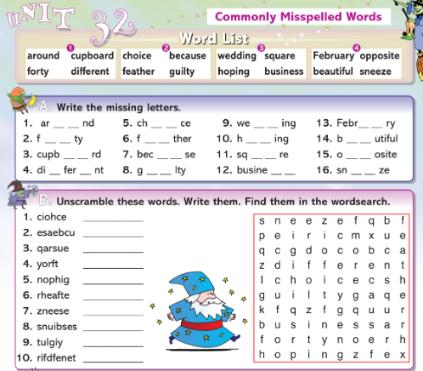

Mental Maths 4: (Week 34 – Monday and Problem Solving). The girls will have these books at home so write away into them as we usually do.

Tables: revise 12 multiplication tables.

Tuesday 26th May

Maths:
Weight: The metre stick.
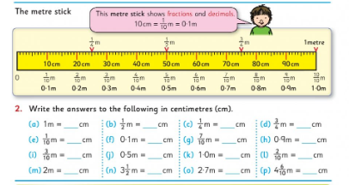

Algebra: more pattern work. Fill in the missing numbers.
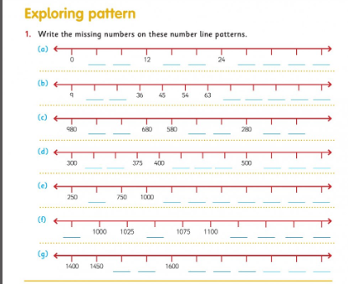

English:
Handwriting: do this sheet of joined writing. It’s in your pack.
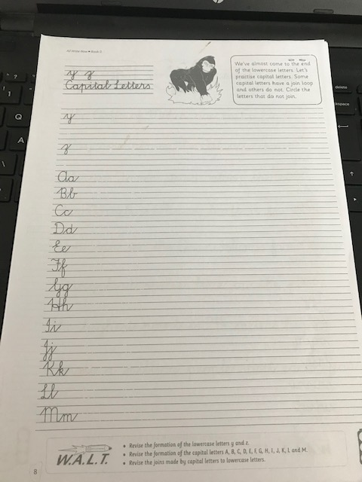

Comprehension:
Read the text below and answer the questions in your copy.
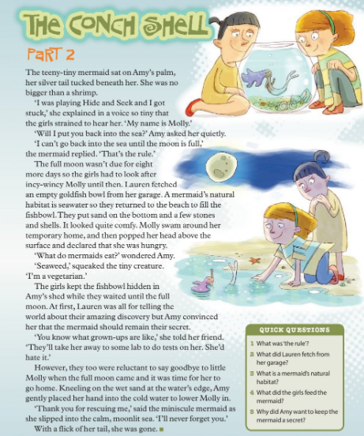
PE:
Athletics with Clare. You worked with Clare last year in 3rd class. She was delivering an Athletics course. She now has weekly videos up on you tube that you can do in your home. Look at the Games Library. Enjoy!
Go to the following website and look up Games Library: http://weplay.ie/peathome/

SPHE: Ms O’ Neill and Ms Conway have compiled a booklet for Friends For Life and you will find it in your pack. Take a look through the booklet and remind yourself of some of the things we were learning this year.

Homework:
Spellings from Spellbound – Unit 32 – Commonly Misspelled Words: Box 2 (C and D).

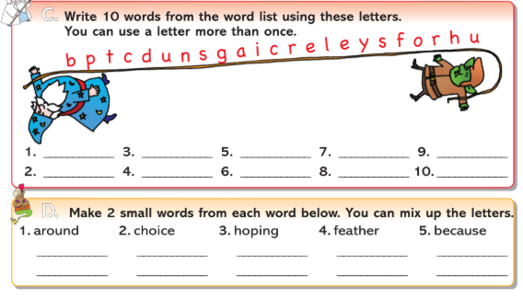

Mental Maths 4: (Week 34 – Tuesday and Problem Solving). The girls will have these books at home so write away into them as we usually do.

Tables: revise 12 multiplication tables.

Wednesday 27th May
Maths:
Length: Adding and subtracting using m and cm.
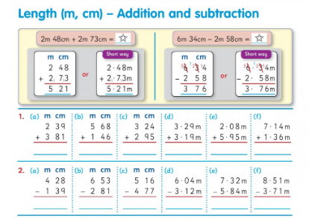

Algebra: Pattern.
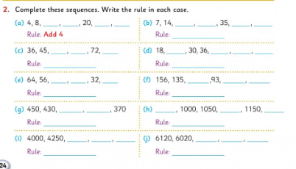

English:
Phonics: words ending in ild and ind. Do page 18 in Treasury D.
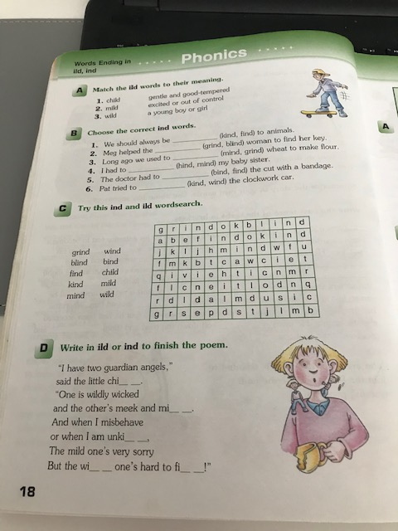

Comprehension: Read the text below and write the answers in your copy.

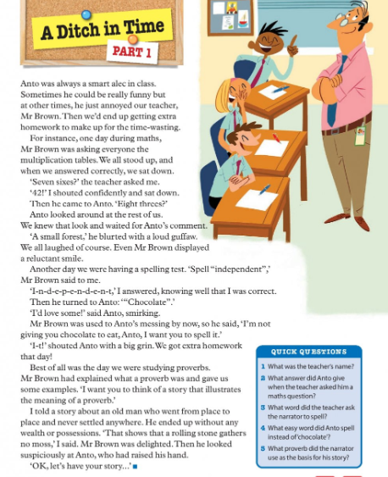

Irish:
Write the words below into your copies and draw a picture.
tralaí - trolley
pas - passport
buidéal uisce - water bottle
ag cuardach - searching
áit slándála - security area
garda slándála - security guard
scuaine daoine - queue of people
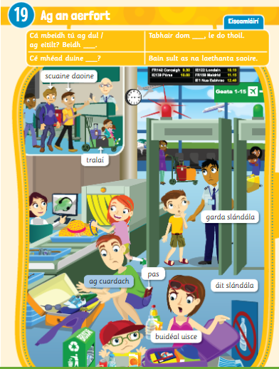

Homework:
Spellings from Spellbound – Unit 32 – Commonly Misspelled Words: Box 3 (E and F).

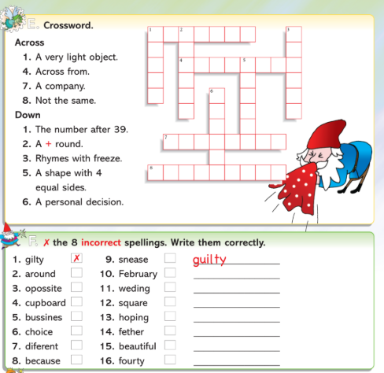

Mental Maths 4: (Week 34 – Wednesday and Problem Solving). The girls will have these books at home so write away into them as we usually do.

Tables: revise 12 multiplication tables.

Thursday 29th May

Maths: Length: multiplication.

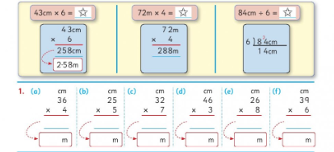

Number: pattern using the 100 square.
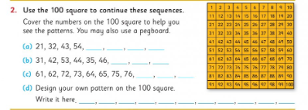

English: Grammar: adjectives – complete Parts A, B and C below into your copies.

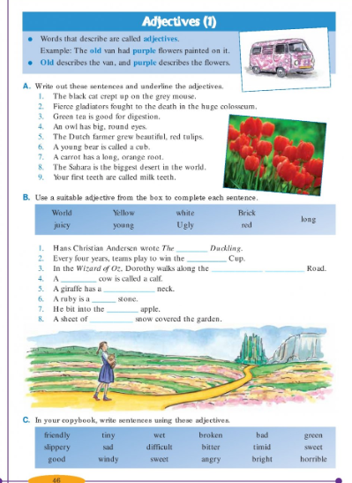

Comprehension:
Read the text and write the answers in your copy.
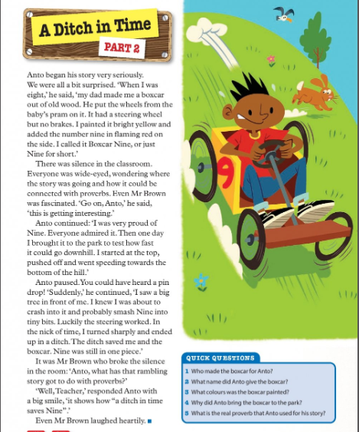

Art:
Draw a self portrait of yourself or maybe someone in your family.
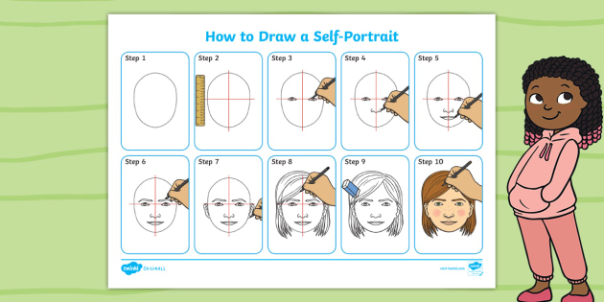

Homework: Spellings from Spellbound – Unit 32 – Commonly Misspelled Words: Go back over Boxes 1 – 4 (G).
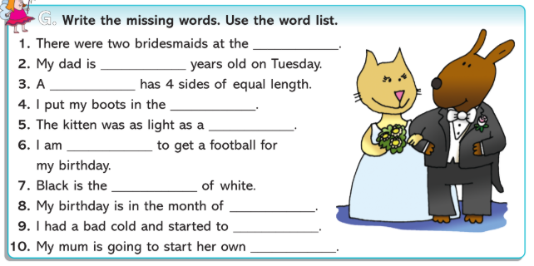

Mental Maths 4: (Week 34 – Thursday and Problem Solving). The girls will have these books at home so write away into them as we usually do.

Tables: revise 12 multiplication tables.

Friday 30th May

Maths:
Weight: addition and subtraction.
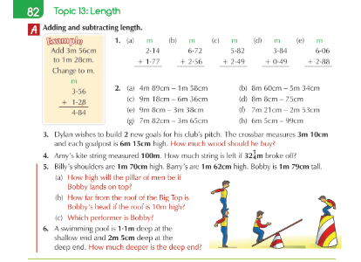

Algebra: pattern.
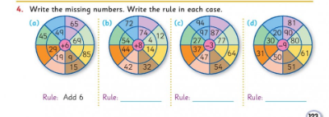

English:
Writing: Go to pg 80 in your Treasury D book and complete parts A and B.
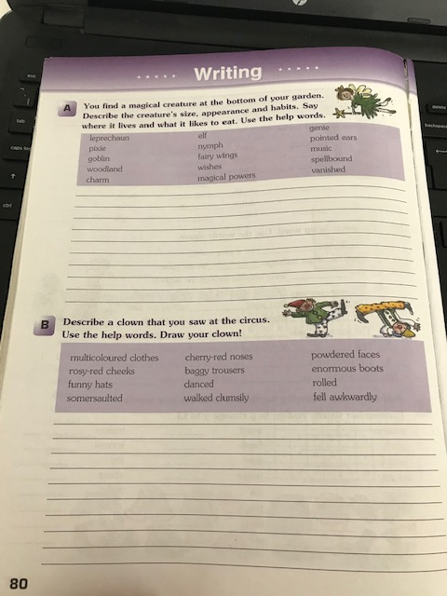

Comprehension:
Read the poem and write the answers in your copy.
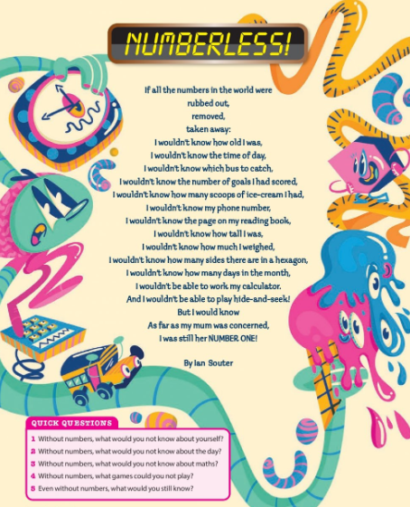

Music: Check out Ms. O’ Neill’s padlet. I have a link up on my padlet to it. Revise some of the songs you play on your tin whistle. Try out the new song ‘Dawning of the Day.’

Weekly Friday Test:

If you would like to give your daughter a test today, here is the list of words:

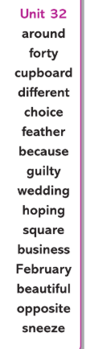

They could also do the Friday review in their Mental Maths 4 books.

Write out the 12 multiplication tables.

