4th class work (Plan 9)
Ms. J. Manley
Hello all. Hope you are all keeping well. Again if you have any questions at all about the work or anything else, please don’t hesitate to contact me via my email address: jennifer.manley@northpresprimary.ie or I can ring you if you wish. The plan below is for the week ahead. Again there is absolutely no pressure to get this work completed. The work below is mostly what we would have been covering in school this week.
I have also created a padlet, which is an online noticeboard. Here is the link:
https://padlet.com/jennifermanley/t1pqxej4f3xt1py6

As Monday is a bank holiday there is no work assigned for this day. Also, as it is the month of June there is no homework.

Tuesday 2nd June
Maths:
Mental Maths 4: (Week 35 – Monday and Problem Solving).
Tables: revise 11 multiplication tables.
Number: long multiplication.

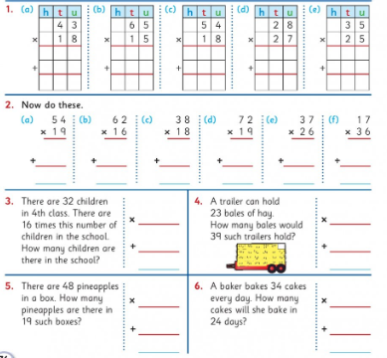

English:
Treasury D: Phonics: page 42. Parts A, B, C and D.

Comprehension: Read the text below and answer the questions in your copy.
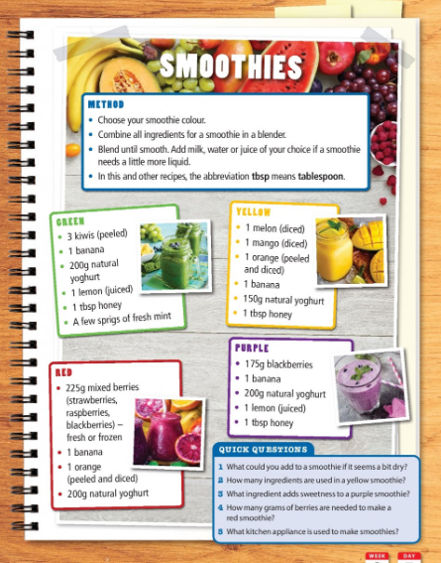

Science / Art:
Mr Donovan has set the girls a challenge. See the class padlet for more information.
Botanical Art Competition.

Wednesday 3rd June

Maths:
Mental Maths 4: (Week 35 – Tuesday and Problem Solving).
Tables: revise 11 multiplication tables.

Number: long multiplication.

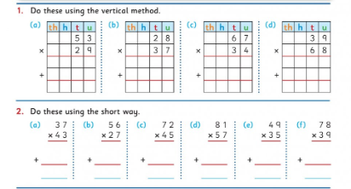

English:
Treasury D: Adverbs: page 84. Parts A and B.

Comprehension: Read the text below and answer the questions in your copy.
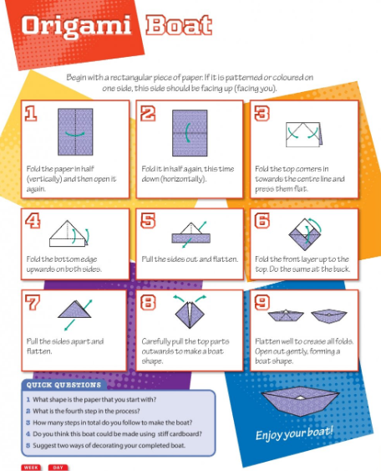
Irish: see Padlet for video.
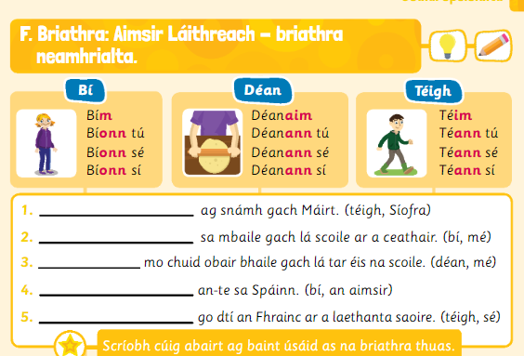
Thursday 4th June
Maths:
Mental Maths 4: (Week 35 – Wednesday and Problem Solving).
Tables: revise 11 multiplication tables.
Number: long multiplication.

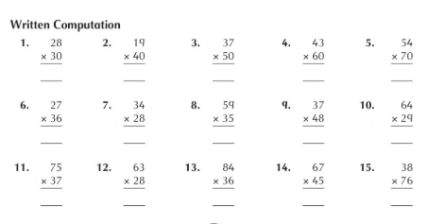

English:
Treasury D – Writing – page 20. Parts A, B, C and D.

Comprehension:
Read the text and write the answers in your copy.

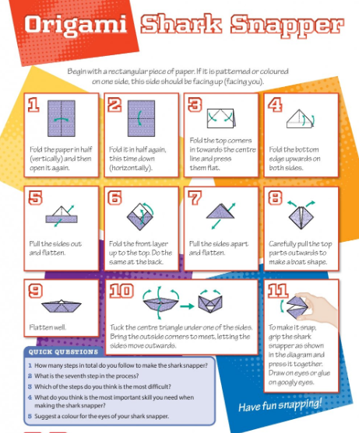

Science / Art:
Mr Donovan has set the girls a challenge. See the class padlet for more information.
Botanical Art Competition

Friday 5th June

Maths:
Mental Maths 4: (Week 35 – Tuesday and Problem Solving).
Tables: revise 11 multiplication tables.
Number: long multiplication.

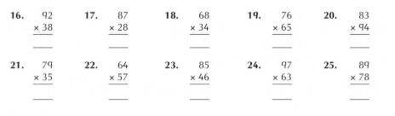

English: Handwriting: do this sheet of joined writing. It’s in your pack.

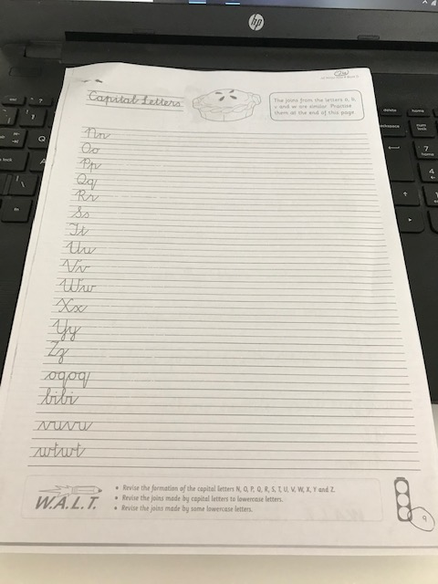

Comprehension:
Read the text and write the answers in your copy.
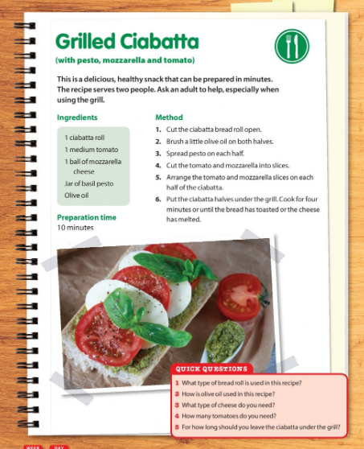

English writing exercise:
This week you have been reading about procedural writing. Example: a recipe. Create your own recipe (cake, smoothie, muffins whatever you like). Include a title, ingredients, utensils, the steps involved. I would love to see some of them. Email them to me please.

Music: Check out Ms. O’ Neill’s padlet. I have a link up on my padlet to it. Revise some of the songs you play on your tin whistle.

