5th Class – Ms Wallace
Work Plan 2
English:
Oral Language:
- Story Cubes: Create a story mentioning all 9 images in any order. Remember the 5 ‘W’ who, what, when, where and why.
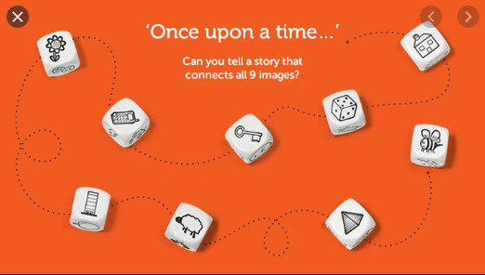
- Talk about current affairs – watch News2Day videos and give a summary of the main stories in the news.
- Encourage your child to describe stories they are reading with a clear beginning, middle and end.
- Words of the Day: ‘catastrophic’ ‘devastating’ ‘dormant’
  - Introduce the new word daily, look the word up in the dictionary, discuss it and put it into a sentence. Try to use the word orally throughout the day. Revise the bank of words daily.
Reading:
- Reading Zone 5: Read story ‘Seventh Wonder’ on pg 103. Read the story aloud and ask your child questions about the story. Complete the activities from pg 105 and pg 106 based on the story.
  - You can find the Reading Zone book on the Folens website. You can access the Folens website through the school website.
- Leisure reading: Continue reading library books.

Writing:
- Persuasive Writing: Read the powerpoint on Twinkl about persuasive writing. Design and complete a leaflet or poster to advertise any product of your choice (new toy, new book, etc).
  - https://www.twinkl.ie/resource/au-l-53229-introduction-to-persuasive-text-powerpoint
- Diary Entry: Write a short diary entry for each day. Begin the entry by describing the day and include details about your feelings and what you did that day. Don’t forget to sign your name at the end!
Spellings:
- Learn the following spellings. Look up spellings you do not understand in your dictionary. Put the spellings into sentences. Get someone at home to test your spellings at the end of the week.
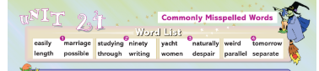
Gaeilge:
- Practice the following questions:
  - Cé tusa? Is mise ______. Cá bhfuil tú i do chónaí? Tá mé i mo chónaí _______.
  - Cén rang ina bhfuil tú? Tá mé i rang a _____. Cén aois thú? Tá mé _____ mbliana d’aois/ Tá mé ______ bhliain déag d’aois.
  - Ask different people in your house the questions and let them ask you.
  - Use teddies and toys, ask the questions and give their answers.
Maths:
- Mental Maths: Do whatever questions you are able to do in the card below.
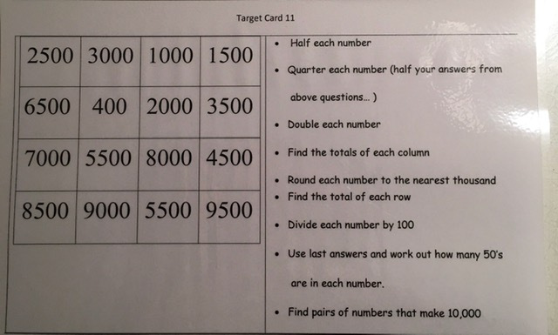
- Length activity: Measure the height of people in your house.
  - Record the length in cm and in metres e.g. 132 cm or 1m 32cm.
  - Sort the heights from smallest to tallest.
  - Create a bar chart to show your results. Create five questions and find the answers e.g. how much taller is ….than…/what is the total height of … and ….
- Money activity: Sort all your loose change out. Sort in 5c, 10c, 20c, etc. How much do you have in 2c/50c etc? How much do you have altogether?
  - Find a variety of coins that will add up to 50c 75c €1, €2.50 etc
  - Role play a shop, label food with prices and give the correct change when an item is bought.
  - Change the coins from cent to euro e.g. 64c = €0.64. Do some mental maths… how much more do you need to get €2, €1.60, €3 etc.
- Mental Maths: Using the CJ Fallon website find Brain Teasers book 5 and complete pages 6 and 7. You can access the Fallons website through the school website.
- Revise all multiplication and division tables. Test yourself
Science:
Experiment: Make Germs Scatter
- All you need is black pepper, water and soap. This experiment will help children see the importance of washing their hands under the current circumstances. Complete the experiment and write out a step by step guide of what you did in the experiment. Remember to include details of the things you needed for the experiment, what you did, what you saw, and draw a picture at the end.
  - You can access the experiment here: https://www.education.com/science-fair/article/pepper-and-soap-experiment/
https://www.youtube.com/watch?v=djxmuDz8c3s
Geography:
- Go on a minibeast hunt outside. Use the sheet from Twinkl to help you. Draw a picture of the minibeasts you found and record where you found them. You can access the sheet here: https://www.twinkl.ie/resource/T-T-019-Minibeast-hunt-sheet
History:
Get the children to make a time capsule and include some of the following:
- Write a letter to themselves. Tell their age and include details about their friends, favourite books, tv show, song, sport etc. Write some details about what is going on at the moment and say how you feel. Talk about the future, what you would like to be when you grow up and talk about some things you would like to do as an adult.
- Maybe cut out some articles from a newspaper that you think are important.
- Draw a picture of your family, draw some pictures of what it is like today.
- Put it all together in a box, lunchbox etc and hide it somewhere for years to come.
Music:
- Make percussion instruments from used tin cans. Put different items into the cans to make different sounds e.g. rice, pasta, pebbles etc.
- Cover the top of the can with paper and shake to make different sounds.
- Try and make your own piece of music using the different sounds.
- Continue revising tin whistle lessons.

Art Activity:
- Make coin rubbings using a variety of different coins.
- Decorate your time capsule.

Physical Activity:
- Pick some activities and challenges from the folder that I sent to each parent to complete.

Here are some other activities that your daughter can complete at home with you. Pick an activity below to complete during the week.
- Help someone with the cooking at home.
- Bake something nice.
- Help to tidy up at home, make your bed each day, tidy your bedroom, put toys away etc.

