Dear Parents,

I have outlined a suggested weekly plan of work for the girls for Monday 27th – Friday 1st May. Please let me know if you are having trouble accessing Edmodo at any stage and I will send you a document with all of the book pages on it.

I have not listed either PE or Religion in the plan below. However, it would be great for the girls to be doing a little of each. everyday.
Physical Education:
- Continue with Active Homework Journal every day.
- www.gonoodle.com
- https://rtejr.rte.ie/10at10/
- P.E. with Joe Wicks, The Body Coach TV Live on youtube, Monday to Friday 9 a.m.: https://www.youtube.com/results?search_query=joe+wicks+kids+workout+
- If you have a football, practice GAA/soccer skills. If you have a skipping rope, do lots of skipping – get creative!
- You could set up an obstacle course outside if you have an area to do so.
- Getting out for a daily walk, skipping, stretch, sprints on the road would be great!
- PE with coach Clare (some of the girls might know her as she came to the school to teach athletics!) Each week she will share a new video! https://www.youtube.com/watch?v=Zv0b9VzlOdE&feature=youtu.be

Religion:
CJFallon: Friends in Faith: My Confirmation Year:
pgs 13-17 Grow in Faith: https://my.cjfallon.ie/preview/index/26839/10
The girls can access this Religion Book which they can be reading at their leisure. We did not use this book in school but it is one of the only ones available online and has lots of content. It would be great if they could do the Let’s Chat activities with a parent/sibling.
I have also attached a home/school link page for you – it is a helpful guide regarding their Maths work in Equations and Variables this week.
If you have any questions/problems accessing any of these, don’t hesitate to contact me on the mobile number which I provided or at Aideen.ahern@northpresprimary.ie .

Best wishes to you all and keep safe,
Ms Ahern 😊
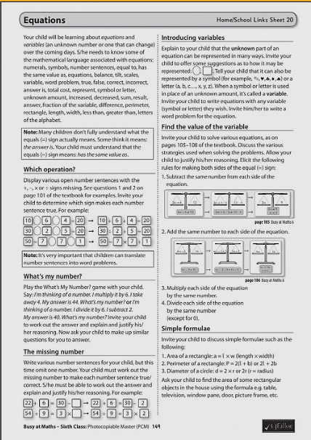

Monday 27th April 2020:
English:
- Folens New Treasury 6:  Chapter 13 – pg78, 79. Do all of A. Pick one activity from B and do Vocabulary section,  https://www.folensonline.ie/  2. Prim-Ed New Wave English  -Do one  https://www.prim-ed.ie/shop/new-wave-english-in-practice-6th-class/  Just click on preview book and it will give you the whole book | 3. Folens Spellbound F  Unit 25, pg 52 Part A. Also, look up any unknown words in dictionary. Write a sentence for each word.  https://www.folensonline.ie/  4. Novel:  Read 1/2 chapter.

Maths:
- Master Your Maths:  CJ Fallon Week 27 – Monday pg 58  https://my.cjfallon.ie/preview/student/20359/58  - Busy at Maths: Chapter 20: Equations and Variables pg 101  Q1: (a) (b) (c) (d) Q3: (a) (e) (i) (m)  Q2: (e) (f) (g) (h) Q4: (e) (f) (g) (h)  CJ Fallon:  https://my.cjfallon.ie/preview/student/16908/117 | - Tables Practice:  https://www.topmarks.co.uk/maths-games/hit-the-button  - Word Problem:  360 straws are shared equally between Sam, Rob and Stephen. They make shapes with the straws using 1 straw for each side.  Sam makes pentagons, Rob makes hexagons and Stephen makes octagons.  How many shapes do they make altogether?
Gaeilge:
- CJ Fallon: Léigh sa Bhaile F:
Lch 4: Read the sceál ‘An Nuacht’. Then listen to it using the audio file in the resources area. Look up any unknown words in your foclóir and write into cóipleabhar. Freagair na ceisteanna. (Answer the questions)

Sceál:
https://my.cjfallon.ie/preview/student/16889/14

Audio clip:
http://data.cjfallon.ie/audio/LeighsaBhaile-F-p4.mp3

Science: (This can be done any day of the week)
- Edco: Window on the World Science 6. Pg 24 and 25. Experiments can be done any time during the week!
https://www.edcolearning.ie/Book/List - can be found at the bottom of the booklist.
-Read both pages. Make a snake spiral and use a radiator in your home to try out experiment. Complete ‘Heating Water’ experiment. Draw a diagram of one of the experiments you did. Write the answers for the questions asked – either 1,2(snake experiment) or 3,4 (heating water experiment)

Tuesday 28th April 2020:
English:
- Folens New Treasury 6:  Chapter 13 – pg80  Word Study: Prefixes. DO NOT DO ‘Phonics: Word Play’  https://www.folensonline.ie/  - Prim-Ed New Wave English  -Do one a day  https://www.prim-ed.ie/shop/new-wave-english-in-practice-6th-class/ | - Folens Spellbound F  Unit 25, pg 52 Part B, C. Also, look up any unknown words in dictionary. Write a sentence for each word.  https://www.folensonline.ie/  - Novel:  Read rest of chapter. Do following activity at end of chapter:  - Pick an event in the chapter, rewrite this event in from one of the other character’s point of view.
Maths:
- Master Your Maths:  CJ Fallon Week 27 – Tuesday pg 58  https://my.cjfallon.ie/preview/student/20359/58  - Busy at Maths: Chapter 20: Equations and Variables pg 102  Q1: Do all of q1 – you do not need to write the sentences into your copy. Just write 1(a) = ____ etc  CJ Fallon:  https://my.cjfallon.ie/preview/student/16908/117 | - Word Problem:  Owen buys 2 CDs at €15 each and 3 DVDs at €18 each. How much change does he get from €100?  - Tables Practice:  https://www.topmarks.co.uk/maths-games/mental-maths-train
Gaeilge:
- Edco: Graiméar le Chéile: Rang 5 agus 6
Lch 8:Uimhreacha Pearsanta
https://www.edcolearning.ie/Book/List

Wednesday 29th April 2020
English:
- Folens New Treasury 6:  Chapter 13 – pg81  Grammar: Subject: Do A and B  https://www.folensonline.ie/  - Prim-Ed New Wave English  -Do one  https://www.prim-ed.ie/shop/new-wave-english-in-practice-6th-class/ | - Folens Spellbound F  Unit 25, pg 52/53 Part D, E. Also, look up any unknown words in dictionary. Write a sentence for each word  https://www.folensonline.ie/  - Novel:  Read 1/2 chapter.
Maths:
- Master Your Maths:  CJ Fallon Week 27 – Wednesday pg 59  https://my.cjfallon.ie/preview/student/20359/59  - Busy at Maths: Chapter 20: Equations and Variables pg 102  Q2: Make up word sentences for (a) (c) (e)  CJ Fallon:  https://my.cjfallon.ie/preview/student/16908/118 | - Tables Practice:  https://www.topmarks.co.uk/maths-games/hit-the-button  - Word Problem:  Frank is on holiday at the seaside.  He buys a cap for €5.40, a pair of shorts for €8.99 and an ice-cream for €1.80.  How much change does he get if he pays with a €20 note?
Gaeilge:
Léigh sa Bhaile F: CJ Fallon

- Lch 4: Read the sceál ‘An Nuacht’ again:
Sceál:
https://my.cjfallon.ie/preview/student/16889/14
Audio Clip: http://data.cjfallon.ie/audio/LeighsaBhaile-F-p3.mp3
- Scríobh ‘An Nuacht’ use this guide or write your own. Inniu an _________. Tá sé an _____ lá de mhí ______. Lá _______ atá ann. Inné, bhí mé______. Inniu tá mé________. Amárach beidh mé________.
History
- Small World 4th History pg 48-50.
CJ Fallon: Read pgs 48- 50 https://my.cjfallon.ie/preview/student/4146/52

Thursday 30th April 2020
English:
- Folens New Treasury 6:  Chapter 6 – pg 41  Top of Page: Writing genre: Writing an Explanation – do part 1,2 and 3.  https://www.folensonline.ie/  - Prim-Ed New Wave English  -Do one  https://www.prim-ed.ie/shop/new-wave-english-in-practice-6th-class/ | - Folens Spellbound F  Unit 25, pg 53 Part F, G. Also, look up any unknown words in dictionary. Write a sentence for each word  https://www.folensonline.ie/  - Novel:  Read rest of chapter. Do following activity  - If the main character walked into your room, what questions would you ask them. Think of at least 5,
Maths:
- Master Your Maths:  CJ Fallon Week 26 pg 59 – Thursday  https://my.cjfallon.ie/preview/student/20359/59  - Busy at Maths: Chapter 20: Equations and Variables pg 102  Q3: Write equations for each word problem and solve. Do all.  https://my.cjfallon.ie/preview/student/16908/119  Complete Questions 1 (a) – (e) and 2 (a) – (e) | - Tables Practice:  https://www.topmarks.co.uk/maths-games/mental-maths-train  - Word Problem:  Lyn and Leo have €10 between them to spend at a funfair.  They both go on the big wheel for €1.25 each and the dodgems for €1.50 each. They each buy an ice cream for 75c.  They share the money left over equally. How much do they each get?
Gaeilge:
- Duolingo:
Practice for 5/10mins

Art:
- Drawing - Shading
Watch the following YouTube video and have a go at all the different types of shading she mentions:
https://www.youtube.com/watch?v=-DDTrpJ4PXg

Friday 1st May 2020
English:
- Folens New Treasury 6:  Chapter 6 – pg 41  Top of Page: Writing genre: Writing an Explanation – do part 4 and 5: Review your first draft. Write your final draft and proofread carefully.  https://www.folensonline.ie/ | - Spelling Test:  Ask a parent/brother/sister to do a Spelling Test with you
Maths:
- Busy at Maths: Chapter 20: Equations and Variables:  Revise what you’ve learned this week. Do a few extra sums from each page if you’d like to strengthen your knowledge. | - Tables Test:  Ask a parent/brother/sister to call out any 10 tables
Music:

- Tin Whistle:
Practice Tin Whistle songs already known. Here is a new song to be learning as well. Dawning of the Day.
I have an audio recording of it for you to listen to and get used to See file: Dawning of the Day Tin Whistle. The sheet music is also there. Don’t forget to clap each line out first before you start to play it! 😊

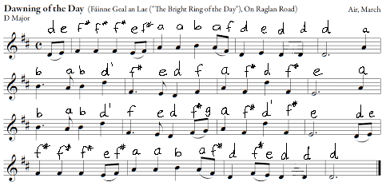

Extra Resources:

