All the Books you will need online and how to get them!

Edco Learning:
Follow this link: https://www.edcolearning.ie/Register
Click ‘I’m a Student’ and fill in the registration form.
Use the username and password below for Primary
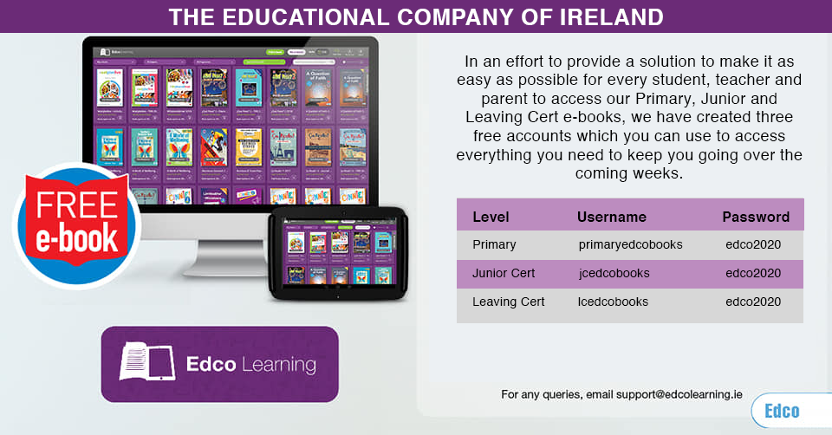
Here are the books we’ll be using from Edco:
-Gaeilge: Graiméar le cheile 5-6
-Window on the World (3 separate books) – Geography, History, Science – 6th Class.

Folens:
Get your parents to complete this on your phone/tablet/laptop:
Parents can follow the steps below to get access:

- Go to FolensOnline.ie and click register
- Select Teacher
- Fill in a username, email and password
- For Roll Number use the code: Prim20

Here are the books we’ll be using from Folens:
-Gaeilge - Abair Liom
-Spellbound – Spellings
-New Treasury 6

CJFallon:
Click on the link below:
https://my.cjfallon.ie/dashboard/student-resources
Here are the books we’ll be using from CJFallon
-Busy at Maths
-Master Your Maths
-Friends in Faith: My Confirmation Year
-Gaeilge: -Léigh sa Bhaile F: this is a great book which has audio clips as well so you can hear them reading the story and the questions.
-Geography Quest 6 , History Quest 6, Science Quest 6

Prim-Ed:
-New Wave English Practice:
https://www.prim-ed.ie/shop/new-wave-english-in-practice-6th-class/
-Just click on preview book and it will give you the whole book and ignore the fact that it says ‘viewing sample’ and do what you can.
-You can get your parents to correct these using this link: (Don’t look at the answers in advance!!)
https://www.prim-ed.ie/contentfiles/41650_NWEIP_TG_6th_Class.pdf

Twinkl:
If you cannot access these books easily, please follow the link below and try to access this work.

Twinkl: this is a daily schedule which you could also follow if you cannot access the online books easily.
https://www.twinkl.ie/home-learning-hub

Prim-Ed Learning Pack:
This is also great if you cannot access the books easily. This is a pack with lots of work – just get your parents to click on the link below and fill in the form. The pack will be emailed to them.
https://www.prim-ed.ie/blog/post/parent-information-centre/?utm_source=IRL+-+Lead+Generation&utm_campaign=5aa6a913f1-E0401IRE+Free+shipping_Queries&utm_medium=email&utm_term=0_8b45d49166-5aa6a913f1-362173577&mc_cid=5aa6a913f1&mc_eid=5afb2264f2

Pobble 365:
Log into www.Pobble365.com – this is a daily writing website that gives you a story starter to complete. Do the starter activities first, then complete/finish the story. There are many extra activities attached to the website and its quite easy to navigate. There are good extra activities attached to the story (Question Time, Picture Perfect, Sentence Challenge & Sick Sentences) Feel free to pick and choose from these. Also, another handy way of keeping your grammar in check with Pobble is to highlight/identify all the adjectives in the passage they wrote. This can be switched up daily to identifying verbs, nouns, adverbs or pronouns also. One feature a day is more than enough.

Duolingo:
https://www.duolingo.com/course/ga/en/Learn-Irish
Follow this link or download the app on your phone/tablet and get practising the Irish! :)

GoNoodle:
-Download GoNoodle on your phone/tablet or play it through your laptop – Don't forget it has some lovely mindfulness activities!

News2Day:
https://trte.rte.ie/news2day/

