Dear Parents,
I hope you are all keeping well and staying safe.
I have reduced the work this week as I feel less is more. I don’t want to overwhelm you. It is completely up to you what you do and how much you do. Only do what you can.
Each day I have Maths, English and homework. Then I have included one of the following per day- Art/Irish/P.E./DEAR (Reading)/Science. I’ll replace Science with Geography/History each of the other weeks.
Please do not feel under pressure. If you do feel under pressure, please email me and we can work out a very simple plan.
This is my Padlet link:
https://mswhelton.padlet.org/stephaniewhelton/8hp68iied42s
But you have all the sheets here for the week and maybe into the week after, so don’t even look at the Padlet if you don’t want to.
For Maths, we are doing capacity which is measuring liquids- its grand for me to teach this as I am teaching ages now! If you don’t feel like doing measuring, then just get the girls to do the sums underneath.
Take care and hope to see ye soon enough. Hi to the girls, I’m missing ye a lot.
Stephanie Whelton
2nd class teacher
Monday 27th April
Maths
- Capacity- this means what something can hold- containers/bottles/buildings/suitcases- we talk about capacity when measuring these things
- Video on padlet explaining about capacity and how to measure at home
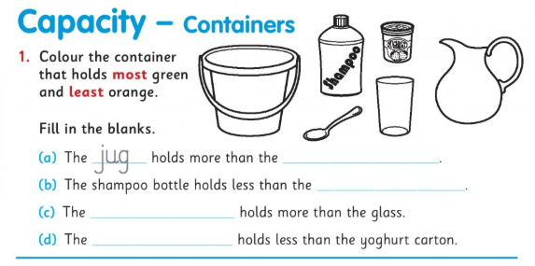
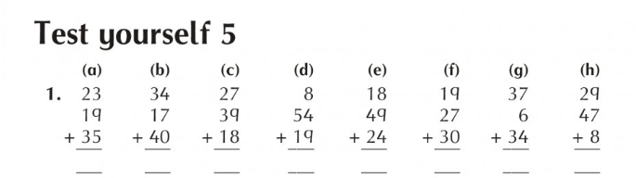
English-Recount writing- what did you do at the weekend? Write what you did- make it up if you want.
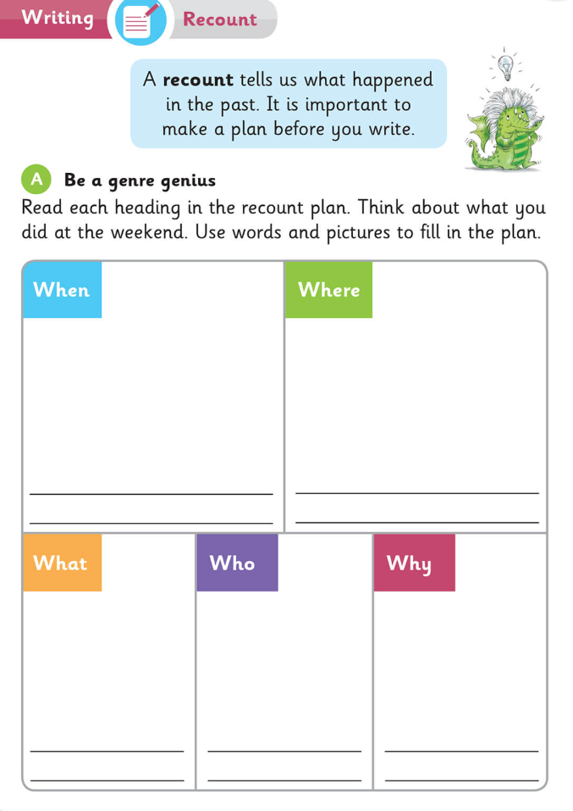
Take a blank page and write a few sentences of what you did, using the plan above. Even the most boring things can work for a story! For example:
Last Saturday I went shopping with my mum. We went to Dunnes. We bought eggs, butter, flour and sugar. First, we got a basket. Then we went to the baking section. To our surprise, there was only one bag of flour left! We were so lucky to get it. We picked out a 1kg bag of sugar and placed it in the basket. Then we got the eggs and butter and queued up. I saw my friend Denisa there. I said hello and she waved at me. When we got home, we baked a lovely madeira cake. We had a cup of tea and ate the cake. It was delicious. It was a great day.
Art
We are doing ‘an gruagaire’ (the hairdresser) in Irish so I thought it would be nice for the girls to draw self-portraits (a picture of themselves). The artist Pablo Picasso liked to draw very unusual portraits, you might like to try this style.
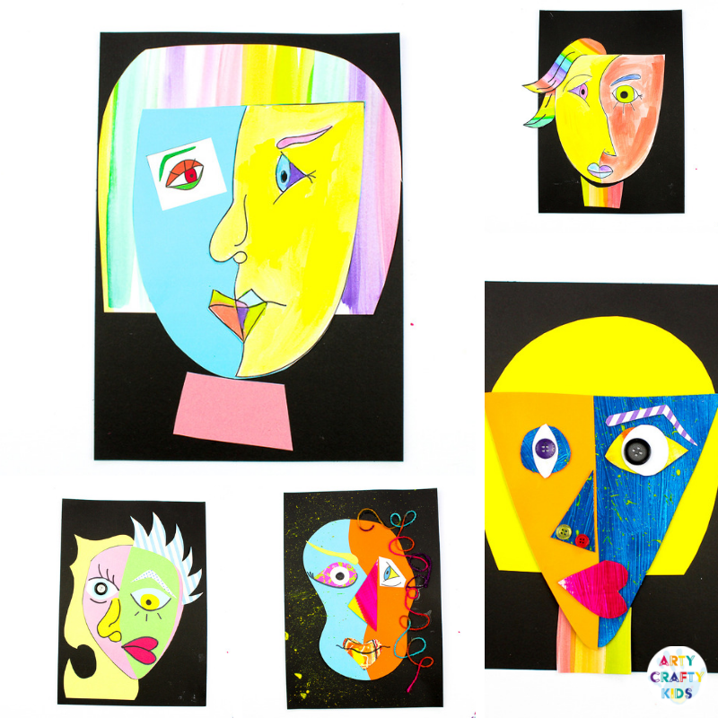

Homework
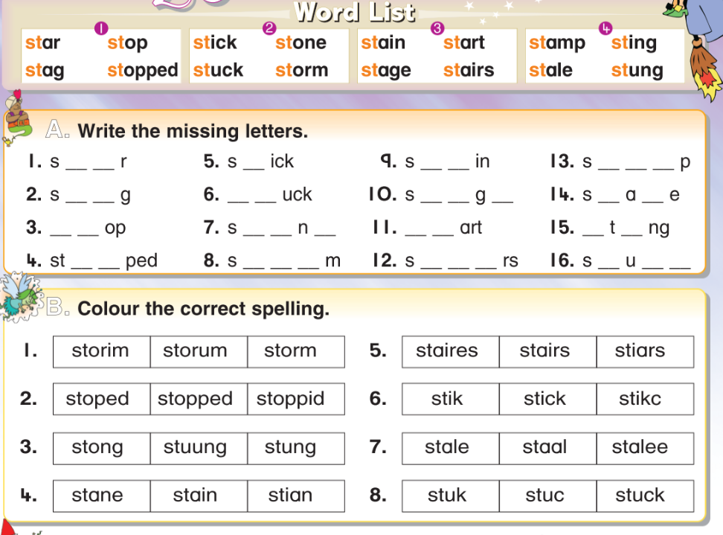
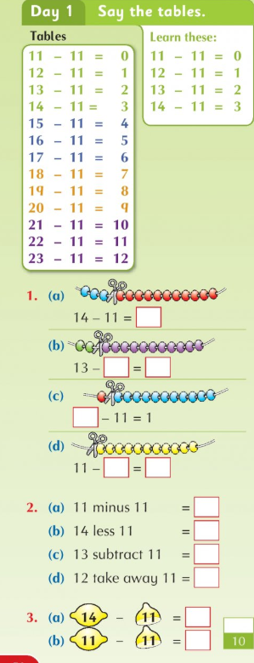
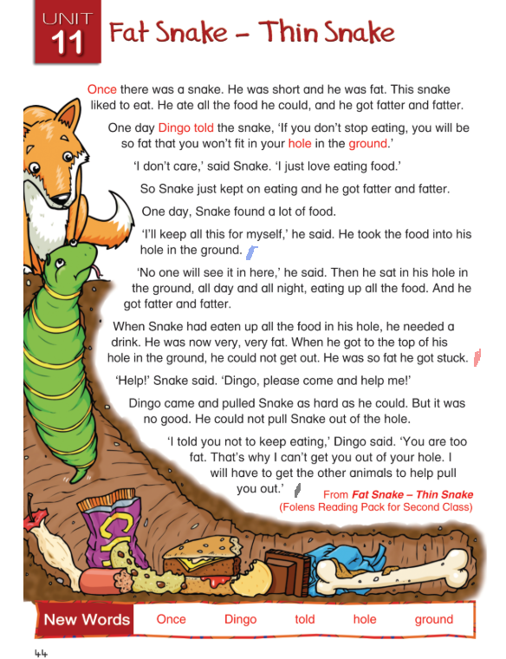
Read the story ‘Fat Snake-Thin Snake’ as far as the blue line.
Write the answers to these questions in your copy:
- What did Snake like to do?
- Where did Snake take the food he had found?

Tuesday 28th April
Maths- use anything small-like a cup or yogurt pot. Look at the cup- if you fill it with water, how many cups of water will you need to fill the bowl/pot/box/jug? Girls, guess first, parents, let them measure. They need to pour the water from the cup into the bowl and then refill the cup and do it again. Video on padlet.
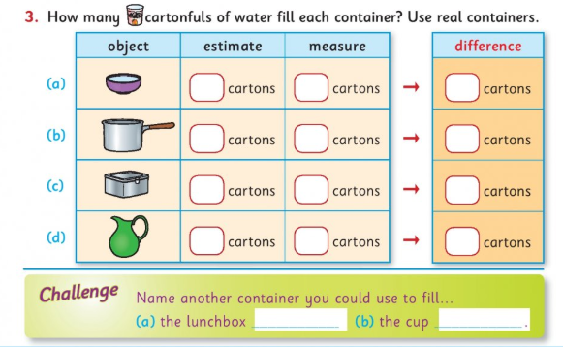
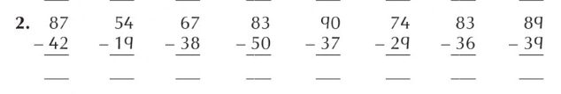
English
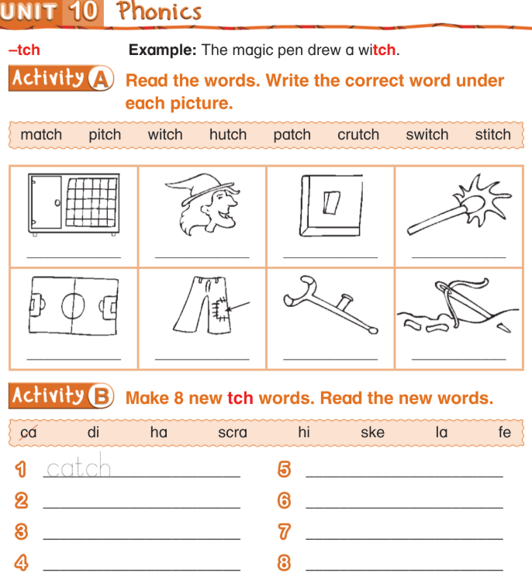
Girls, read all the words. Practice writing them and learning them. If you want to do more, put the words into sentences.

Irish- an gruagaire- the hairdresser
Write the words and draw pictures in your copy (there is a video clip on padlet of me reading the words)
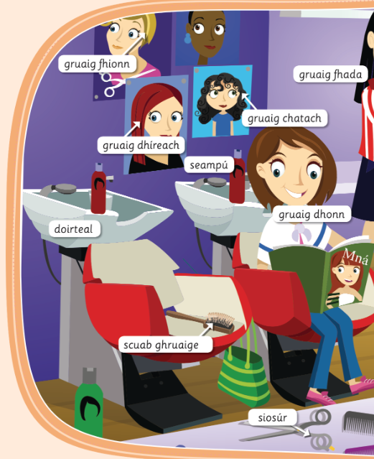
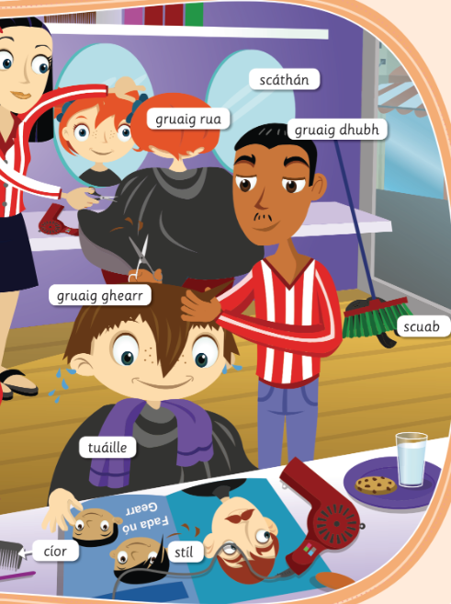
Homework
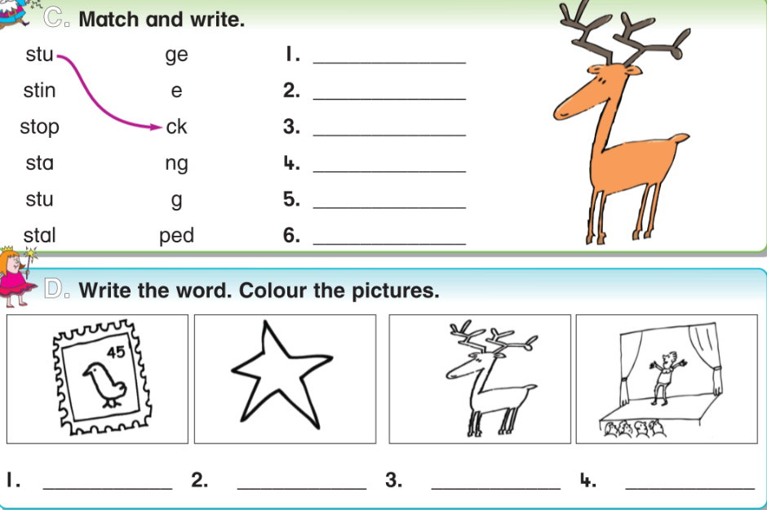
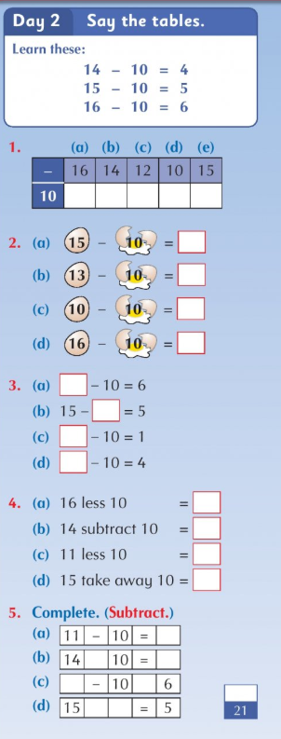
Reading- go back to page 5 to read the story ‘Fat Snake-Thin Snake’ and read as far as the red line.
Write the answers to these questions in your copy:
- Why did Snake need to go out of his hole in the ground?
- Why could Snake not get out by himself?
Wednesday 29th April
Maths- use an empty milk bottle or water bottle or a measuring jug. Guess whether the items below can hold more than a litre or less than a litre or around a litre. Tick the boxes. Then measure. For example, part (b). Fill the bottle with water and pour into the teapot and repeat until the teapot is filled. How many times did you fill the bottle? Video on padlet.
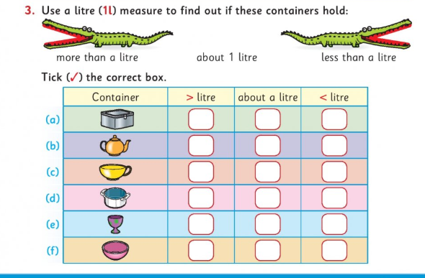
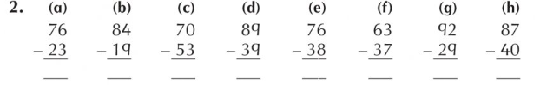

English-read the text and write the answers in your copy.
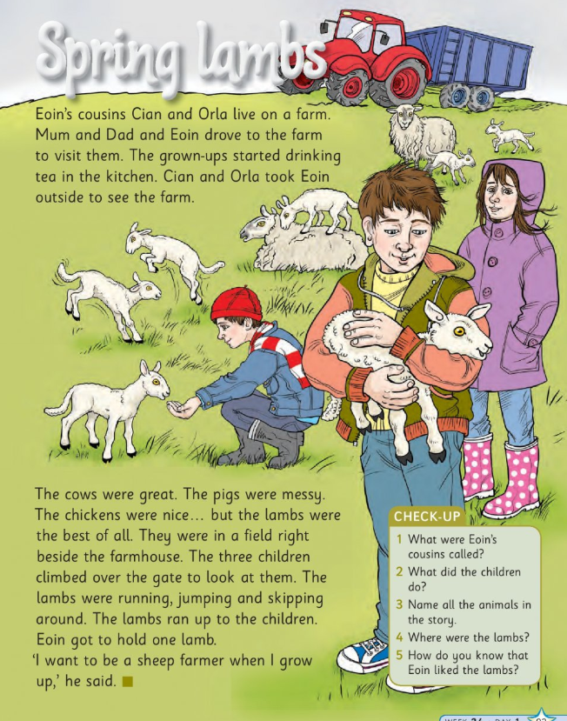
P.E.
*adult supervision required for P.E. I have a link to a yoga website on the Padlet, or you can follow this workout:
Workout- warm up- jumping jacks/ jog on the spot/ bunny hops/ squats/ high knees
30 seconds each, 10 seconds break in between and repeat twice

Circuits- squat jumps/ burpees/ wall squats/ sprint on the spot/ mountain climbers
30 seconds each, 10 seconds break in between and repeat three times

Cool down- stretching and breathing
Homework
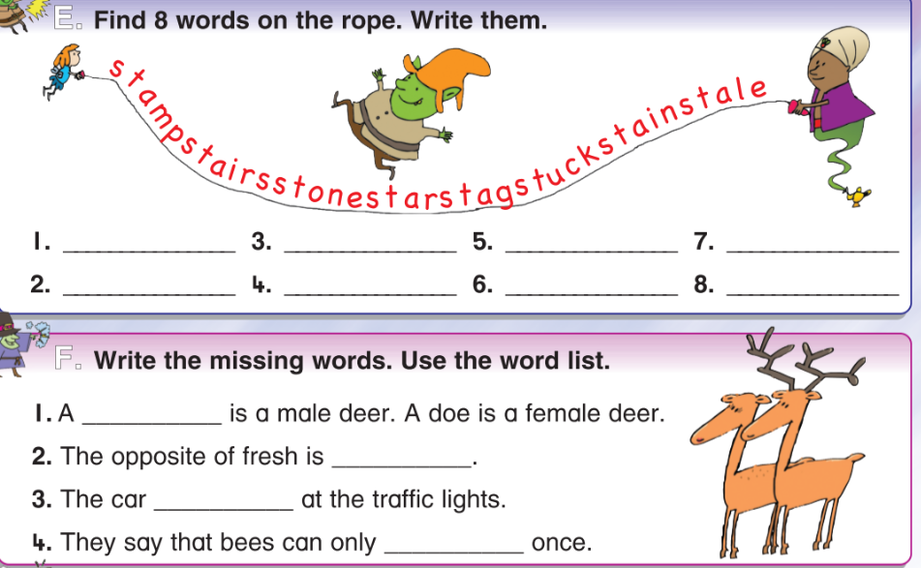
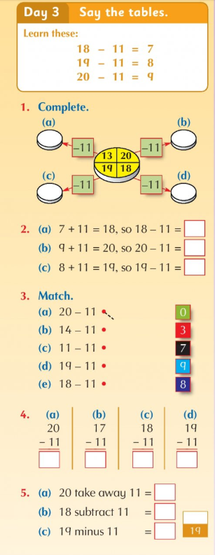
Reading- go back to page 5 to read the story ‘Fat Snake-Thin Snake’ and read as far as the black line. Write the answer to this question in your copy: 5. Which animal tried to pull snake out of the hole?

Thursday 30th April
Maths
Girls, write this down and learn it
1 litre is the same as ½ litre+ ½ litre (two half litres)
1 litre is the same as ¼ litre+¼ litre+¼ litre+¼ litre (four quarter litres)
Video on padlet
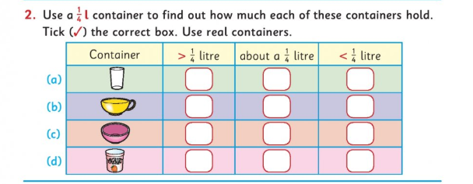

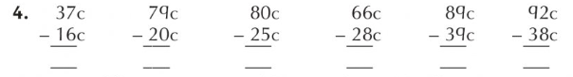

English-read the text and answer the questions in your copy
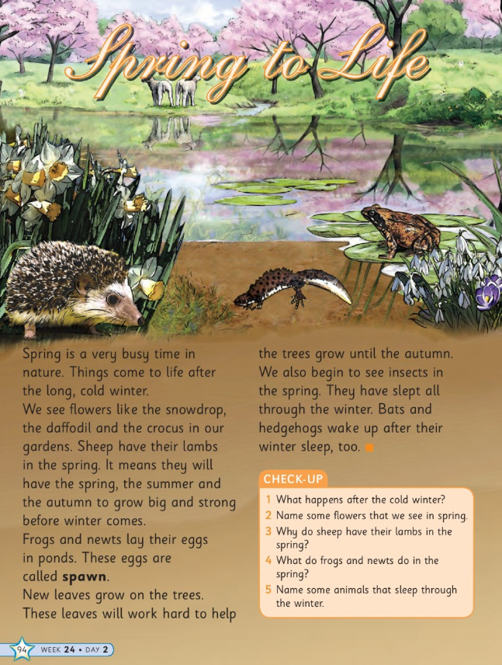

DEAR/listen to reading- DEAR stands for Drop Everything and Read. Girls, take a book and read for 20 minutes. Read to your little brother or sister. Or, go online to listen to reading- storylineonline.com or audible.com have lovely stories that you can listen to.

Homework
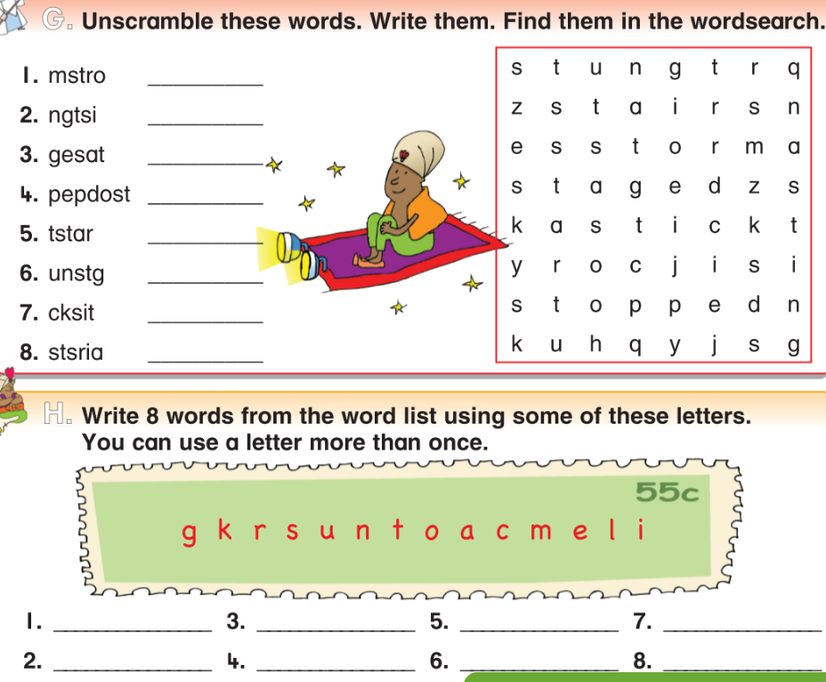
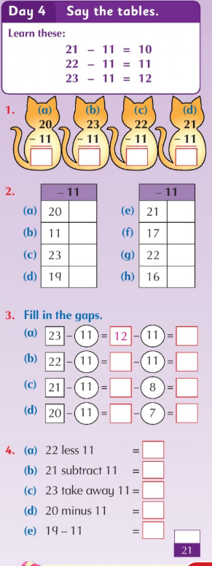
Reading- go back to page 5 to read all of the story ‘Fat Snake-Thin Snake’
Practice writing all the spellings for your test tomorrow
Practice writing out your -11 tables for your test tomorrow

Friday 1st May
Maths- this lesson is about millilitres and litres. Both are ways of measuring liquids- millilitres are used for small amounts- like medicine/recipes/shampoo bottles and litres are used for large amounts (drinks/paint cans/petrol etc). Read the sentences and tick true or false. Then for B, tick under millilitre or litre- cup is measured in millilitres but a fish tank would be measured in litres as it holds more.
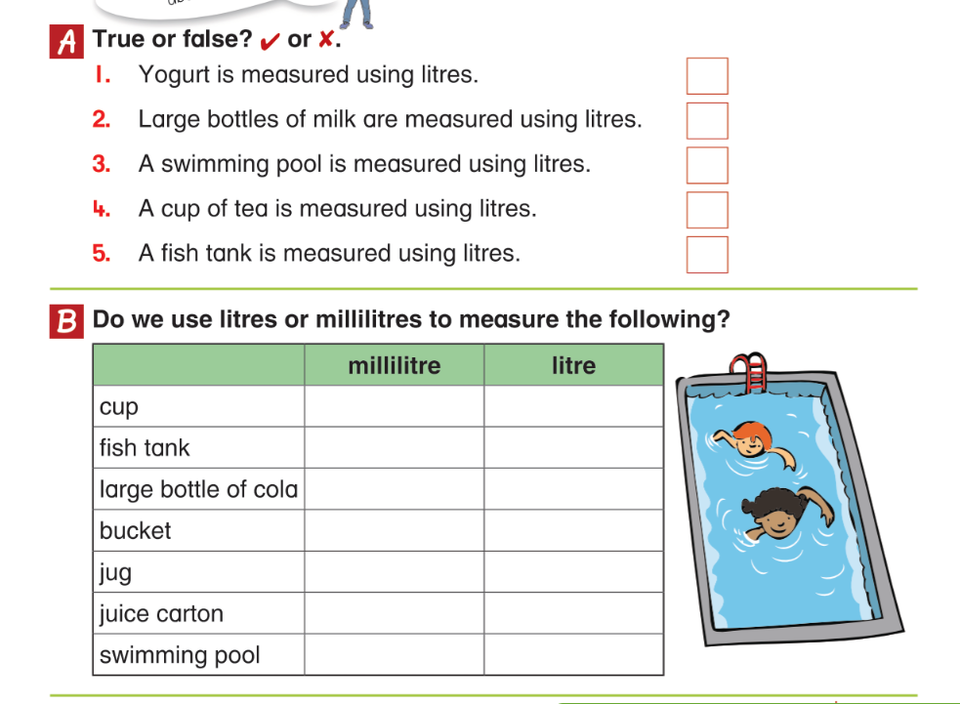
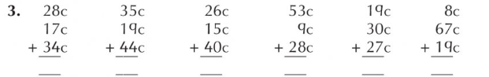

English- grammar- when writing a plural word that ends in s/ss/ch/x/sh, add es
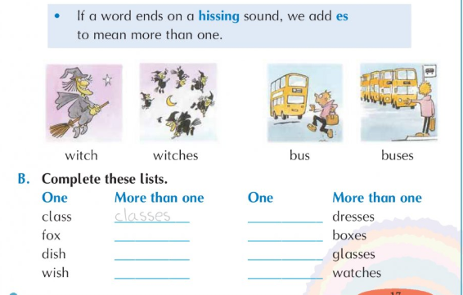
Science- read the text and fill in the fact file about the butterfly bush.
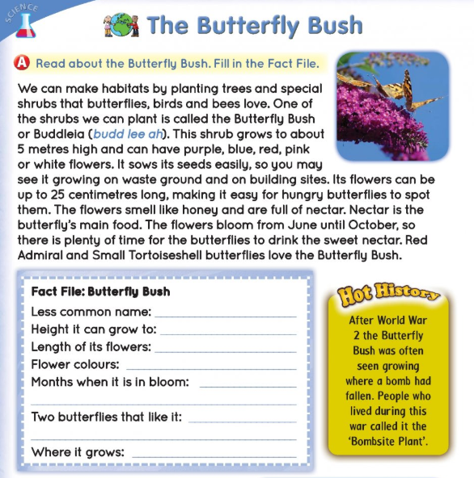
Tests: If you would like to give your daughter a test today, here are the lists:
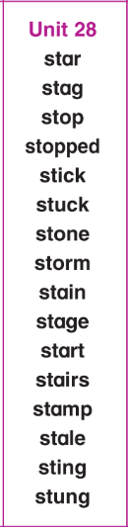
15-11= 14-11= 13-11=
12-11= 16-11= 18-11=
23-11= 19-11= 21-11=
20-11= 22-11=
11-11= 17-11=

