Dear Parents,
I hope you are all keeping well and staying safe.
I have reduced the work this week as we decided as a staff to give less. We don’t want to overwhelm you. It is completely up to you what you do and how much you do. Only do what you can.
Each day I have Maths, English and homework. Then I have included one of the following per day- Art/Irish/P.E./History. There’s no work for Monday 4th May as it’s a bank holiday.
Please do not feel under pressure. If you do feel under pressure, please email me and we can work out a very simple plan.
This is my Padlet link: https://mswhelton.padlet.org/stephaniewhelton/8hp68iied42s
But you have all the sheets here for the week and maybe into the week after, so don’t even look at the Padlet if you don’t want to. Take care and hope to see ye soon enough. Hi to the girls, I’m missing ye a lot.
Stephanie
Tuesday 5th May
Maths
Girls, remember our rhyme- ‘when there’s more on the floor, you go next door and get 10 more’.
Video on padlet explaining how to do these sums.
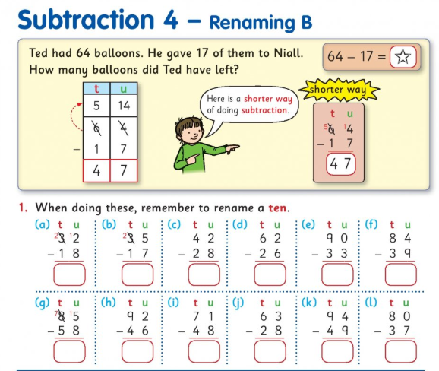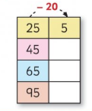
Take 20-use your knowledge of the 100 square. You’re going up two numbers (take 10, take another 10).
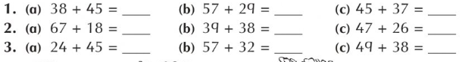

English- Read the report on the blue whale and write the answers in your copy. Remember a report is factual.
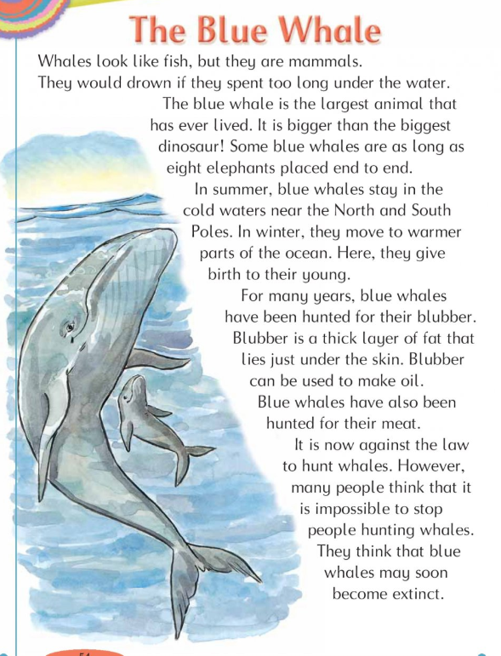
Write the answers into your copy
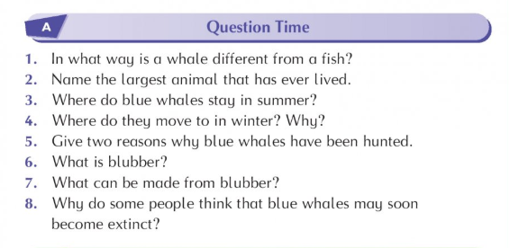
Art-look at this painting by the artist Claude Monet called ‘water lilies’. What do you like about it? What do you see? Can you draw your own version of this?
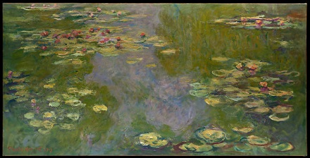
Homework
- 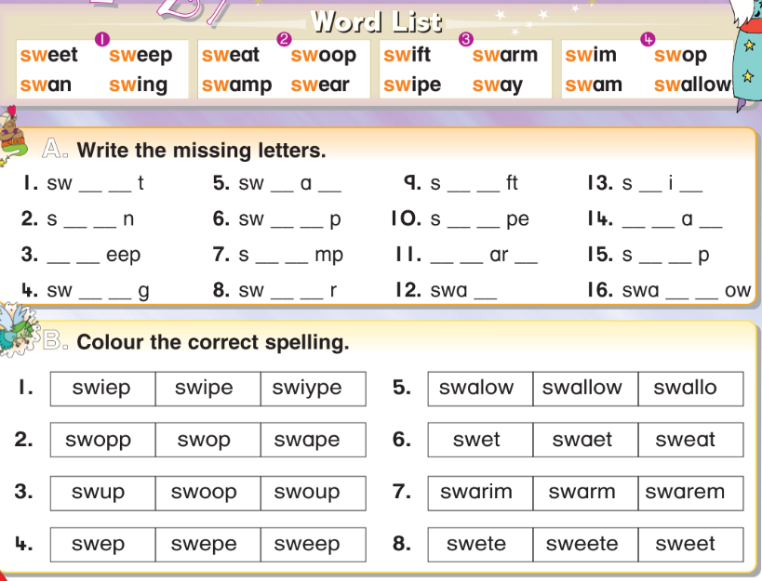
Read the story ‘The Go-Cart’ on page 4 as far as the blue line.
Write the answers to these questions in your copy:
- What did Patrick’s Mum find in the garage?
- Why did Patrick’s dad call them in?
Can you explain what the new words mean? The new words are: bored driveway buggy spare sounds
Put the words into sentences- for example ‘I had a spare pencil so I gave it to my sister’.
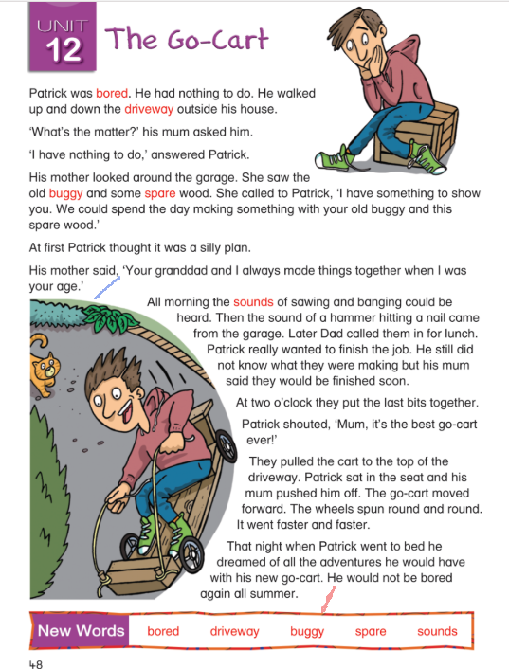
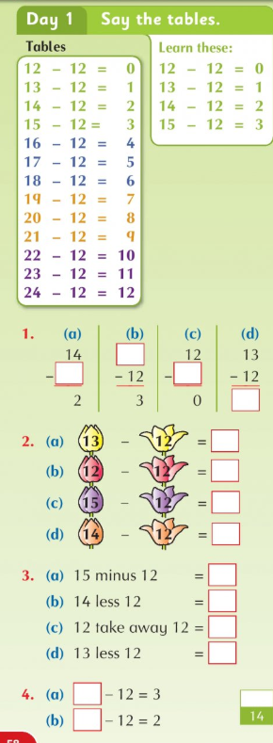
Wednesday 6th May
Maths
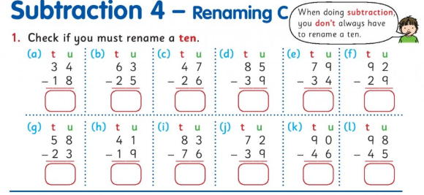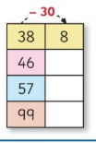
English- Today we are learning about homophones, which are words that sound the same, such as ‘to, too, two’. There will be a powerpoint on Padlet with my voice explaining this.
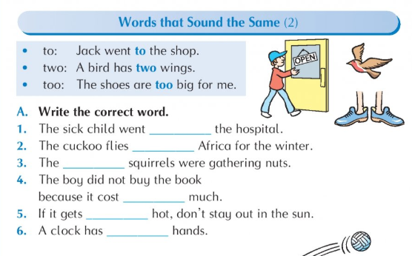
Irish- The theme is the garden. Write the correct word to match the picture. Girls, try them yourself first! Parents- answers below. I will record a video of me saying the words if you want to watch it. It will be on Padlet.
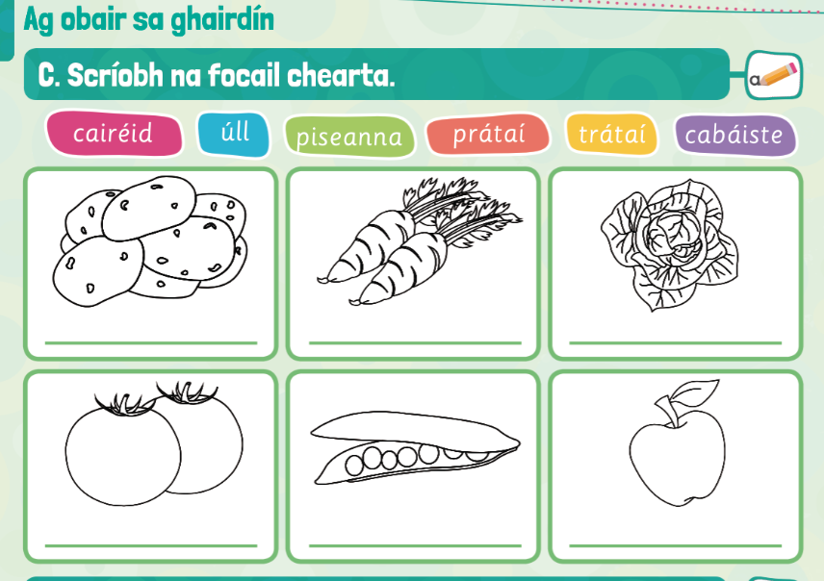Cairéid-carrots piseanna-peas prátai- potatoes trátaí- tomatoes cabáiste- cabbage Úll- apple
Homework
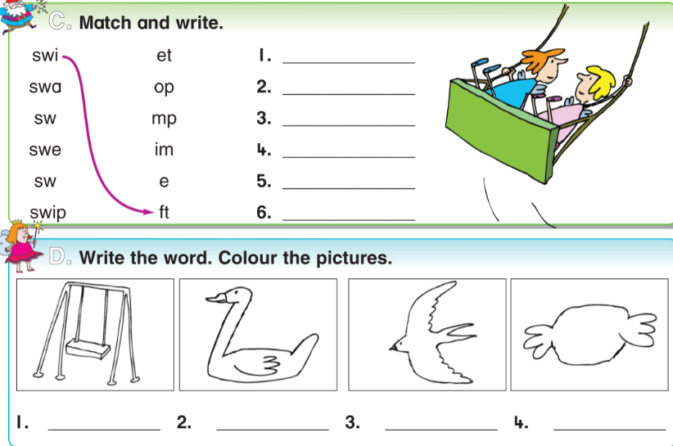
Reading- go back to page 4 to read the story ‘the go-cart’ and read as far as the red line.
Write the answers to these questions in your copy:
- What did Patrick and his Mum make?
- What time did they finish?
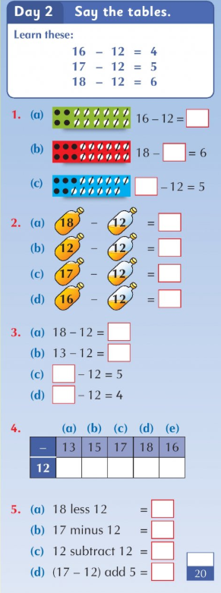

Thursday 7th May
Maths-remember to write the big number first and write neatly (units in line with units)
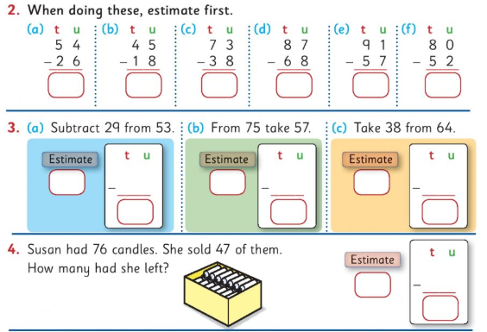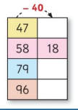
English-read the words and fill in the sentences.
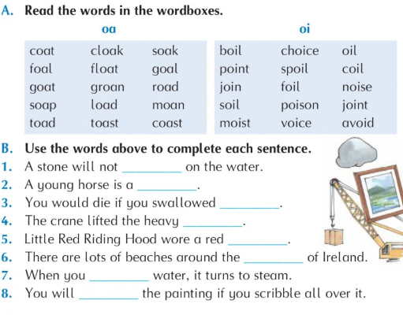
P.E.
*adult supervision required for P.E. I have a link to dance videos online, or you can follow this workout:
Workout- warm up- jumping jacks/ jog on the spot/ bunny hops/ squats/ high knees
30 seconds each, 10 seconds break in between and repeat twice
Circuits- squat jumps/ burpees/ wall squats/ sprint on the spot/ mountain climbers
30 seconds each, 10 seconds break in between and repeat three times
Ball throwing- practice throwing with two hands/one hand and catching with two hands/one hand
If you don’t have a ball, use anything you can safely throw
Kicking skills- practice kicking the ball at a target- use 2 shopping bags to make a goal- practice passing the ball by kicking
Cool down- stretching and breathing
Homework
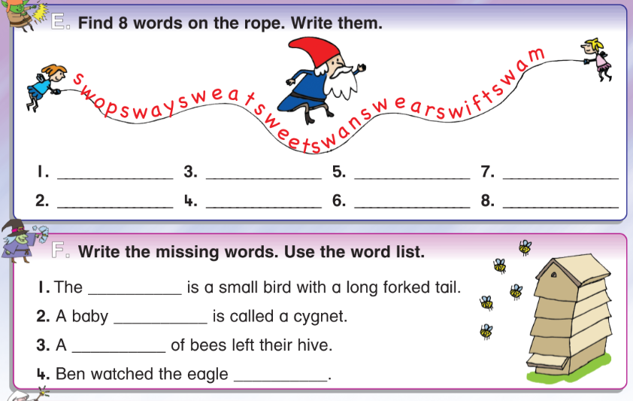
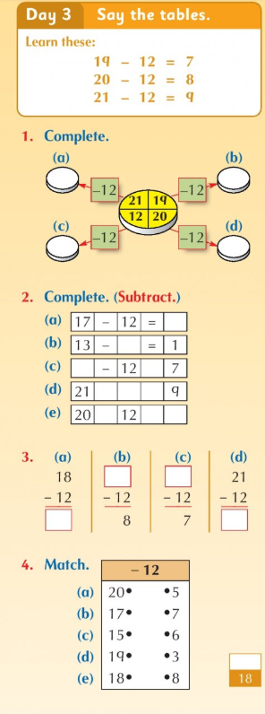
Reading- go back to page 4 to read the rest of the story ‘the go cart’.
Write the answer to this question: What did Patrick dream about that night?
Practice writing all the spellings and tables for your test tomorrow.
Friday 8th May
Maths-girls, you only have to cross out if there’s ‘more on the floor’. Don’t cross out in 2 (a). Check the sign.
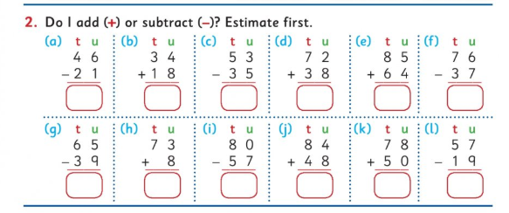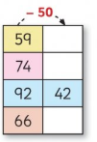
English- this activity is on when to use ‘a’ or ‘an’. When a word begins with a vowel (a, e, i, o, u) you write an. For example I ate an apple. If a word begins with a consonant, you write ‘a’. For example, ‘I saw a bird’. Girls, you can write this into your copies if you can’t print.
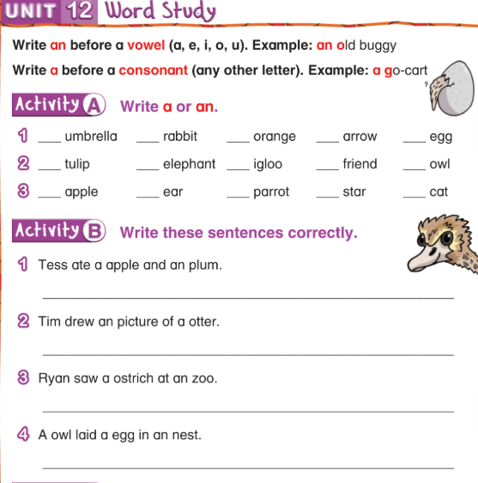
Tests: If you would like to give your daughter a test today, here are the lists:
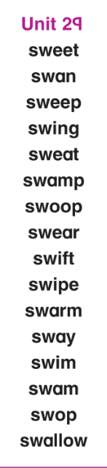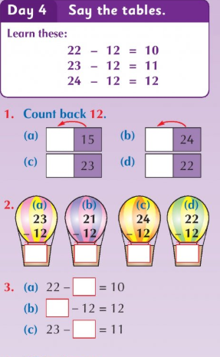
15-12= 24-12= 13-12= 20-12= 17-12=
12-12= 16-12= 18-12= 14-12=
23-12= 19-12= 21-12= 22-12=

History
We are looking at space travel this week. There was a race to the moon between America and Russia. The first man to walk on the moon was the American astronaut Neil Armstrong, in 1969 (the year my parents were married!). He walked 60 metres on the moon. No woman has walked on the moon. That’s very annoying. Maybe some day one of the girls in North Pres will show the boys how it’s done!
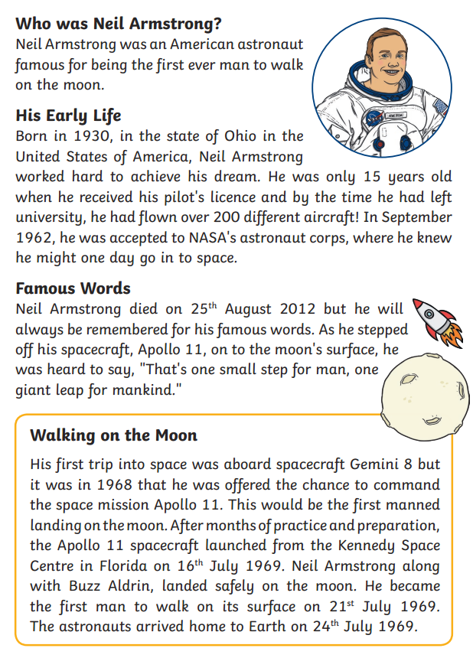
Answer these questions in your copy:
- When was Neil Armstrong born?
- Where was he from?
- How old was he when he received his pilot’s licence?
- How many aircraft did he fly?
- What were his famous words

