Monday 11th May
Maths
Girls, there are 2 parts to these sums. Sometimes you add and subtract. Remember to read the story and underline the numbers. Video on Padlet explaining how to do these sums.
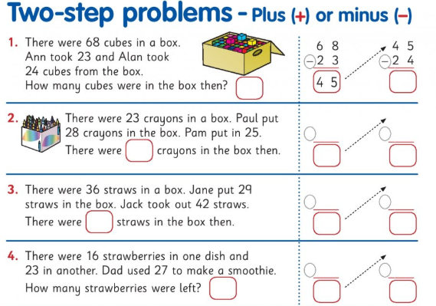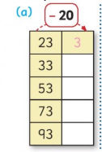
English- Read the report on the Irish explorer Tom Crean and write the answers in your copy. Remember a report is factual.
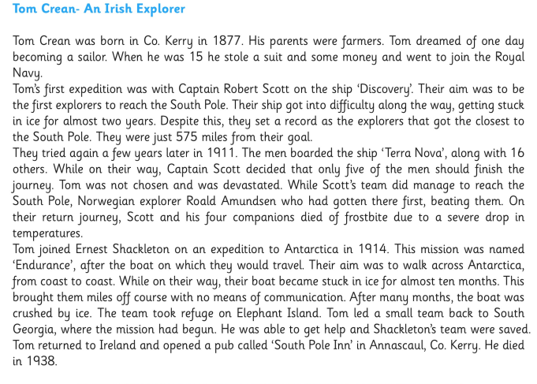
- Where was Tom Crean born?
- When was he born?
- At what age did Tom join the Navy?
- Who led the expedition ‘Discovery’?
- How did Captain Scott and his team die?
English grammar added to padlet-making plural words. Write these words as follows:
Poppy---poppies
Fly----flies
Puppy---
Spy---
Nappy-
Story--
Art-can you draw and colour a lovely rainbow and stick it on your window? It would be nice for people to see it and would really make them smile.
Homework
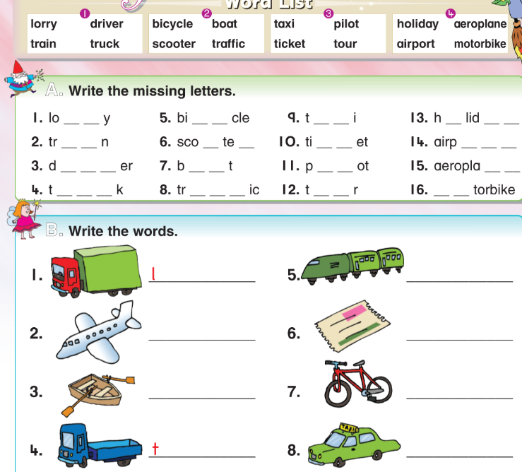
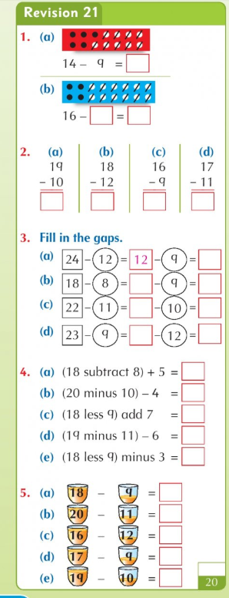
Read the story ‘Pets’ on page 4 as far as the blue line.
Write the answers to these questions in your copy:
1. What do cats do when they are happy? 2. What do hamsters eat?
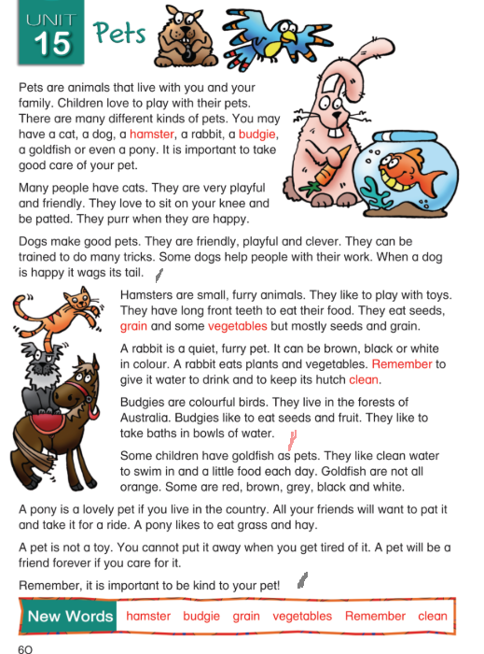
Tuesday 12th May
Maths
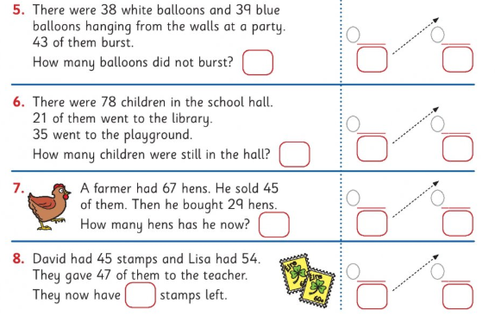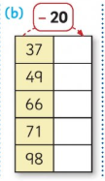

English-read the story and write the answers to the questions.
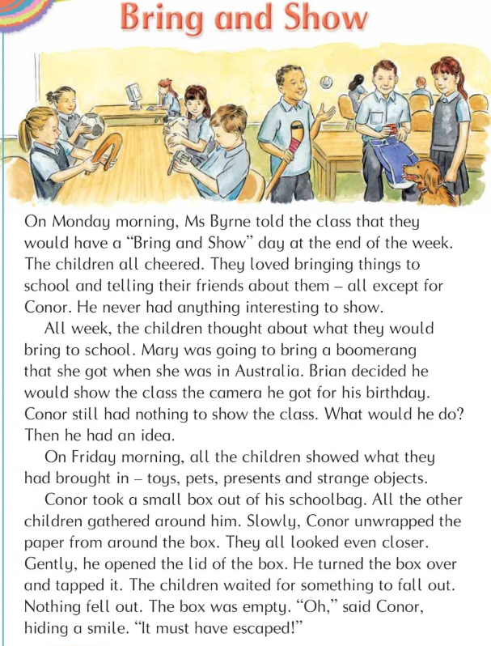
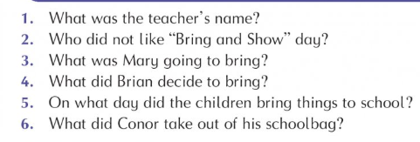

Irish- Write the correct word to match the picture. Girls, try them yourself first! Parents- answers below. I will record a video of me saying the words if you want to watch it. It will be on Padlet.
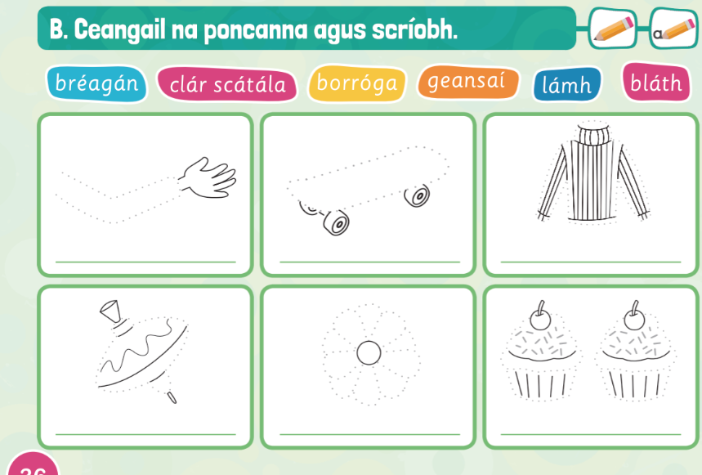
Lámh-hand clár scátála-skateboard geansaí-jumper bréagán-toys blath-flower borróga-buns

Homework
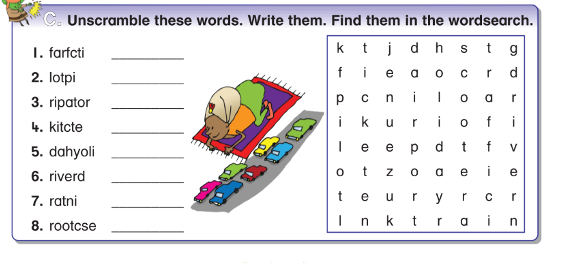Reading- go back to page 4 to read the story ‘Pets’ and read as far as the red line.
Write the answers to these questions in your copy: 3. What do we call a pet rabbit’s home? 4. Where do budgies come from?
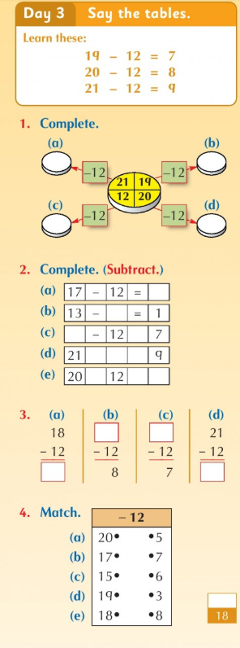

Wednesday 13th May
Maths-
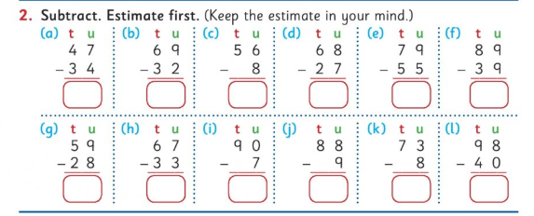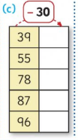

English-re-write the sentences with capital letters.
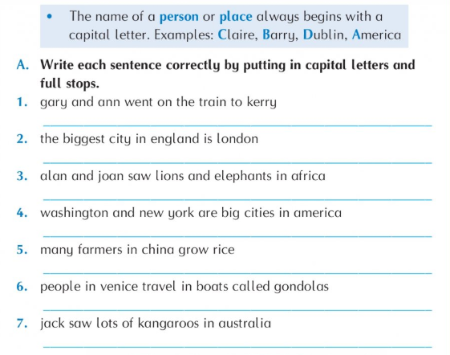
P.E.
*adult supervision required for P.E. I have a link to dance videos online, or you can follow this workout:
Workout- warm up- jumping jacks/ jog on the spot/ bunny hops/ squats/ high knees
30 seconds each, 10 seconds break in between and repeat twice
Circuits- squat jumps/ burpees/ wall squats/ sprint on the spot/ mountain climbers
30 seconds each, 10 seconds break in between and repeat three times
Ball throwing- practice throwing with two hands/one hand and catching with two hands/one hand
If you don’t have a ball, use anything you can safely throw
Kicking skills- practice kicking the ball at a target- use 2 shopping bags to make a goal- practice passing the ball by kicking. Cool down- stretching and breathing
Homework
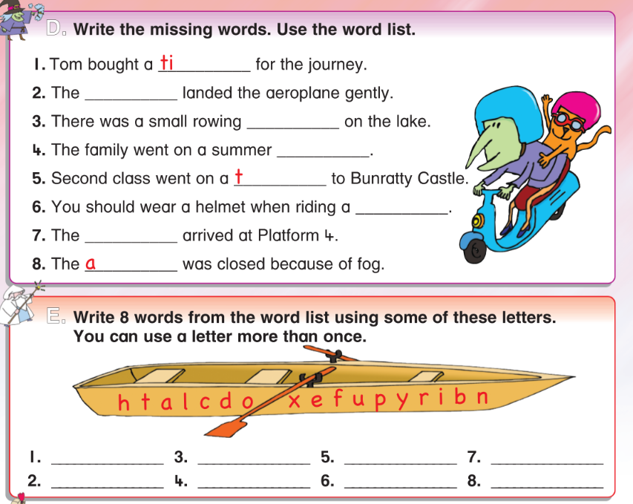
Reading- go back to page 4 to read the story ‘Pets’ as far as the black line.
Write the answer to this question:
- What colour are goldfish? 5. Do you have a pet?
Thursday 14th May
Maths
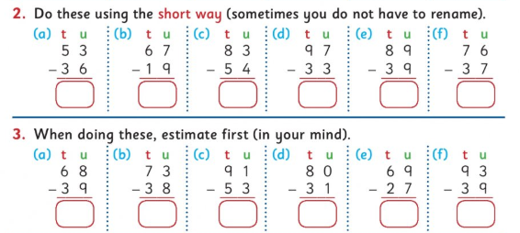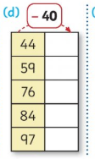

English- more work on grammar- words that sound the same such as there/their/they’re. There will be a powerpoint on Padlet explaining this.
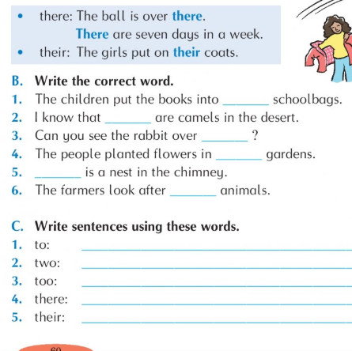
DEAR/listen to reading- DEAR stands for Drop Everything and Read. Girls, take a book and read for 20 minutes. Read to your little brother or sister. Or, go online to listen to reading- storylineonline.com or audible.com have lovely stories that you can listen to.
Homework
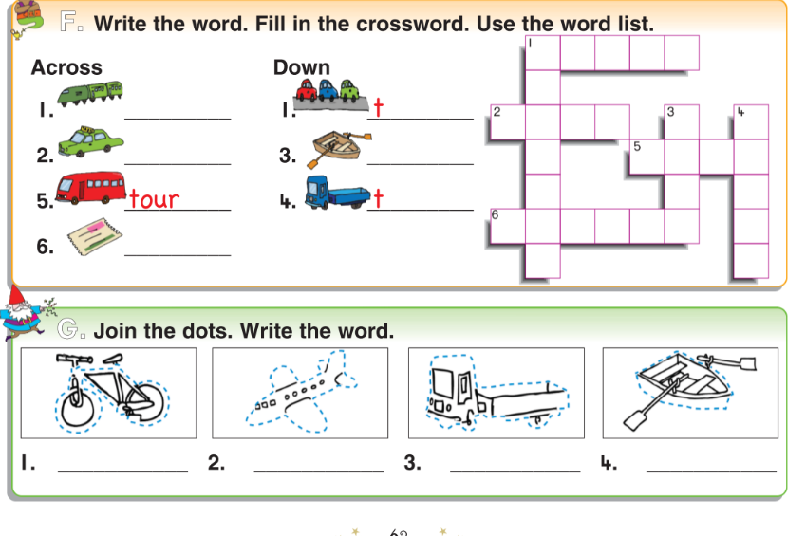

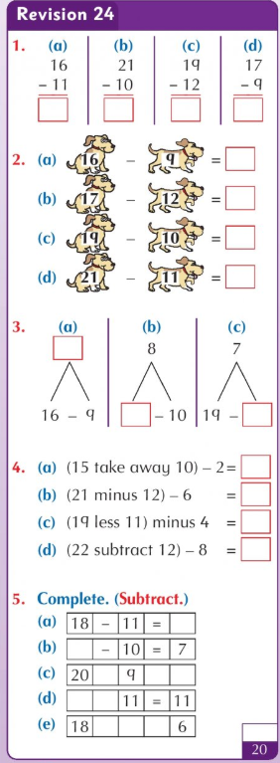
Read the story ‘Pets’ on page 4. Practice your spellings, Go over your tables for a test tomorrow.

Friday 15th May
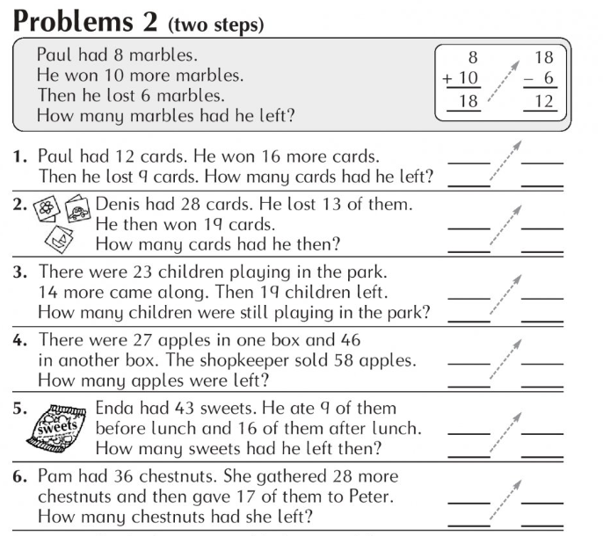
English- question marks.
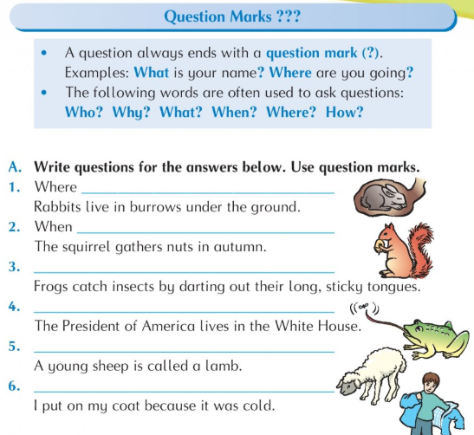
Tests: If you would like to give your daughter a test today, here are the lists:
