Dear Parents,
I hope you are all keeping well and staying safe.
Each day I have Maths, English and homework plus one extra thing. This is what we decided as a staff. Each lesson can be expanded on if you want, just as we would do in school.
Maths-counting forward/back, counting in 10s, telling the time, looking at a calendar for the date, making up word problems, drawing shapes, measuring using a weighing scales/ruler etc.
English- oral language-talking/asking questions/explaining what a word means/talking about likes/dislikes; reading-reading books/stories online/telling why you liked the book/ summarising the story; writing- writing sentences/write a report about an animal/write a recipe/write a shopping list/write your spellings/practice handwriting.
This is my Padlet link: https://mswhelton.padlet.org/stephaniewhelton/8hp68iied42s
We will deliver the books and copies next week.
Stephanie
Monday 18th May
Maths-data- girls, look at the pictogram and answer the questions. I will continue to add Maths videos to Padlet if I feel it is needed.
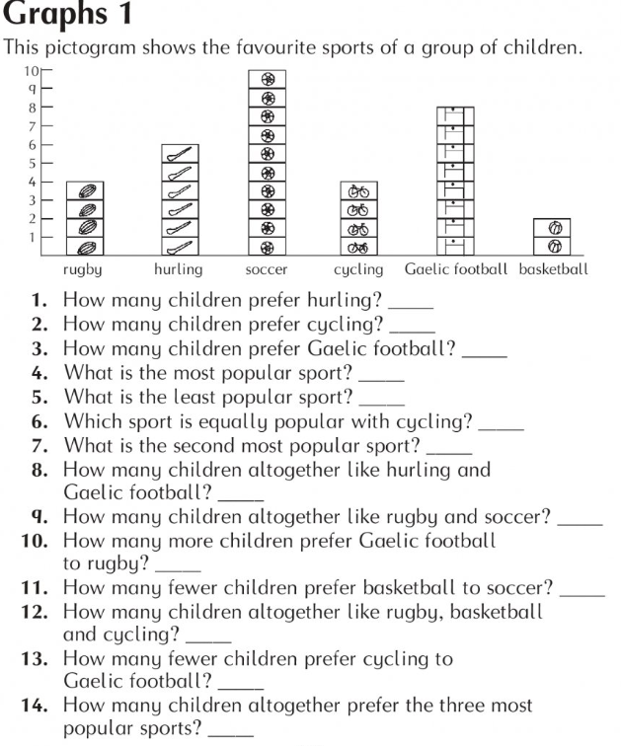

English-Read the story and write the answers to the questions. Write a summary of the story- 5/6 sentences explaining what happened.
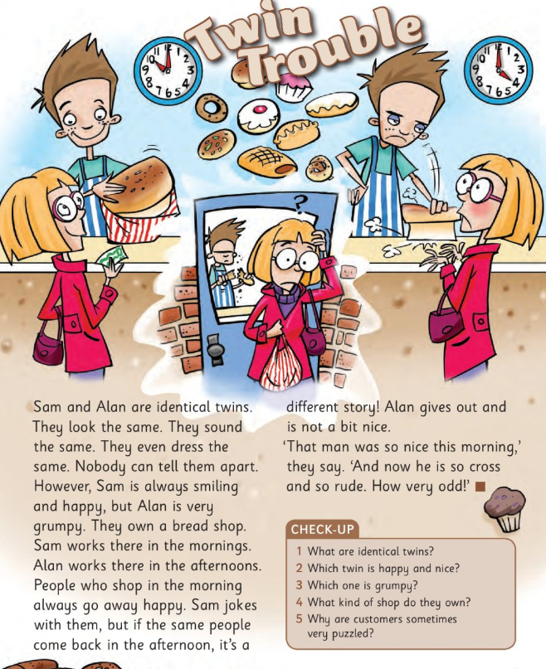

Irish-write the correct word, most are like the English version. Video on Padlet of me saying the words. Bosca ceoil- accordion. Fidil- fiddle (like a small violin).Feadóg stáin-tin whistle. Giotár-guitar. Trumpa-trumpet. Pianó-piano. Druma-drums.
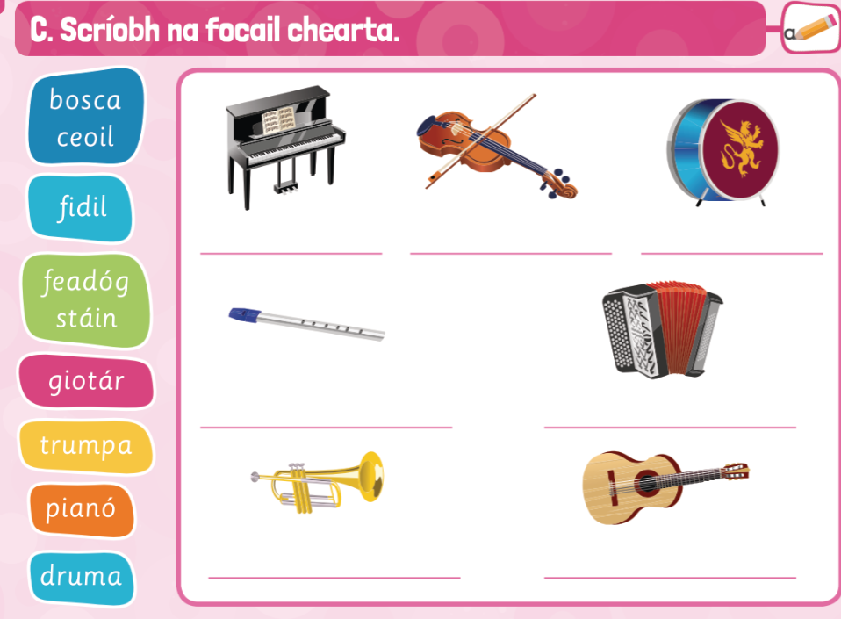

Homework-Spellings-learn box 1, write A,B.
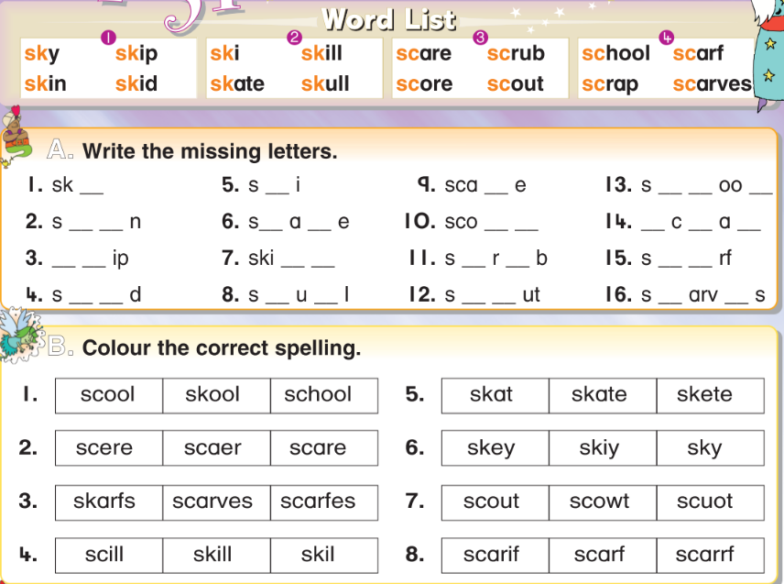
Homework-Tables- revise +1 tables
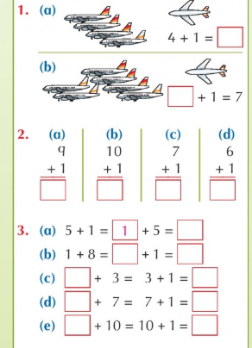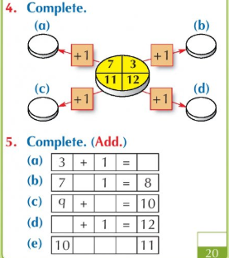
Homework-Reading-read the story ‘Copper’ as far as the first X. Write the answers to the questions.
- What kind of animal was Copper? 2. What was caught around Copper’s leg?
Tuesday 19th May
Maths- look at the block graph. ‘How many more’/’how many fewer’ means you need to subtract.
-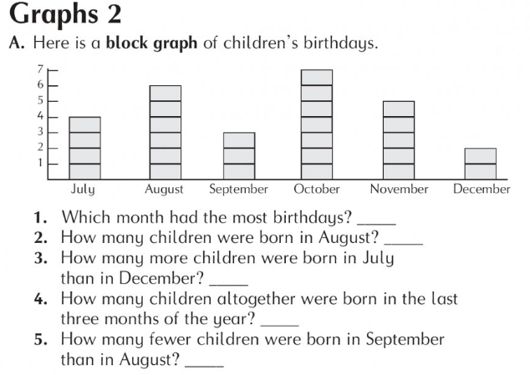
28+42= | 39+57= | 84-22= | 78-17= | 72+___=100 | 64+___=90 | 120=100+ ___
English- read the recipe (procedure) and write the answers. Can you write your own recipe?
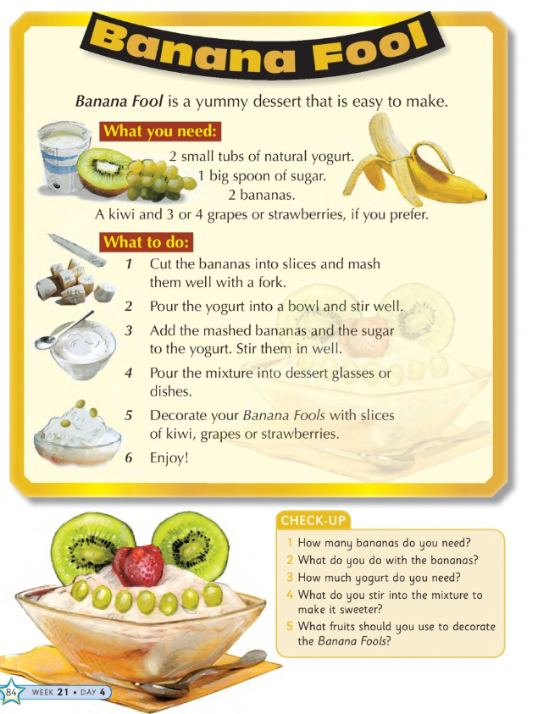
History- Bealtaine means ‘May’. Read about the traditions around Bealtaine in Ireland.
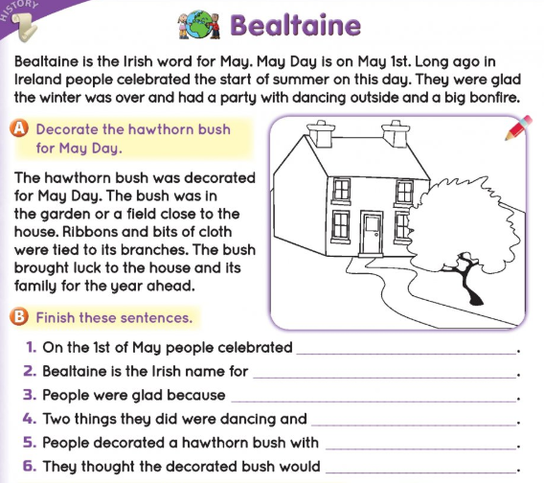
Homework-Spellings-learn box 2 and write C,D.
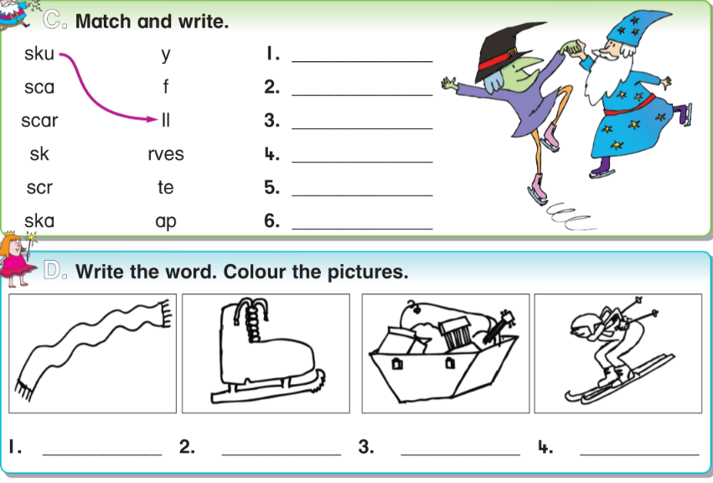Homework-Tables-revise +2 tables
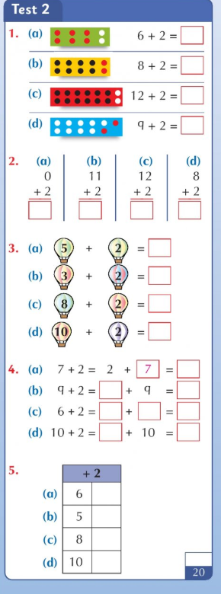
Homework-Reading-Read the story ‘Copper’ as far as the second X. Write answers to these questions:
- Where did Megan go for help?
- 4. Who owned Cooper?

Wednesday 20th May
Maths
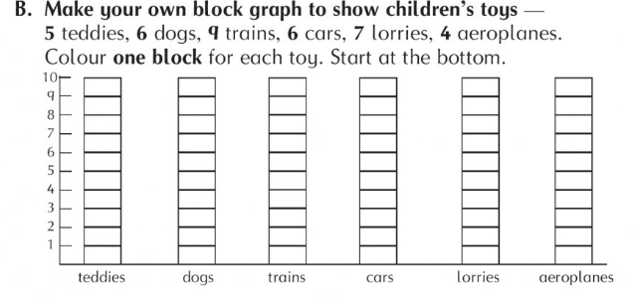
What is the most popular toy? ___________________ What is the least popular toy? ____________________
How many more trains than lorries? _______________ How many fewer aeroplanes than lorries? ___________
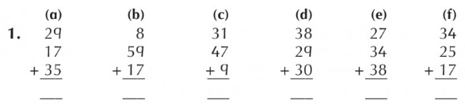
English- fill in the missing nouns and write some of your own sentences.
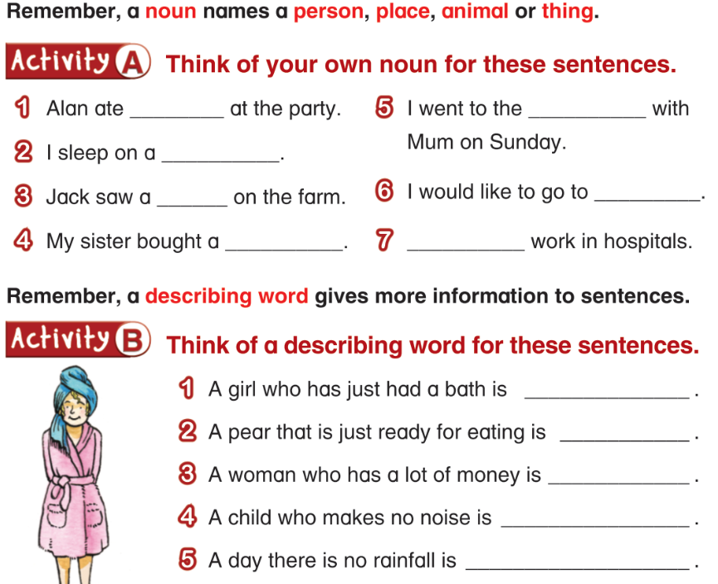
History- read about May wildflowers. Tell your parents what you learned. Write a few sentences about Bealtaine.
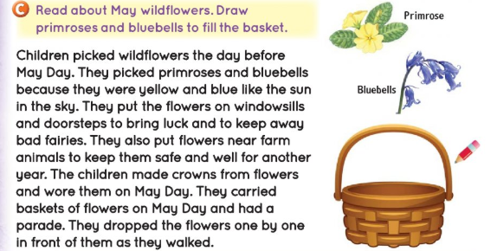
Homework-Spellings-learn box 3 and write E,F.
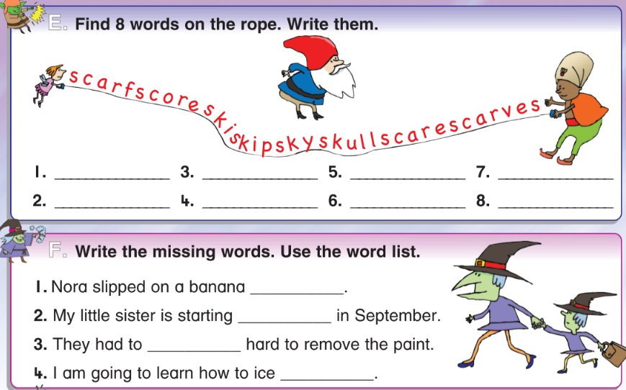
Homework-Tables- revise +3
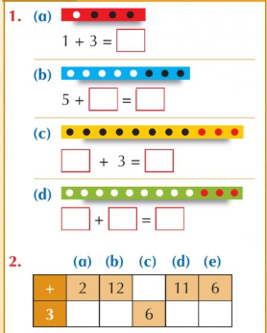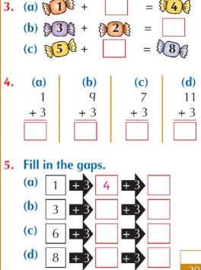
Homework-Reading- read the story ‘Copper’ as far as the third X. Answer the question:
5. What was Megan’s reward for helping the pony?
Thursday 21st May
Maths- A pictogram is a way of understanding data or information, using pictures.
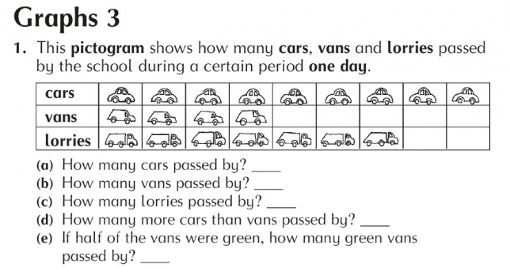
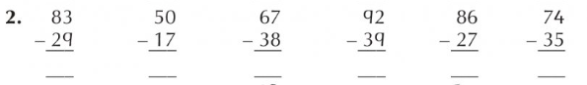
English- These are irregular plurals-they do not follow the ‘add s’ rule. Make up your own sentences too.
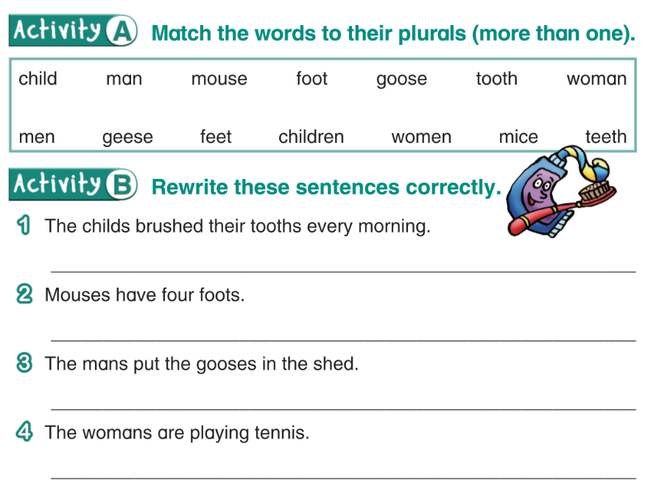

History- Read Joan’s story about May Day. Read the sentences and think of questions for the answers.
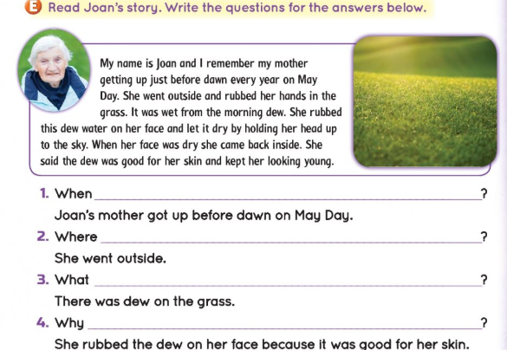
Homework-Spellings-learn box 4 and write G,H.
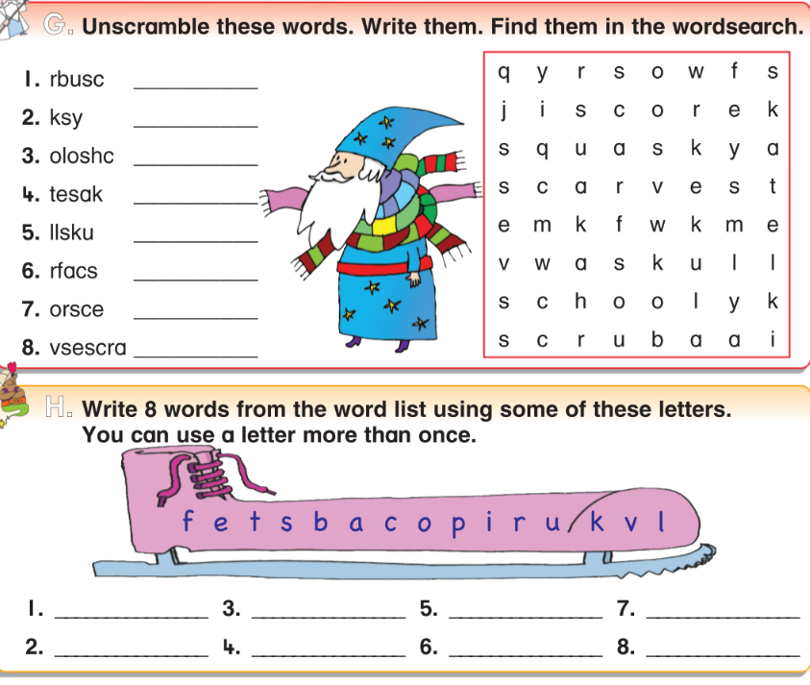Homework-Tables- revise +4
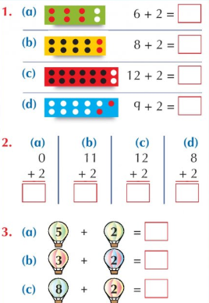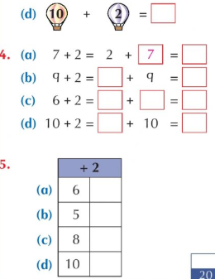
Homework-Reading- read all of the story ‘Copper’. Practice your spellings and tables (+1 to +4) Art-draw a self-portrait
Friday 22nd May
Maths- part e- which two fruit was liked by the same number of people.
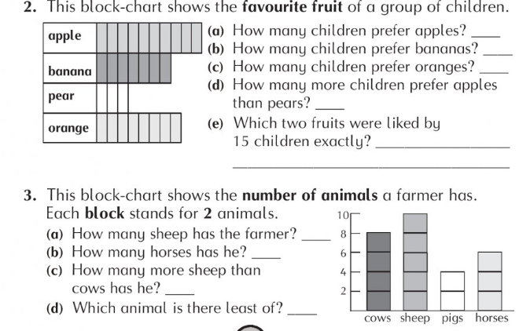
English- Read this explanation about glass and write the answers. Talk about the making of glass.
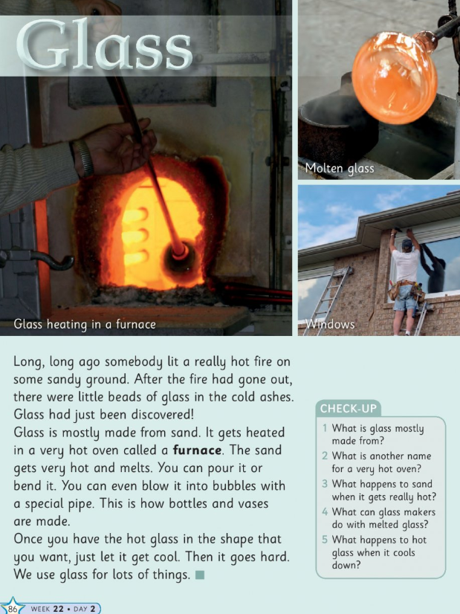
Geography-Small World book p.80-read the text and fill in the missing words. Write sentences using the words listed.
Tests: if you want to give your daughter a test, here are the lists:
