Dear Parents,
I hope you are all keeping well.
We will be delivering books from Monday 25th May. We are dividing up the deliveries so I will not be delivering to all of you. I have listed below a plan for the week which includes your daughter’s books. You will have copies too which will be very useful.
I have printed off my plan that will last til the end of June. There is a copy of this in each girl’s bag of books etc so you do not need to print anymore. There is more than enough in the sheets to keep the girls going. I’m sending you this work plan so you have something to start with on Monday.
Each day I have Maths, English and homework plus one extra thing. This is what we decided as a staff. Each lesson can be expanded on if you want, just as we would do in school.
Maths-counting forward/back, counting in 10s, telling the time, looking at a calendar for the date, making up word problems, drawing shapes, measuring using a weighing scales/ruler etc.
English- oral language-talking/asking questions/explaining what a word means/talking about likes/dislikes; reading-reading books/stories online/telling why you liked the book/ summarising the story; writing- writing sentences/write a report about an animal/write a recipe/write a shopping list/write your spellings/practice handwriting.
This is my Padlet link: https://mswhelton.padlet.org/stephaniewhelton/8hp68iied42s
Stephanie
Monday 25th May
Maths-Maths Challenge book p.32
English-Write the words with their magic e ending. Read them and put 10 of the words into sentences.
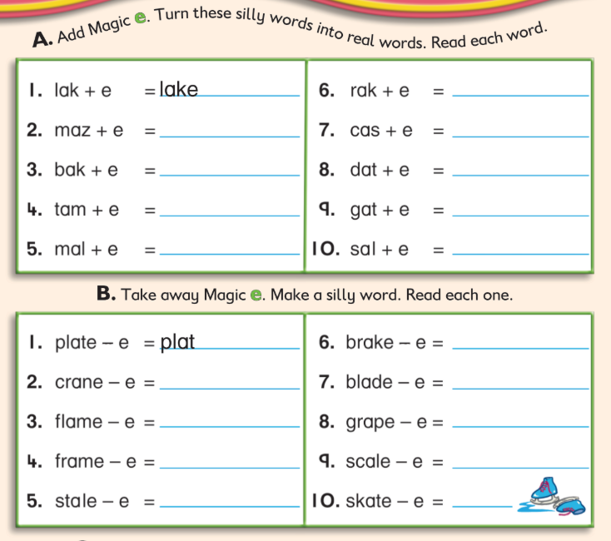

Irish- match the colour to its word and colour the parrot. Video on padlet of me saying the words.
Write the Irish words. Write some sentences- ‘Is maith liom glas’- I like green.
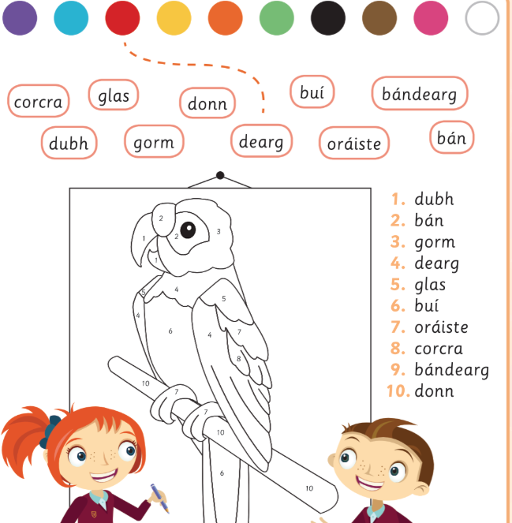
Homework
Spellbound p.66 box 1, write A/B Tables p.64 Test 5, revise +5 tables
Reading-read ‘Horses’ as far as the first X and answer the questions. 1. How many legs has a horse? 2. What is the name for a horse’s feet?
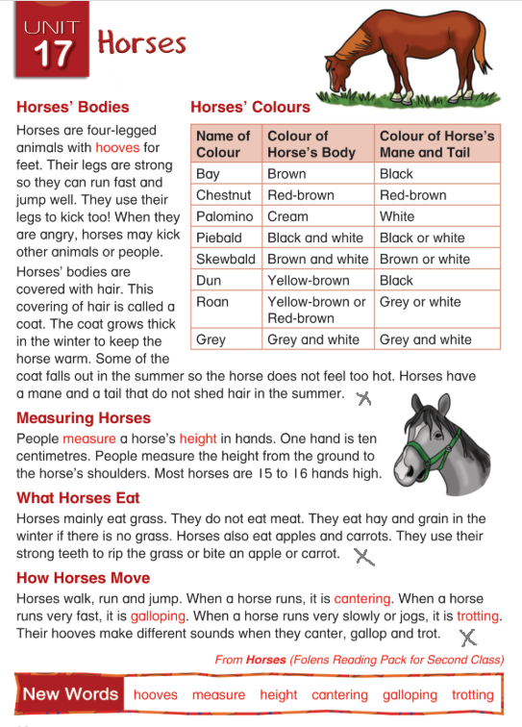

Tuesday 26th May
Maths-Maths Challenge book p. 33
English- read this old Irish legend and write the answers. Can you write your own story?
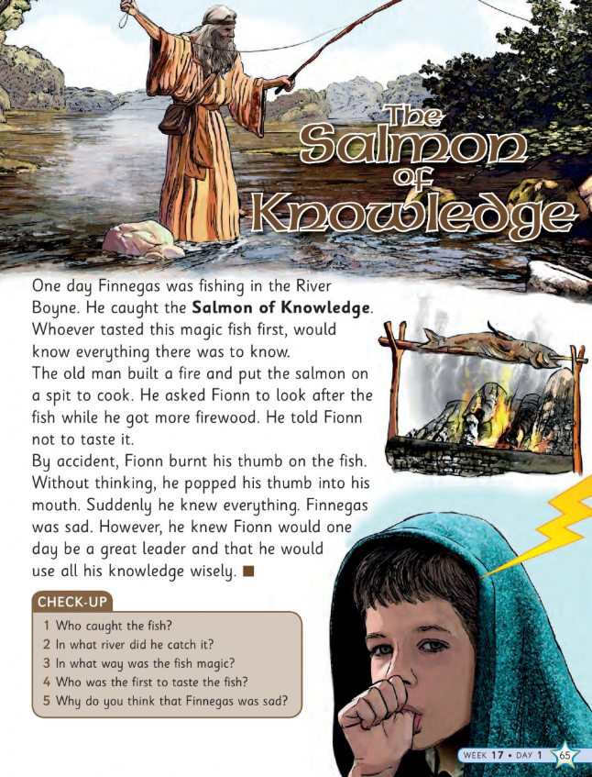
Science- Small World book p.83 ‘where does light come from?’
Homework Spellings Spellbound p.66 box 2 and C, D Tables Table Topper book p. 64 Test 6 revise +6 tables
Reading- read the text ‘Horses’ as far as the second X. Write the answer to the questions:
- Why do horses have strong legs? 4. What happens to a horse’s coat in winter?

Wednesday 27th May
Maths- Maths Challenge book p.34
English- how to make plurals when a word ends in f or fe. Write 5 extra sentences with these words.
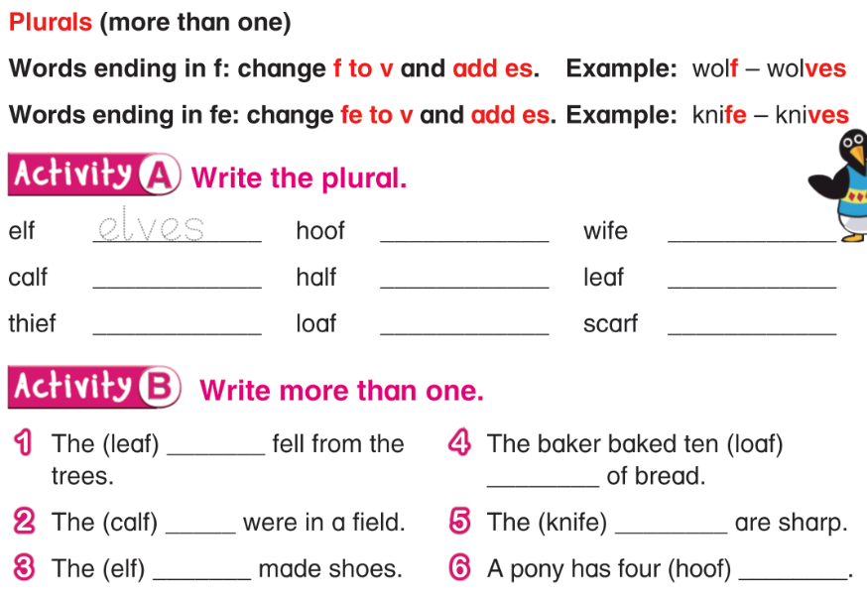
Science-Read yesterday’s lesson on light (Small world p.83). Write the ten hot sun facts into your small world copy.
Homework-Spellings- Spellbound book p.67 box 3 and E, F Tables-Table Toppers book p.65 Test 7, revise +7 tables
Reading- read ‘horses’ text on page 15 of this plan and answer this question: 5. What does a horse eat?

Thursday 28th May
Maths- Maths Challenge book p. 35
English- Write A and B and write 5 of your own sentences using ‘I’m’ and ‘He’s’
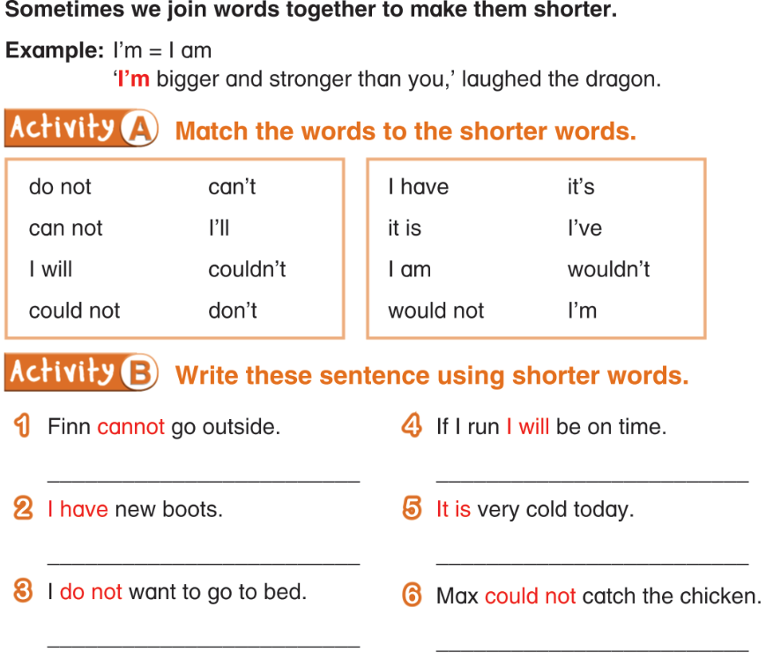
Handwriting- complete 1 page of your handwriting book
Homework- Spellings-Spellbound p.67 box 4 G, H Tables-Table Toppers book p.65 Test 8, revise +8 table
Art-draw a portrait of a family member
Friday 29th May
Maths-Maths Challenge book p.36
English- read the text and write the answers. Can you research the Titanic with your parents?
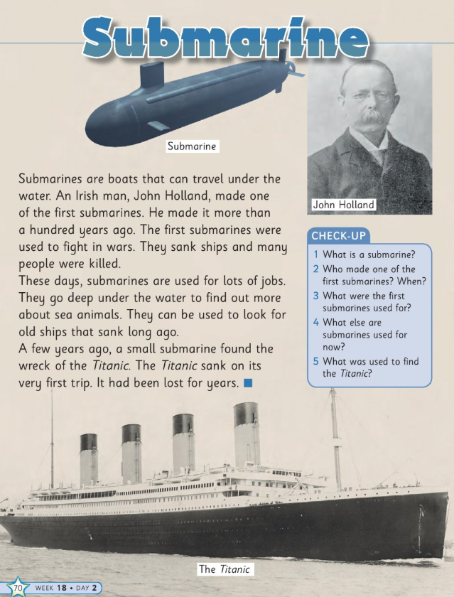
English- use your copies to do some free writing. Maybe you can write about something you learned about this week- such as Submarines or the Salmon of Knowledge.
Tests- you can give your daughter a test on the spellings from this week (a list is on p.80 unit 32)
Tables
6+5= 9+5= 11+5= 10+6= 12+6= 7+6=
11+7= 9+7= 7+7=
12+8= 7+8= 10+8=

