4th class work (Plan 3)
Ms. J. Manley
Hello all. Hope you had a nice Easter break and I hope you are all keeping well. Again if you have any questions at all about the work or anything else, please don’t hesitate to contact me via my email address: jennifer.manley@northpresprimary.ie
Below is a list of some academic work if you wish to proceed with this with your child. I am going to outline the work one week at a time, outlining subjects to be covered each day from Monday to Friday with the homework included at the end of each day. Again there is absolutely no pressure to get this work completed. The work below is mostly what we would have been covering in school this week.
There is no need to print off the pages unless you really want to. The girls are well able to read the pages and complete written activities in their copies or on any pages that you may have at home. It might be handy to use the zoom tool on the bottom right of the screen so you can see the images more clearly.

Monday 20th April
Maths:
- Money
- Word problems with money
- Figure out first is the sum an addition or a subtraction problem.
- Write the sums into your copies.
- Make sure to line the sums up correctly under each other as shown below:
- €5.67 2. €15.69
+€3.89 +€03.78

English:
Read the text and answer the quick questions in your copy.

PE:
- www.gonoodle.com For exercises/dancing etc. We do this everyday in school as a movement break. The girls love it.
- P.E. with Joe Wicks, The Body Coach TV Live on youtube, Monday to Friday 9 a.m. These are excellent workouts.

Irish:
Write the words and draw pictures in your copy (if you go onto the Folens website (Abair Liom F), you will hear the pronunciation of each of these words).
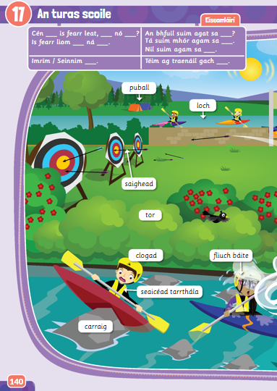
Loch – lake
Puball – tent
Carraig – rock
Clogad – helmet
Fliuch báite – soaking wet
Seaicéad tarrthála – life jacket
Saighead – arrow
Tor - shrub / plant

History:
The Celts. Read the following piece and answer the questions into your copies.
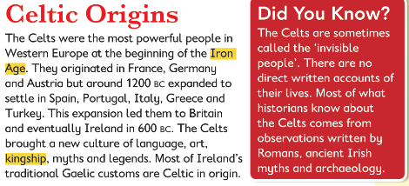
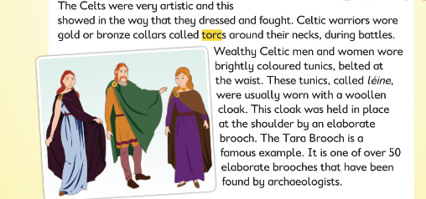

- When did the Celts begin to settle in Ireland?
- Why are the Celts sometimes called ‘invisible people?’
- Name three crops grown by Celtic farmers.
- How were the Celts able to dominate Celtic culture?

Homework:
Spellings from Spellbound – Unit 19 – The Classroom: Box 1 (A and B).
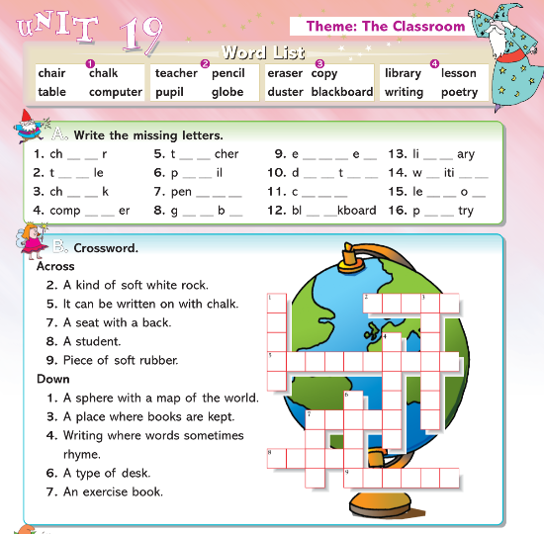

Mental Maths 4: (Week 29 – Monday and Problem Solving). The girls will have these books at home so write away into them as we usually do.

Tuesday 21st April
Maths:
- Money
- Word problems with money
- Figure out first is the sum an addition or a subtraction problem.
- Write the sums into your copies.
- Make sure to line the sums up correctly under each other as shown below.

- €17.99
€28.35
+€16.34

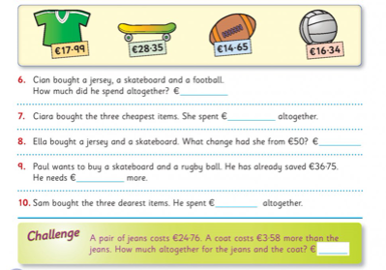

English:
Read the text and answer the questions in your copy.
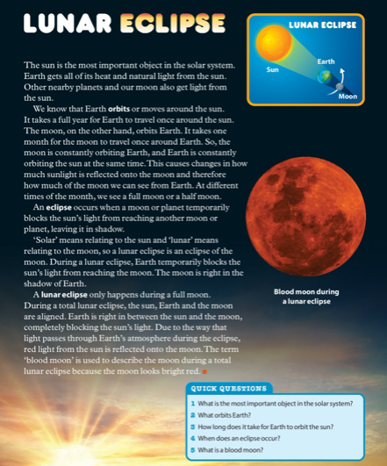

Geography:
Life in the school community. Read the following piece and answer the questions into your copies.
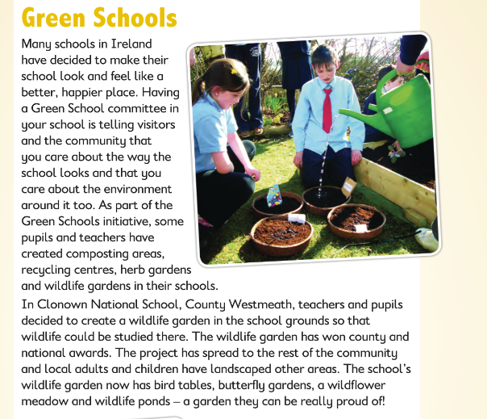
- What is the name of this school?
- What county is this school in?
- Name all the various parts of the school’s wildlife gardens.
- Do you have anything similar in your school or area.

Homework:
Spellings from Spellbound – Unit 19 – The Classroom: Box 2 (C and D).
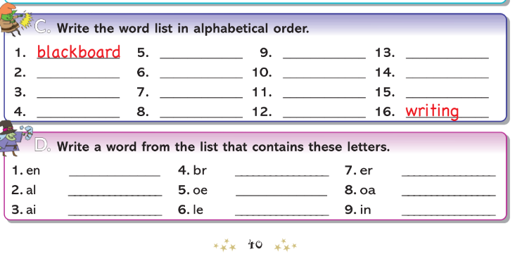

Mental Maths 4: (Week 29 – Tuesday and Problem Solving). The girls will have these books at home so write away into them as we usually do.

Wednesday 22nd April
Maths:
- Money
- Multiplication with money
- Write the sums into your copies.
- Make sure to line the sums up correctly under each other as shown below.
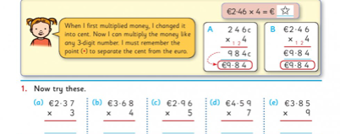
English:
Read the text and answer the questions in your copy.
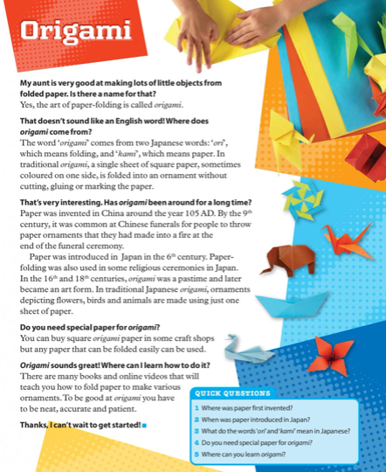
Irish:
Write the words and draw pictures in your copy (if you go into the Folens website, you will hear the pronunciation of each of these words)
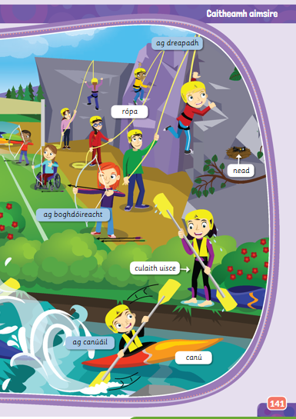

Ag dreapadh – climbing ag canúáil - canoeing
Nead – nest rópa - rope
Canú – canoe culaith uisce – swimsuit / wetsuit
Ag boghdóireacht - archery
Homework:
Spellings from Spellbound – Unit 19 – The Classroom: Box 3 (E and F).
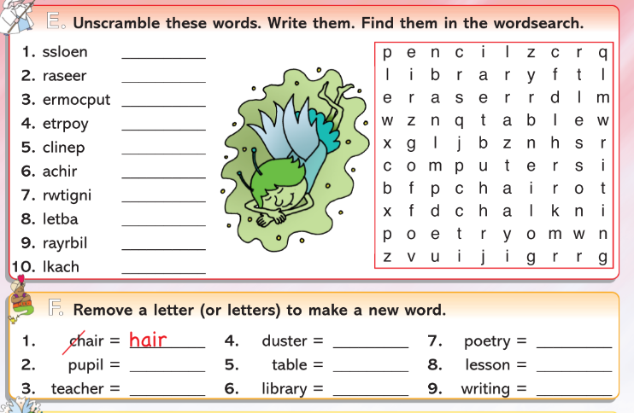

Mental Maths 4: (Week 29 – Wednesday and Problem Solving). The girls will have these books at home so write away into them as we usually do.

Thursday 23rd April
Maths:
- Money
- Multiplication with money
- Write the sums into your copies.
- Make sure to line the sums up correctly under each other as shown below.
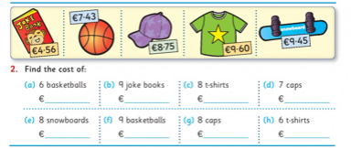
English:
Read the text and write the answers in your copy.
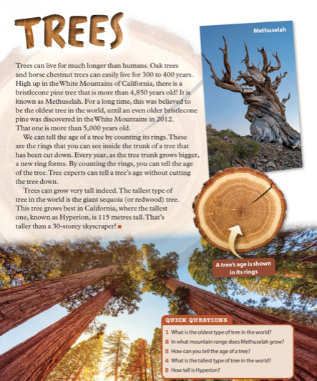
Science:
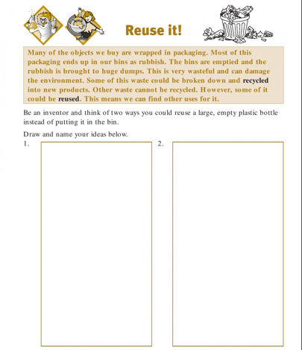

Homework:
Spellings from Spellbound – Unit 19 – The Classroom: Go back over Boxes 1 – 4 (G and H).
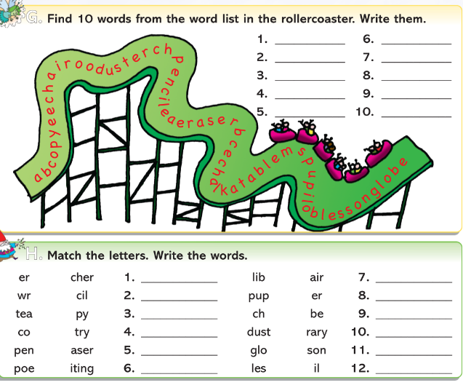

Mental Maths 4: (Week 29 – Thursday and Problem Solving). The girls will have these books at home so write away into them as we usually do.

Friday 24th April
Maths:
- Money
- Multiplication with money
- Write the sums into your copies.
- Make sure to line the sums up correctly under each other as shown below.
English:
Read the text and write the answers in your copy.
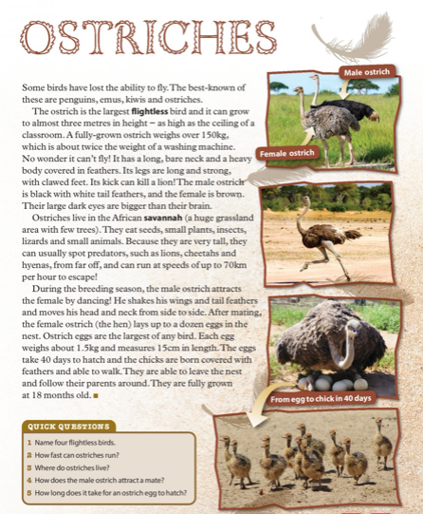
Irish:
Use the previous words learned earlier in the week to complete this word search below.
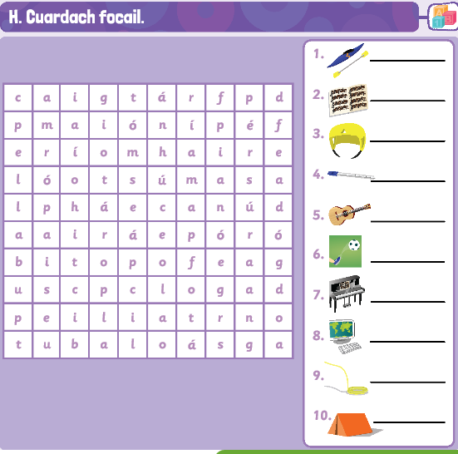
Art:
- Shadow art: with the nice weather it might be a nice idea to collect any toys, dolls, items around the house and using a pencil and paper draw around the shadows of these items outside in the sunshine. Colour them in.
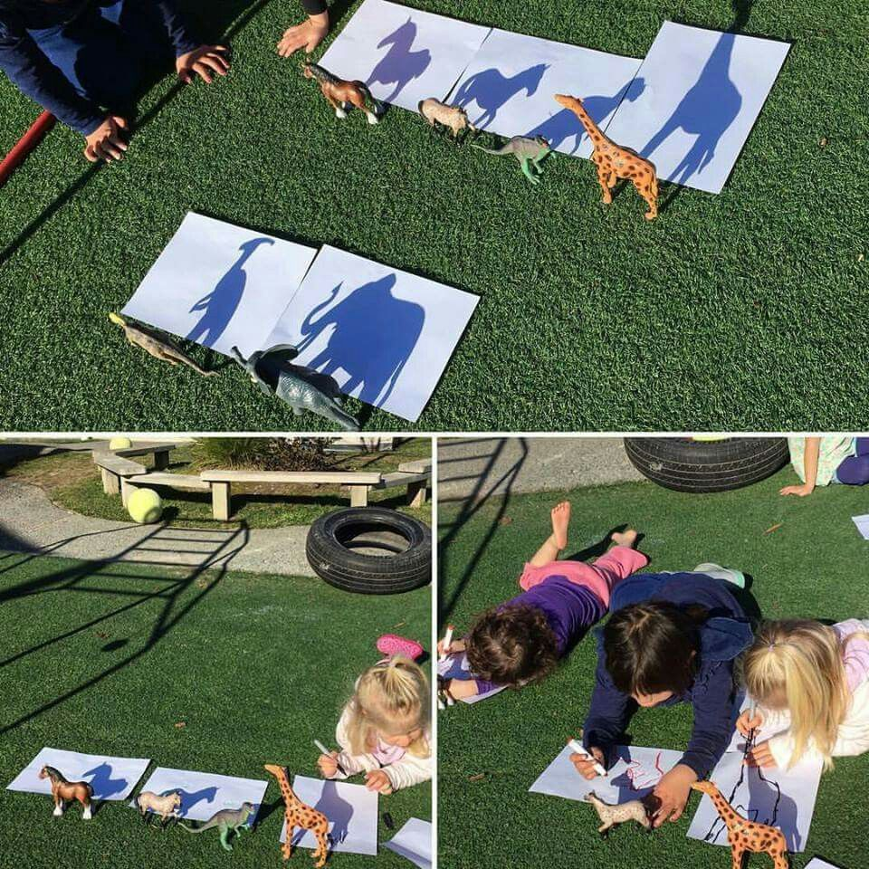
Weekly Friday Test:
If you would like to give your daughter a test today, here is the list of words:
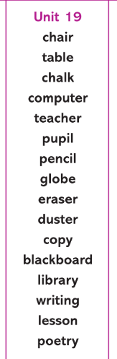

They could also do the Friday review in their Mental Maths 4 books.

-

