2nd class Ms.Whelton
I hope you are all keeping well and staying safe. Here is another plan for your daughter while school is closed. My email is stephanie.whelton@northpresprimary.ie if you need more information or have any questions. If there is something you need me to explain, I can ring you to discuss this. I can also make a video clip and email it to you.
As I mentioned to you before, only do what you can. Please do not feel under pressure. We are just trying to do our job as best we can. Try not to compare your situation with what other parents are doing- they are finding it hard too and no two homes are the same. Only you know what you can do and there are far more important things to worry about.

The plan has 2 parts- I’d suggest doing either part 1 or part 2

Part 1- Padlet
I have created a padlet, which is an online noticeboard. Here is the link:
https://mswhelton.padlet.org/stephaniewhelton/8hp68iied42s

The Padlet has everything you need in one place. You look at the column for that day and follow it. Everything opens straight away. You do need internet access to use it.
It has:
- Book pages which you can open directly
- Video clips of me teaching a few topics
- Power points
- Youtube links
- Homework book pages
- I can add more video clips teaching a specific skill if you request one

Part 2- word document
This word document has:
- Book pages that the girls would have been doing in school
- Homework book pages
It does not have any links/ power points/ video clips-they are all on the Padlet. It is just a basic word document. Some parents may prefer to use a word document instead of using internet access that you need for the Padlet. There is no need to print off the pages unless you really want to. The girls are well able to read the pages and complete written activities in their copies. If you have run out of copies, most supermarkets (definitely Super Valu and Dunnes) have a stationery section where you can buy copies.
It might be handy to use the zoom tool on the bottom right of the screen so you can see the images more clearly.
Monday 20th April
Maths
- Counting using 100 square in homework journal
- Example, start at 96, count back in 10s (96, 86, 76, 66, 56 etc)
- Example, start at 93, count back in 20s (93, 73, 53, 33, 13)
- Write sums below into a copy
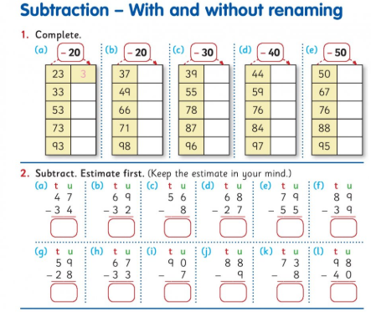
English
Read the text and answer the questions in your copy.
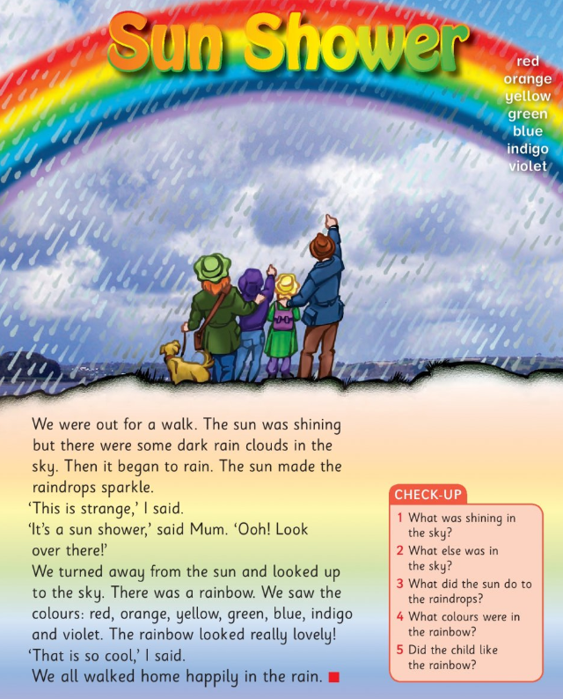

Irish
Write the words and draw pictures in your copy (there is a video clip on padlet of me reading the words)
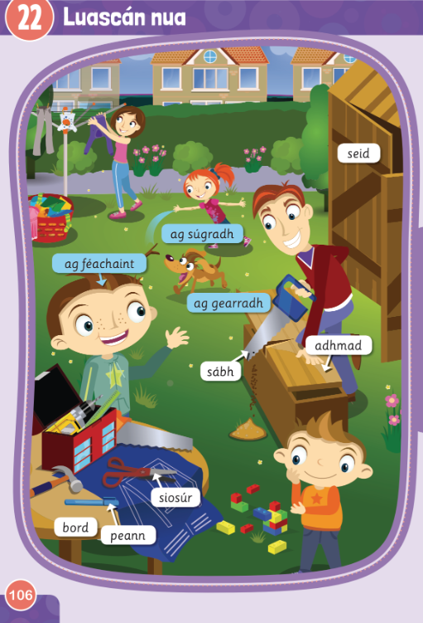

History
Talk about how you have changed over time and draw your own timeline
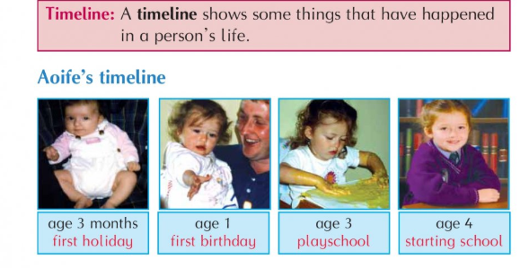
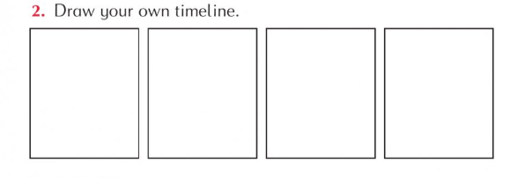
Homework
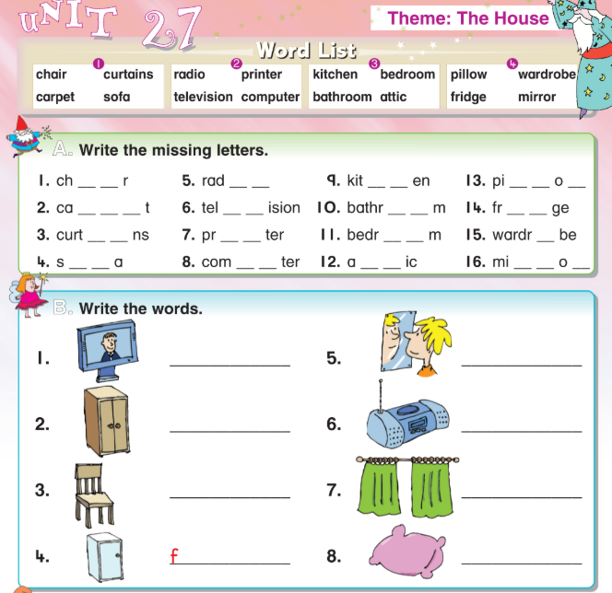
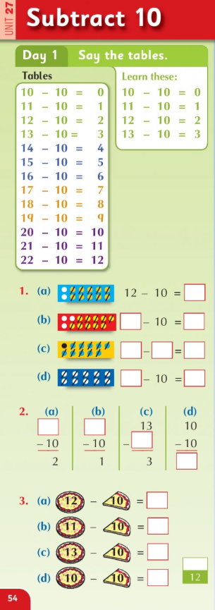
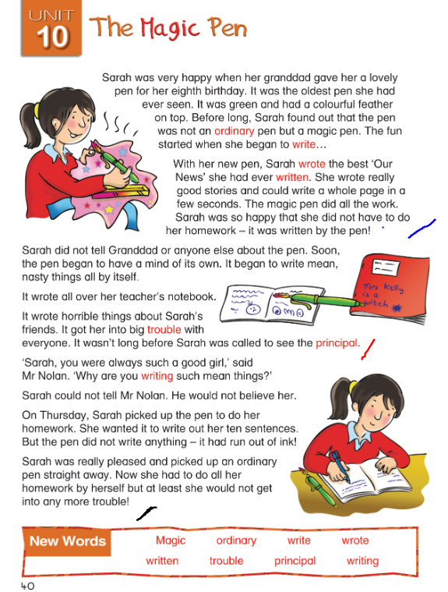
Read the story ‘The Magic Pen’ as far as the blue line.
Write the answers to these questions in your copy:
- Describe the pen that Sarah’s Grandad gave her.
- What did the pen help Sarah write?

Tuesday 21st April
Maths
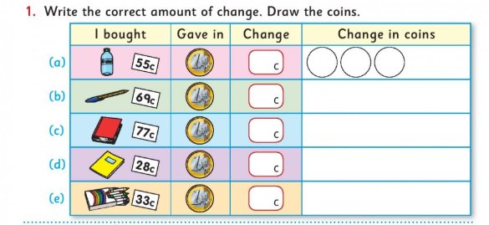
English
Read the text and answer the questions in your copy.
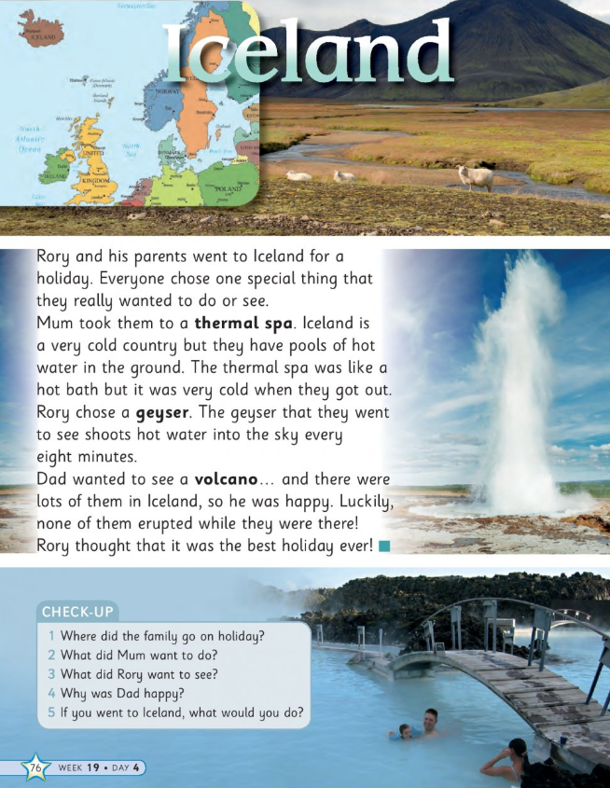

Geography
Look at the map and find the counties you know. Have you been to any of the places?
Write the names of the counties.
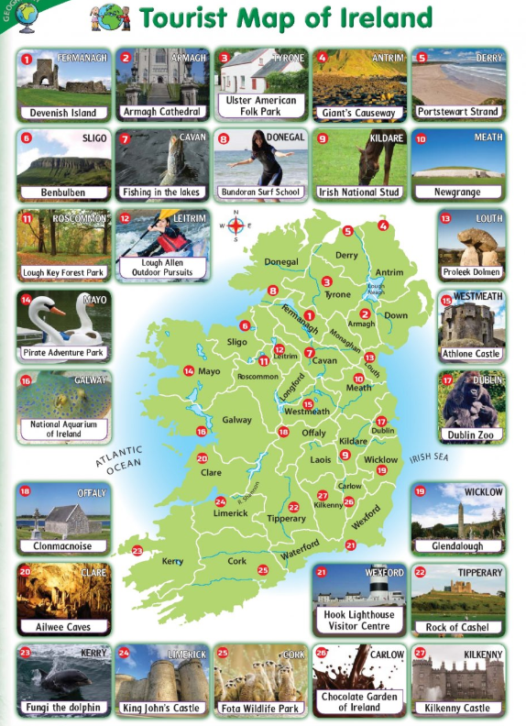
Homework
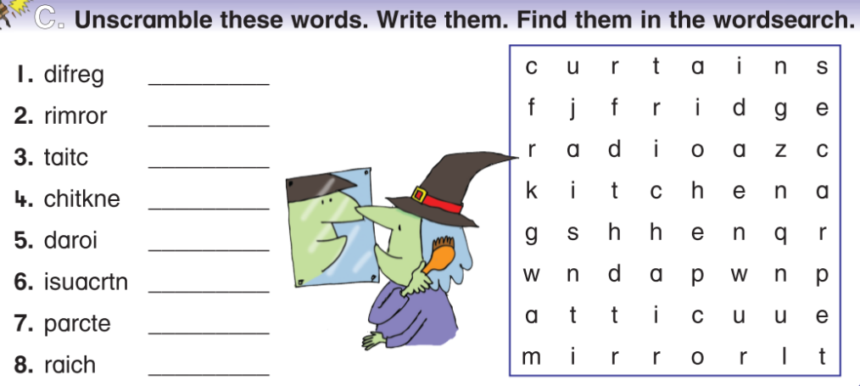

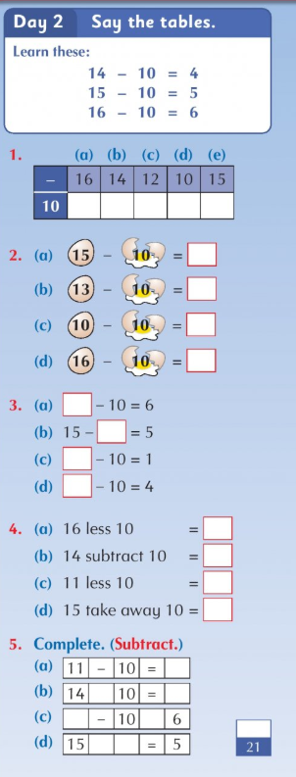
Reading- go back to page 5 to read the story ‘The Magic Pen’ and read as far as the red line.
Write the answers to these questions in your copy:
- What did the pen write about Mrs.Kelly?
- Who is Sarah’s principal?

Wednesday 22nd April
Maths
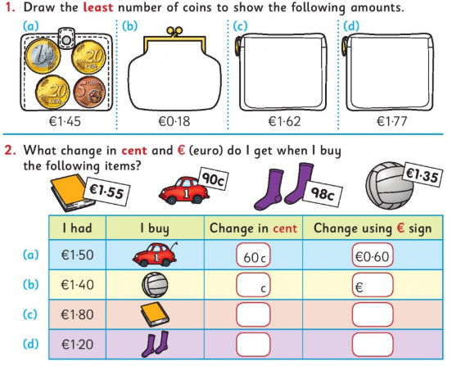
English
Read the text and answer the questions in your copy.
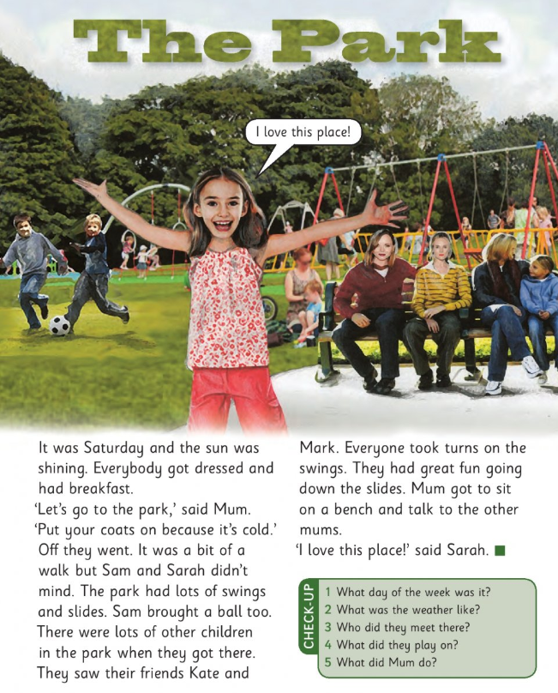
P.E.
*adult supervision required for P.E.
Workout- warm up- jumping jacks/ jog on the spot/ bunny hops/ squats/ high knees
30 seconds each, 10 seconds break in between and repeat twice

Circuits- squat jumps/ burpees/ wall squats/ sprint on the spot/ mountain climbers
30 seconds each, 10 seconds break in between and repeat three times

Cool down- stretching and breathing

Irish
Write the words and draw pictures in your copy (there is a video clip on padlet of me reading the words)
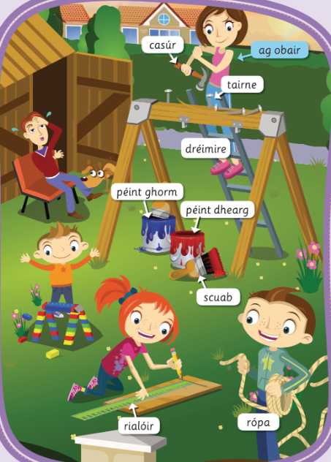

Homework
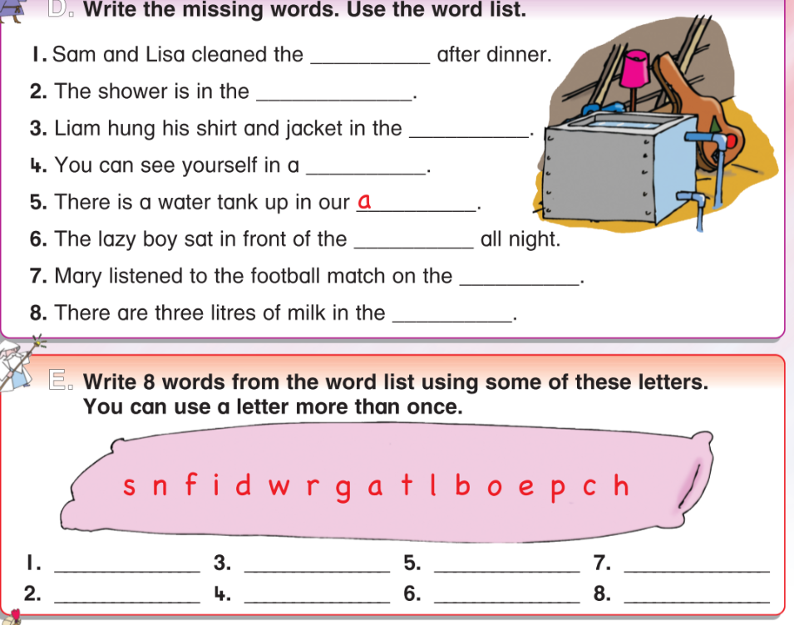
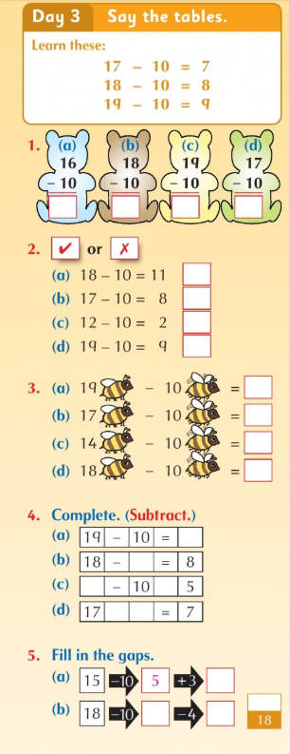
Reading- go back to page 5 to read the story ‘The Magic Pen’ and read as far as the black line.Write the answer to this question in your copy: 5. What happened to the pen on Thursday?
Thursday 23rd April
Maths
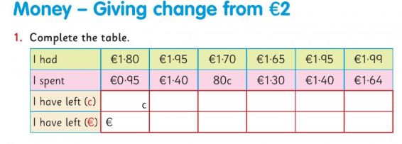
English
Read the text and write the answers in your copy.
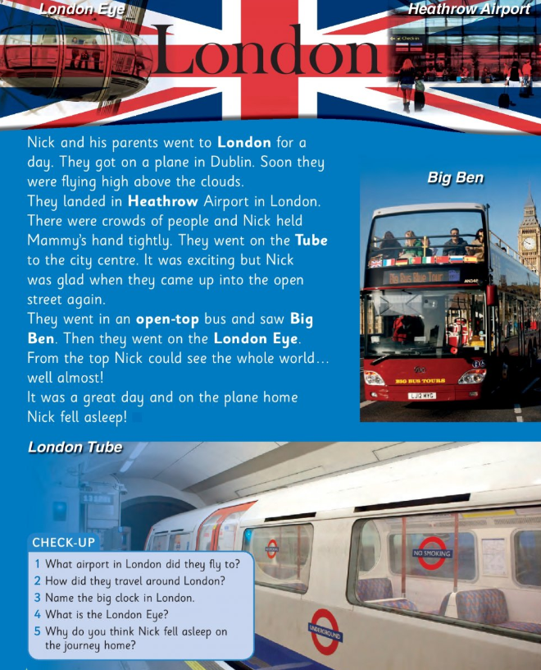

Science
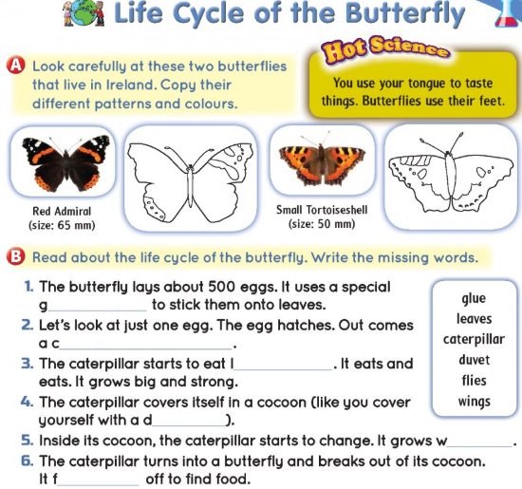
Homework
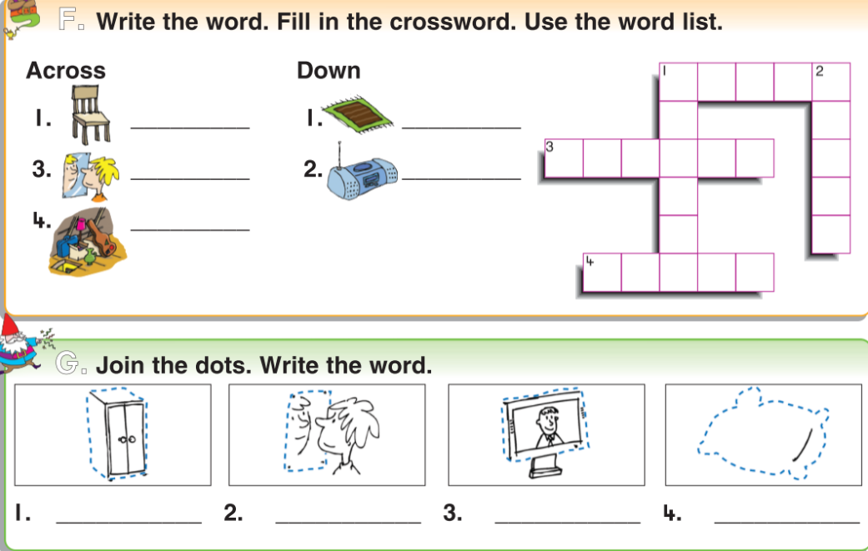
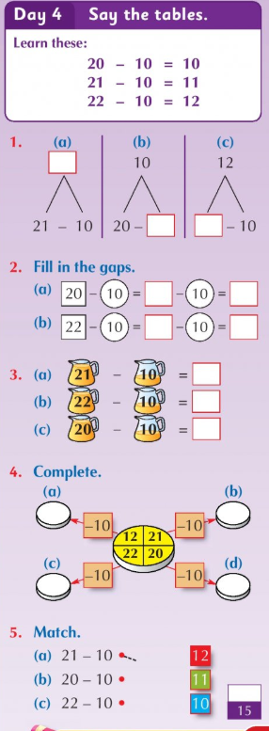
Reading- go back to page 5 to read all of the story ‘The Magic Pen’

Friday 24th April
Maths
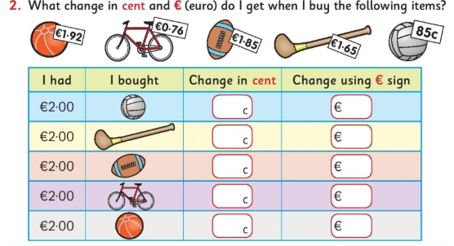
English
Read the text and write the answers in your copy.
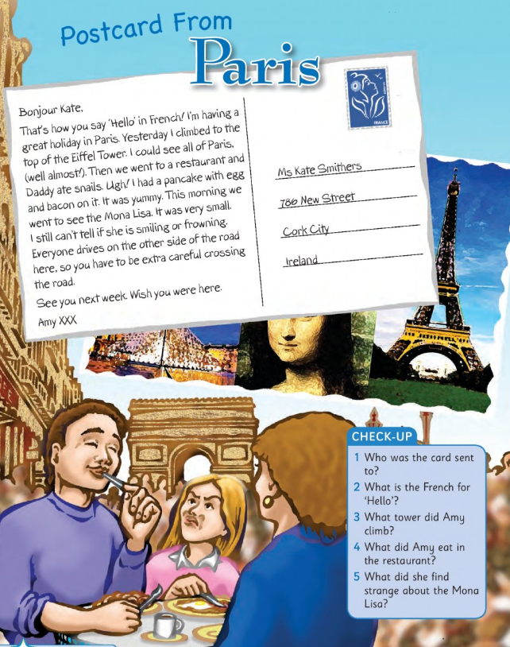
Irish
Read the story and write it into your copy (there is a video clip of me reading it on Padlet)

Scéal- An Luascán Nua
Tá gach duine sa ghairdín.  Tá Mamaí ag cur éadaí ar an líne éadaigh.  Tá Síofra ag súgradh le Tafaí.  Tá Daidí ag gearradh adhmad le sábh. | 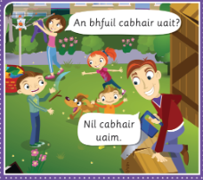
Tá tuirse ar Dhaidí.  Tá Mamaí ag obair agus tá an luascán nua déanta aici.  Tá péint ghorm agus péint dhearg acu.  Beidh a lán spraoi acu ar an luascán nua. | 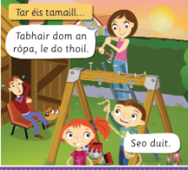

Tests
If you would like to give your daughter a test today, here are the lists:
