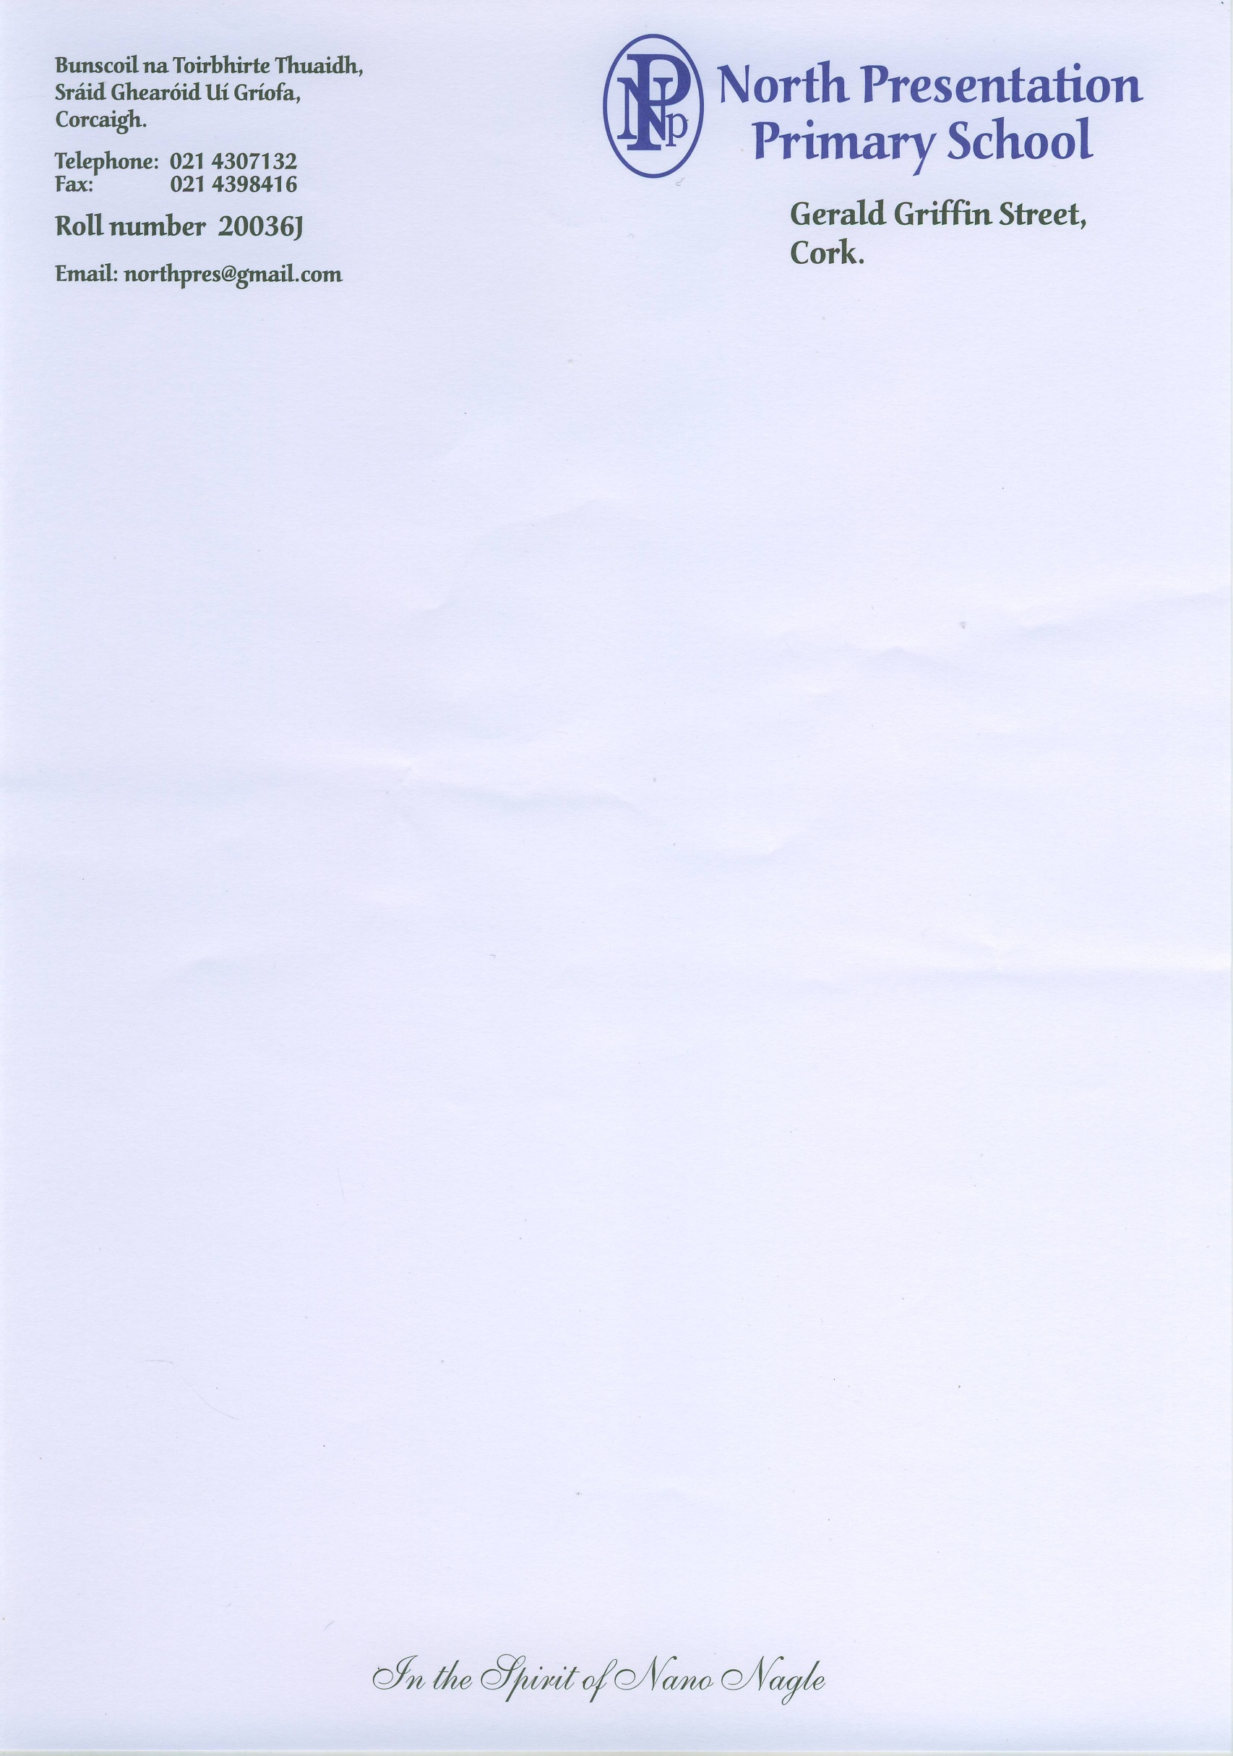 **Roll No: 20036J**

**Registered Charity Number: 20111717**

**Telephone: (021) 4307132**

**Email:** [**applications@northpresprimary.ie**](mailto:applications@northpresprimary.ie)

**Application Form – North Presentation Primary School**

**Personal Information of Child**

**Class you wish to enrol your child in:**

**First Name: Surname:**

**Address and Eircode:**

**Date of birth: PPSN:**

**Male: ____ Female: _____**

**Nationality:**

**Number of years living in Ireland (if not born here):**

**Contact details of Parents/Guardians:**

1. **Name:**

**Relationship to child:**

**Contact Number:**

**Email address:**

1. **Name:**

**Relationship to child:**

**Contact Number:**

**Email address:**

**Number of children in family: Place of this child in the family:**

**Language spoken in the home:**

**Brothers/sisters attending North Presentation Primary School:**

**Parents/Grandparents who attended North Presentation Primary School:**

**Previous school/ preschool:**

**Medical Conditions/Allergies:**

**Concerns regarding: hearing, sight, speech, behaviour, co-ordination etc.:**

**Linked with other agencies: e.g. Early Intervention, Occupational Therapy, Speech and Language Therapy etc.:**

**Any other relevant information:**

**Signed: (parent/guardian): Date:**

**Please ensure all information id filled in and return this form to** [**applications@northpresprimary.ie**](mailto:applications@northpresprimary.ie) **or hand it in to the school office.**

**Office Use Only**

**Date Received:**