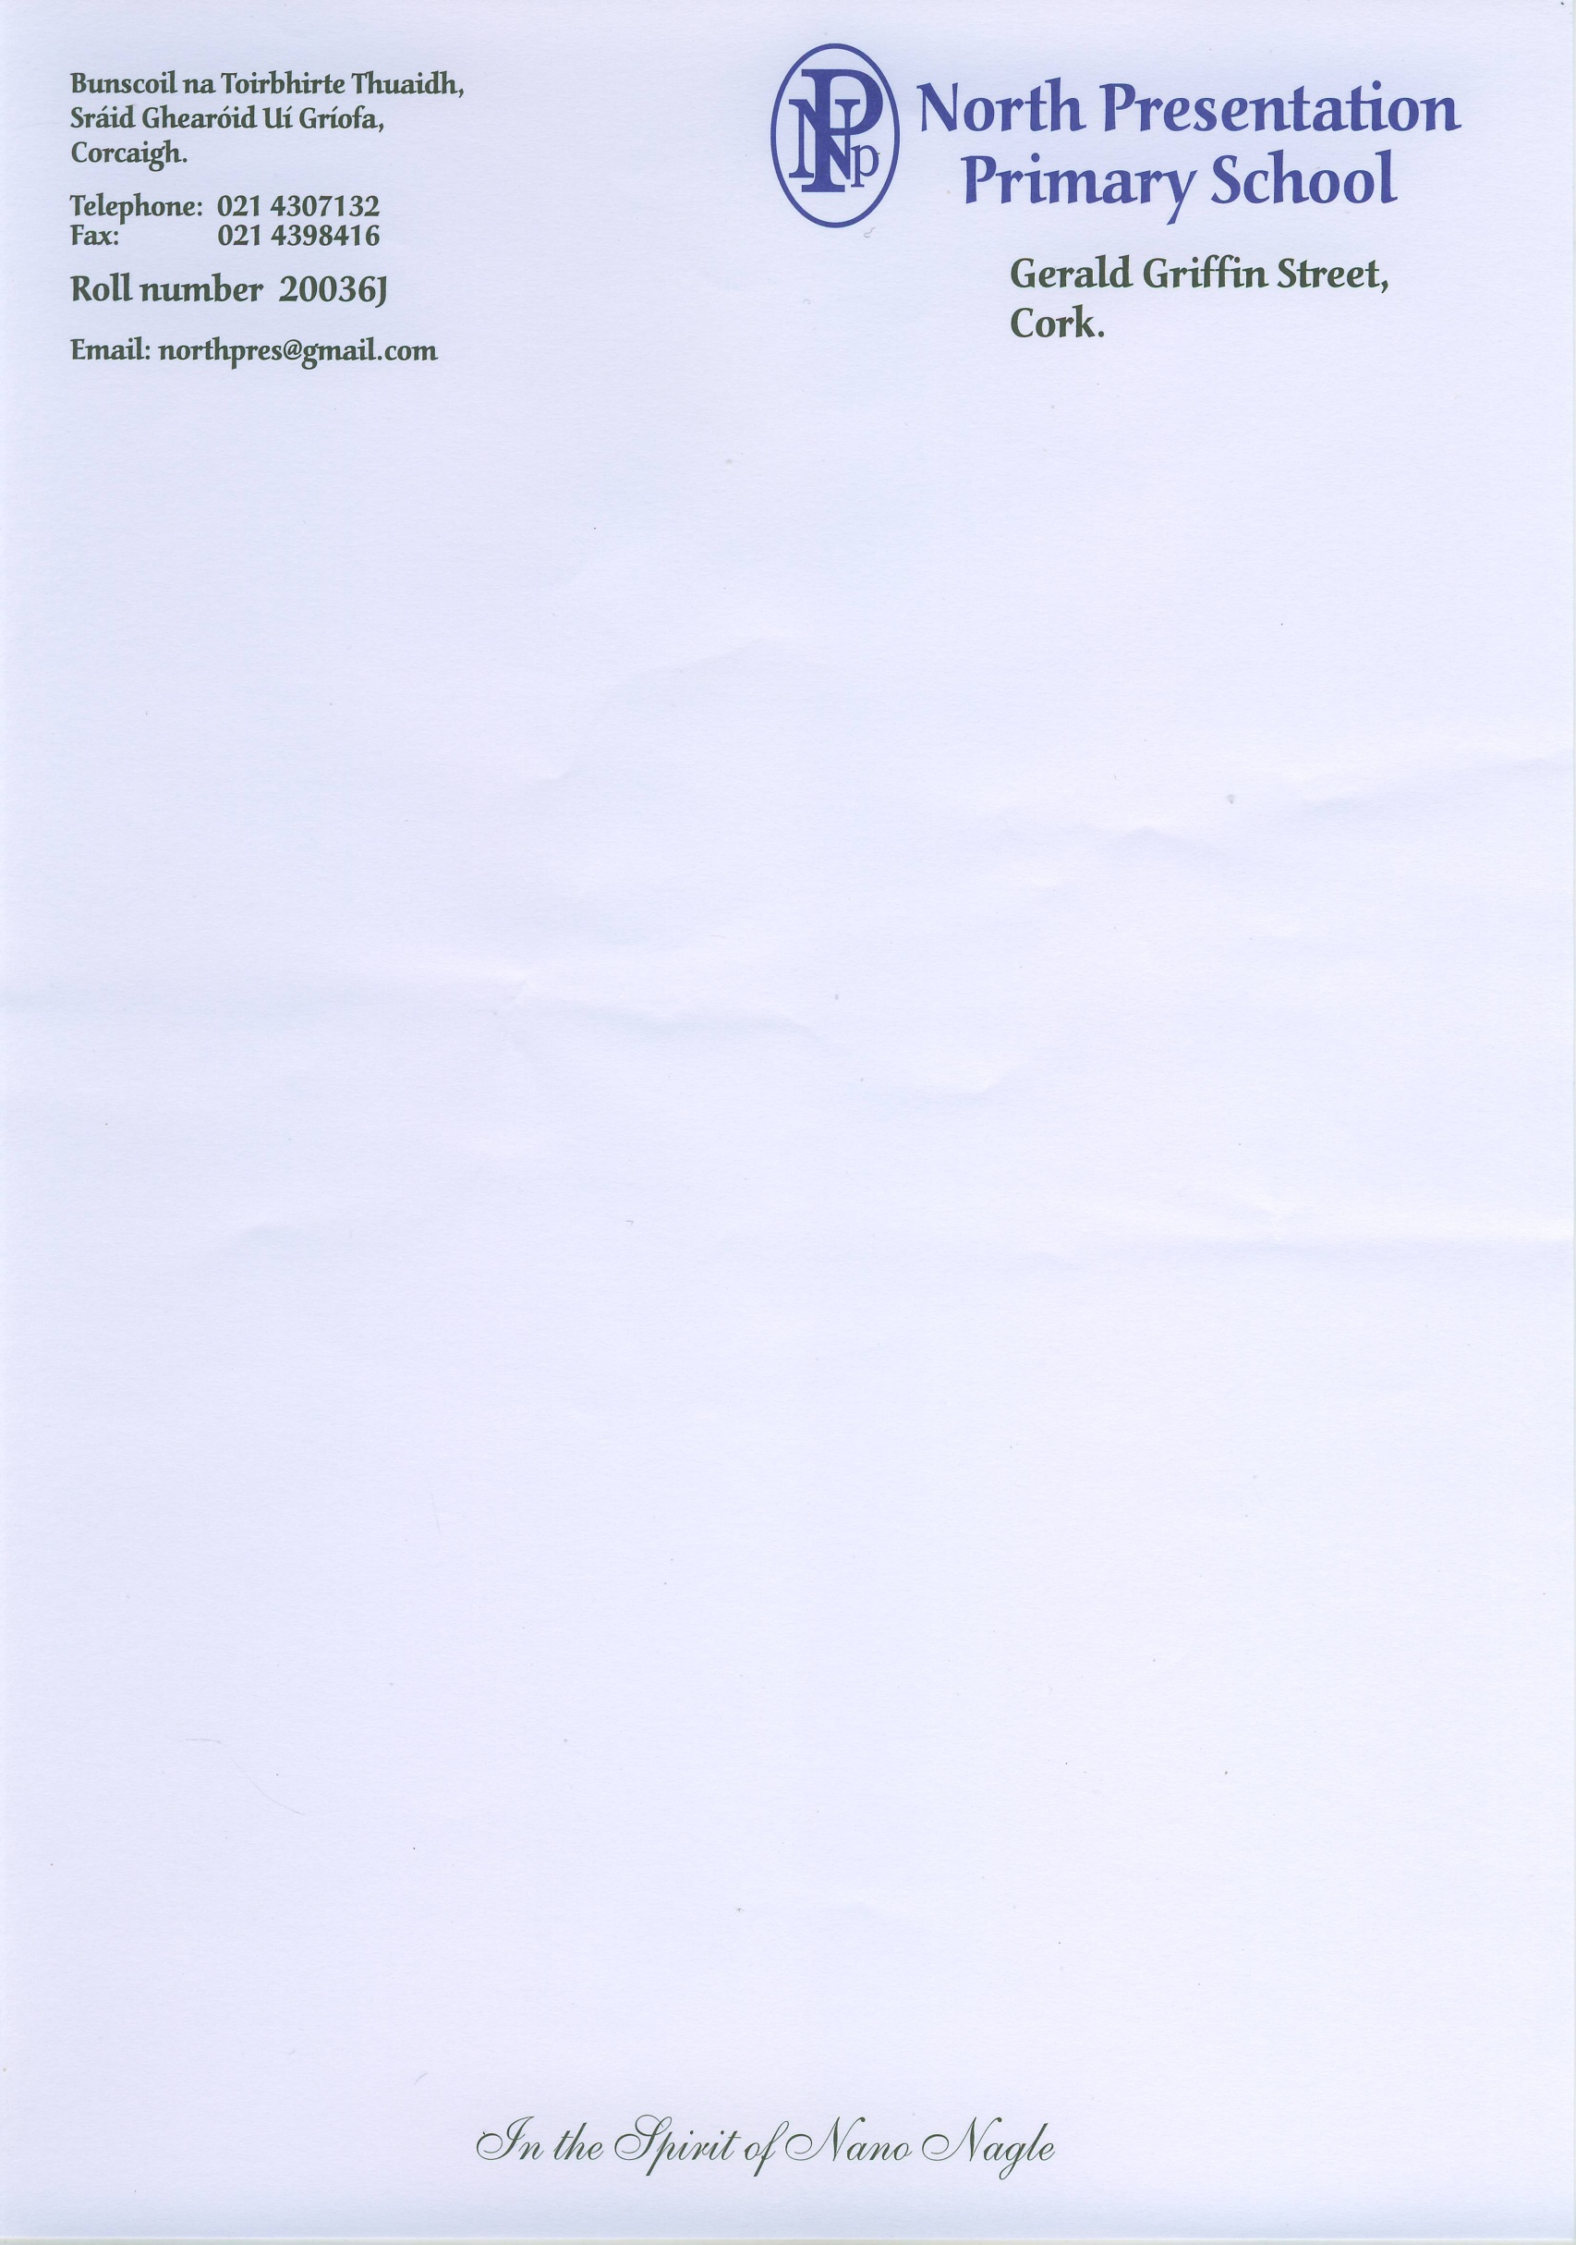 **Roll No: 20036J**

**Registered Charity Number: 20111717**

**Telephone: (021) 4307132**

**Email:** [**applications@northpresprimary.ie**](mailto:applications@northpresprimary.ie)

**Early Start Application Form – North Presentation Primary School**

**Children must be aged more than 3.5 years and less than 5 years on the 1st of September 2025**

**Personal Information of Child**

**First Name: Surname:**

**Address and Eircode:**

**Date of birth: PPSN:**

**Male: ____ Female: _____**

**Nationality:**

**Contact details of Parents/Guardians:**

1. **Name:**

**Relationship to child:**

**Contact Number:**

**Email address:**

1. **Name:**

**Relationship to child:**

**Contact Number:**

**Email address:**

**Number of children in family: Place of this child in the family:**

**Language spoken in the home:**

**Brothers/sisters attending North Presentation Primary School:**

**Medical Conditions/Food Allergies:**

**Is your child toilet trained?**

**Is your child currently attending or has your child attended any of the following services?**

-Speech and language therapy ___________________

-Occupational therapy _________________________

Or other, if yes please give further detail___________________________________________________

_____________________________________________________________________________________

**If we can give a choice of time which would suit you best?**

8.40 am-11.10 a.m. or 11.40 am – 2.10 p.m.

**Signed: (parent/guardian): Date:**

**Please ensure all information is filled in and return this form to** [**applications@northpresprimary.ie**](mailto:applications@northpresprimary.ie) **or hand it in to the school office.**

**Office Use Only**

**Date Received:**